

Good Shepherd Lutheran Church & School
is a welcoming, Christ-centered family,
dedicated to sharing our love and faith.

GOOD SHEPHERD LUTHERAN CHURCH
(The Lutheran Church-Missouri Synod)
PASTOR STEVE ANDERSON
5659 Honore Ave., Sarasota, Florida 34233
941-921-3673

Email : parishcoord@goodshepherdsarasota.org
pastor@goodshepherdsarasota.org
www.goodshepherdsarasota.org
GOOD SHEPHERD LUTHERAN SCHOOL
941-922-8164
Email: GSLS@comcast.net



2.15.26
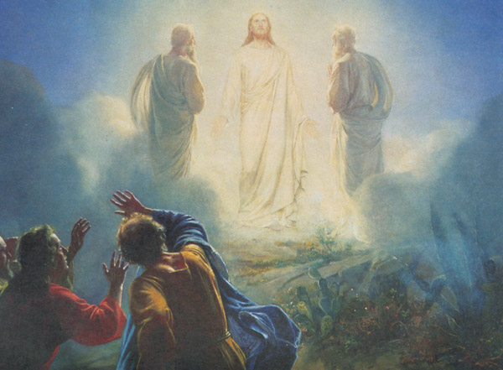
TRANSFIGURATION OF OUR LORD
Sunday, February 15, 2026, 9:15 AM

LORD’S SUPPER - As Lutherans, in joyful obedience to the clear teaching of our Lord Jesus, we invite to His table at Good Shepherd those who trust His Word, repent of their sins, and set aside refusal to forgive and love just as we have been loved and forgiven by God. If you are unsure about whether you should commune or not, speak to an usher prior to the service. Thank you and welcome!

PRESERVICE MUSIC

WELCOME AND ANNOUNCEMENTS

OPENING HYMN “Immortal, Invisible, God Only Wise” LSB 802

THE SERVICE OF CONFESSION AND ABSOLUTION

P In the name of the Father and of the + Son and of the Holy Spirit.
C Amen.

P If we say we have no sin, we deceive ourselves, and the truth is not in us.
C But if we confess our sins, God, who is faithful and just, will forgive our sins and cleanse us from all unrighteousness.

(Silence for reflection on God's Word and for self-examination.)
P Let us then confess our sins to God our Father.
C Most merciful God, we confess that we are by nature sinful and unclean. We have sinned against You in thought, word, and deed, by what we have done and by what we have left undone. We have not loved You with our whole heart; we have not loved our neighbors as ourselves. We justly deserve Your present and eternal punishment. For the sake of Your Son, Jesus Christ, have mercy on us. Forgive us, renew us, and lead us, so that we may delight in Your will and walk in Your ways to the glory of Your holy name. Amen.

P Almighty God in His mercy has given His Son to die for you and for His sake forgives you all your sins. As a called and ordained servant of Christ, and by His authority, I therefore forgive you all your sins in the name of the Father and of the + Son and of the Holy Spirit.
C Amen.

KYRIE LSB 152

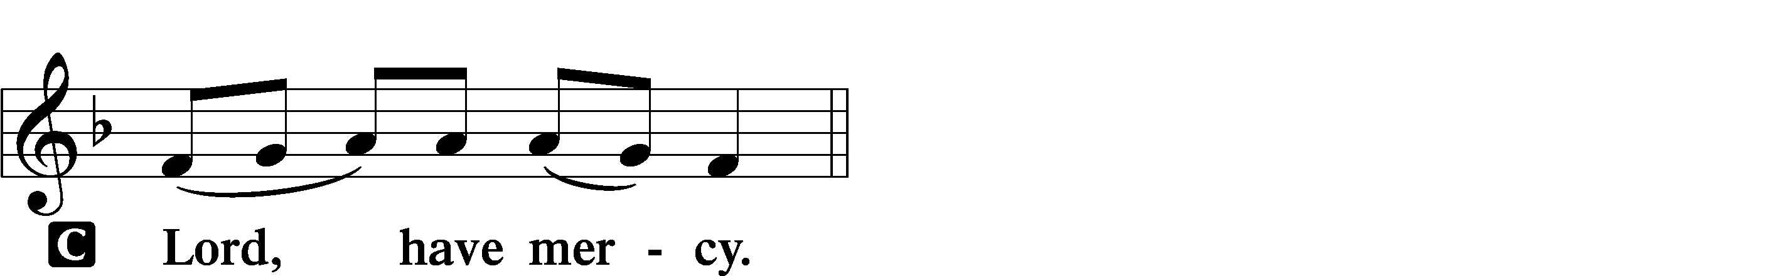
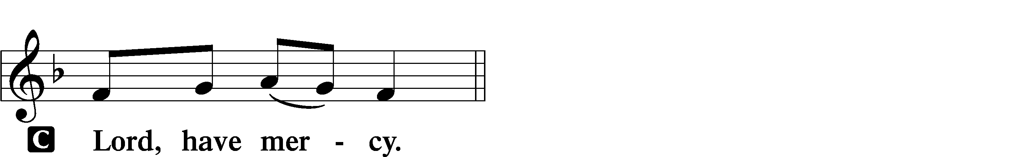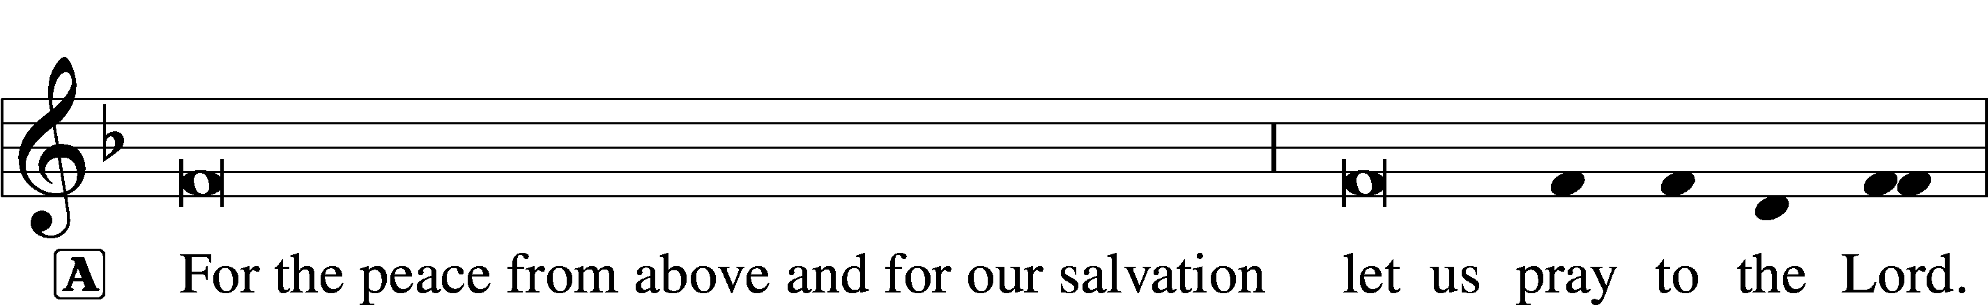

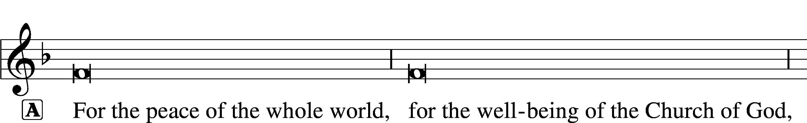



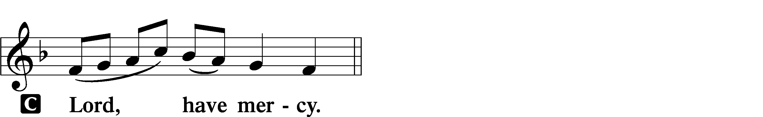

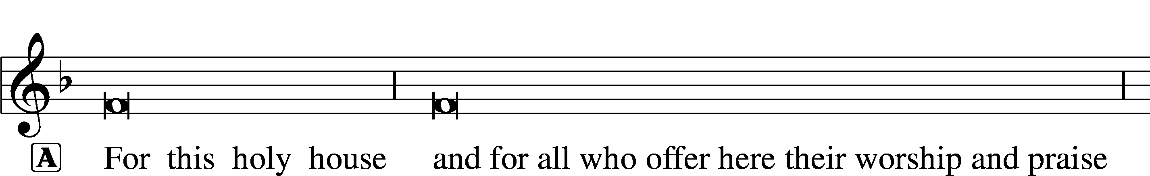



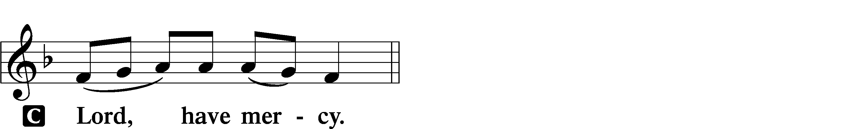





THIS IS THE FEAST LSB 155
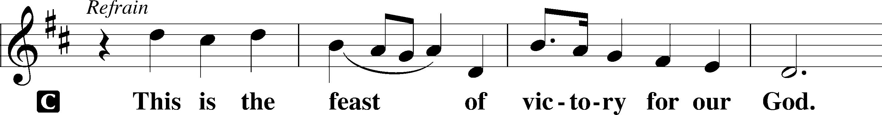

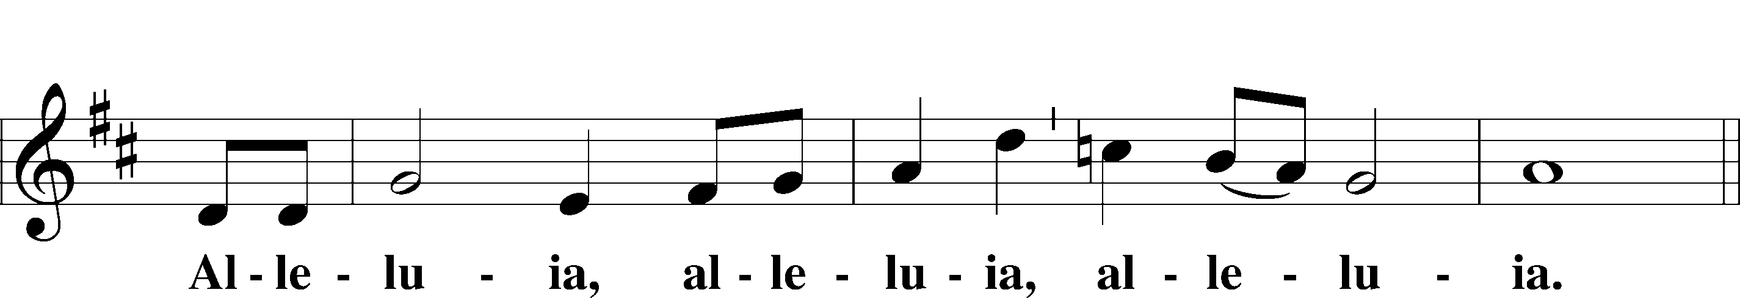

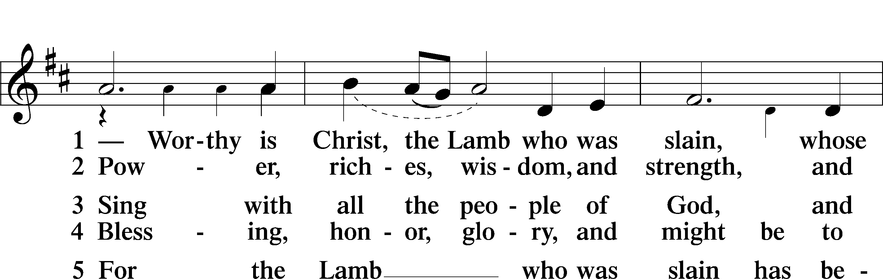

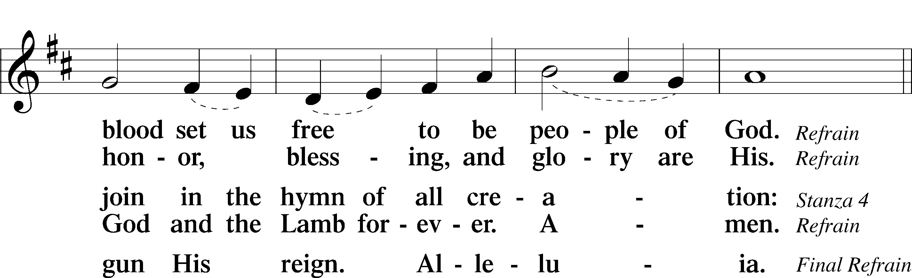

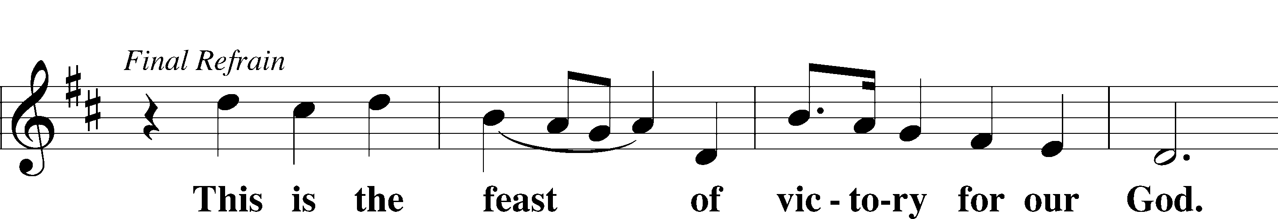

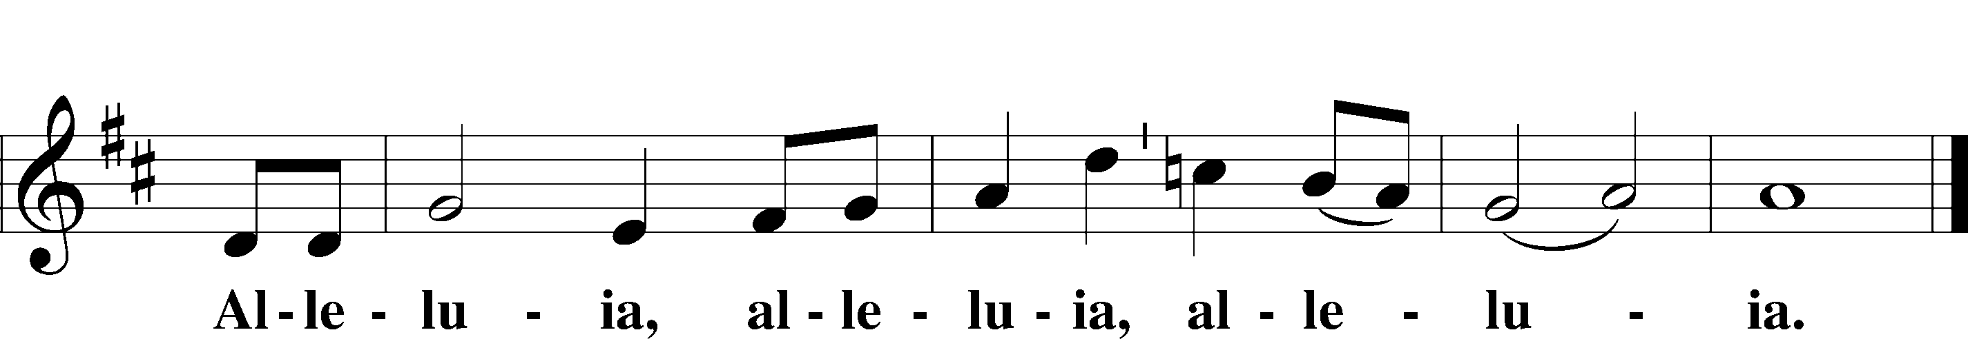

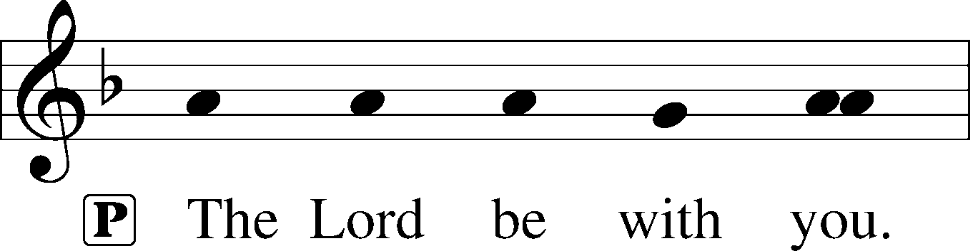
SALUTATION and COLLECT OF THE DAY

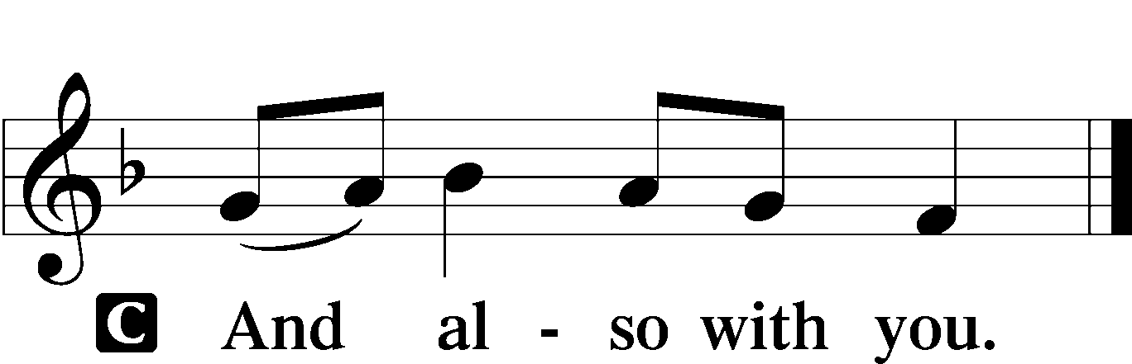

P Let us pray. O God, in the glorious transfiguration of Your beloved Son You confirmed the mysteries of the faith by the testimony of Moses and Elijah. In the voice that came from the bright cloud You wonderfully foreshowed our adoption by grace. Mercifully make us co-heirs with the King in His glory and bring us to the fullness of our inheritance in heaven; through the same Jesus Christ, our Lord, who lives and reigns with You and the Holy Spirit, one God, now and forever.

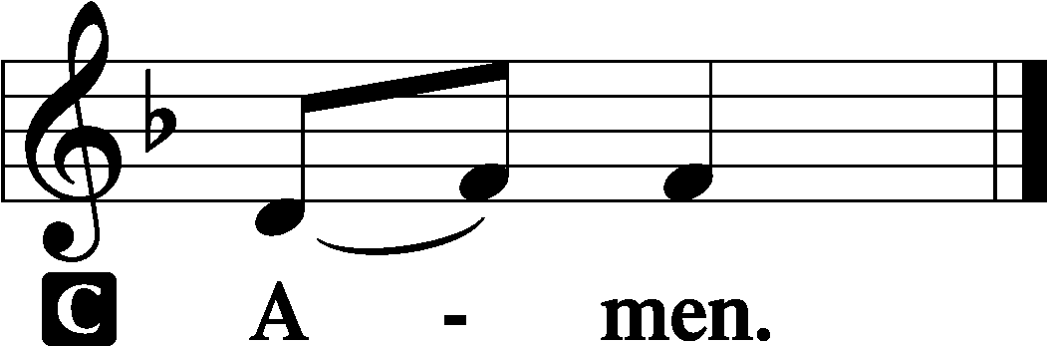
THIS WEEK’S THEME... God Manifests His Glory in the Body of Christ Jesus, Transfigured for Us by His Cross

OLD TESTAMENT READING Exodus 24:8–18

And Moses took the blood and threw it on the people and said, “Behold the blood of the covenant that the Lord has made with you in accordance with all these words.” Then Moses and Aaron, Nadab, and Abihu, and seventy of the elders of Israel went up, and they saw the God of Israel. There was under his feet as it were a pavement of sapphire stone, like the very heaven for clearness. And he did not lay his hand on the chief men of the people of Israel; they beheld God, and ate and drank. The Lord said to Moses, “Come up to me on the mountain and wait there, that I may give you the tablets of stone, with the law and the commandment, which I have written for their instruction.” So Moses rose with his assistant Joshua, and Moses went up into the mountain of God. And he said to the elders, “Wait here for us until we return to you. And behold, Aaron and Hur are with you. Whoever has a dispute, let him go to them.” Then Moses went up on the mountain, and the cloud covered the mountain. The glory of the Lord dwelt on Mount Sinai, and the cloud covered it six days. And on the seventh day he called to Moses out of the midst of the cloud. Now the appearance of the glory of the Lord was like a devouring fire on the top of the mountain in the sight of the people of Israel. Moses entered the cloud and went up on the mountain. And Moses was on the mountain forty days and forty nights.

L This is the Word of the Lord.
C Thanks be to God.

CHOIR ANTHEM “ The Cloud and Fire” C. Austin Miles

EPISTLE 2 Peter 1:16–21

For we did not follow cleverly devised myths when we made known to you the power and coming of our Lord Jesus Christ, but we were eyewitnesses of his majesty. For when he received honor and glory from God the Father, and the voice was borne to him by the Majestic Glory, “This is my beloved Son, with whom I am well pleased,” we ourselves heard this very voice borne from heaven, for we were with him on the holy mountain. And we have something more sure, the prophetic word, to which you will do well to pay attention as to a lamp shining in a dark place, until the day dawns and the morning star rises in your hearts, knowing this first of all, that no prophecy of Scripture comes from someone’s own interpretation. For no prophecy was ever produced by the will of man, but men spoke from God as they were carried along by the Holy Spirit.

L This is the Word of the Lord.
C Thanks be to God.

ALLELUIA AND VERSE

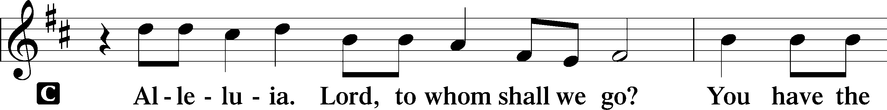

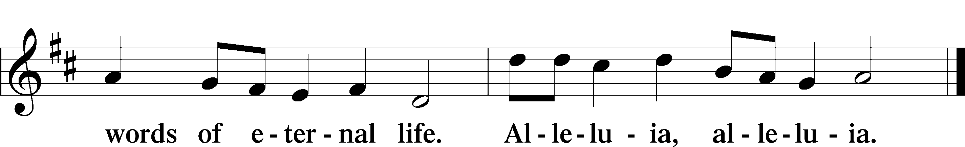

HOLY GOSPEL Matthew 17:1-9

P The Holy Gospel according to St. Matthew, the seventeenth chapter.
C Glory to You, O Lord.

After six days Jesus took with him Peter and James, and John his brother, and led them up a high mountain by themselves. And he was transfigured before them, and his face shone like the sun, and his clothes became white as light. And behold, there appeared to them Moses and Elijah, talking with him. And Peter said to Jesus, “Lord, it is good that we are here. If you wish, I will make three tents here, one for you and one for Moses and one for Elijah.”5He was still speaking when, behold, a bright cloud overshadowed them, and a voice from the cloud said, “This is my beloved Son, with whom I am well pleased; listen to him.” When the disciples heard this, they fell on their faces and were terrified. But Jesus came and touched them, saying, “Rise, and have no fear.” And when they lifted up their eyes, they saw no one but Jesus only. And as they were coming down the mountain, Jesus commanded them, “Tell no one the vision, until the Son of Man is raised from the dead.”

P This is the Gospel of the Lord.
C Praise to You, O Christ.

CHILDREN’S CHAPEL

HYMN OF THE DAY “ O Wondrous Type! O Vision Fair” LSB 413, vs. 1-4

SERMON Matthew 17:1-9; “I Can’t Know”

APOSTLES’ CREED

C I believe in God, the Father Almighty, maker of heaven and earth.
And in Jesus Christ, His only Son, our Lord, who was conceived by the Holy Spirit, born of the virgin Mary, suffered under Pontius Pilate, was crucified, died and was buried. He descended into hell. The third day He rose again from the dead. He ascended into heaven and sits at the right hand of God the Father Almighty. From thence He will come to judge the living and the dead.
I believe in the Holy Spirit, the holy Christian Church, the communion of saints, the forgiveness of sins, the resurrection of the body, and the life + everlasting. Amen.

PRAYER OF THE CHURCH
Each Petition ends with:

P Lord in Your mercy,
C Hear our Prayer.
THE OFFERING
While we gather the offering today you are invited to fill out the red “Record of Fellowship” forms located at the end of the pew. If you would, please pass the red pad down the pew so everyone can complete the record. Thanks!

+SERVICE OF THE SACRAMENT +

Preface LSB 160







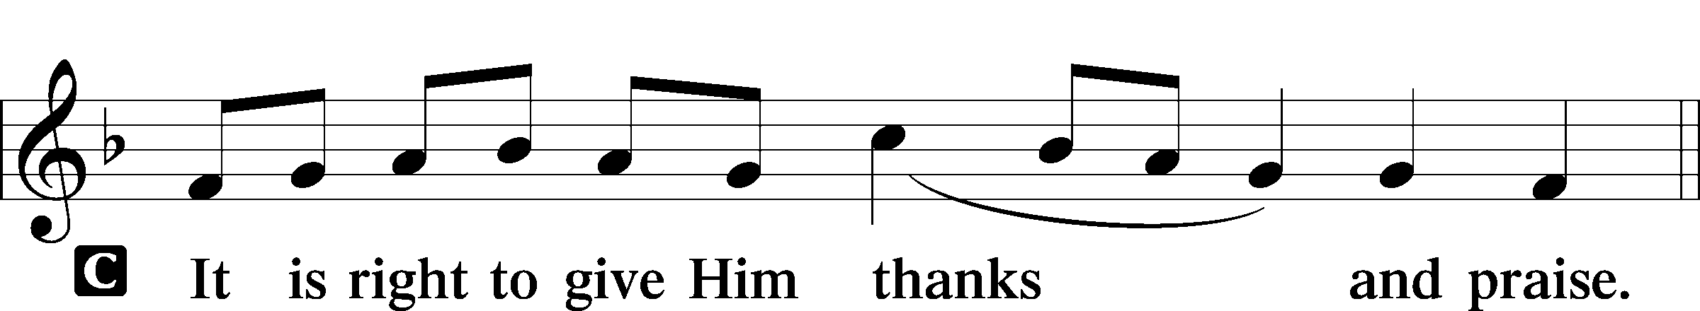

P It is truly good, right, and salutary . . . evermore praising You and
saying:

SANCTUS LSB 161

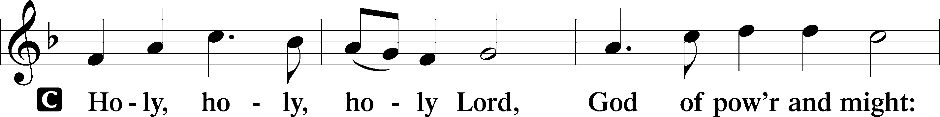
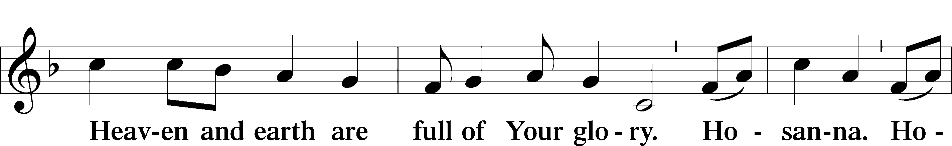
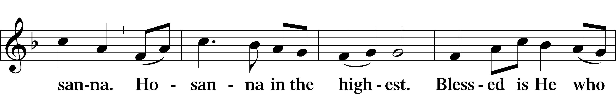
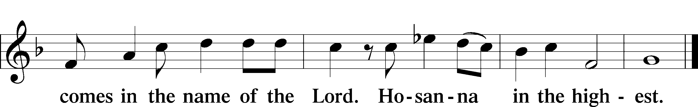

LORD'S PRAYER

P Lord, remember us in Your kingdom and teach us to pray:
C Our Father who art in heaven, hallowed be Thy name, Thy kingdom come, Thy will be done on earth as it is in heaven; give us this day our daily bread; and forgive us our trespasses as we forgive those who trespass against us; and lead us not into temptation, but deliver us from evil. For Thine is the kingdom and the power and the glory forever and ever. Amen.

THE WORDS OF OUR LORD

PAX DOMINI

P The peace of the Lord be with you always.
C And also with you.

AGNUS DEI LSB 163

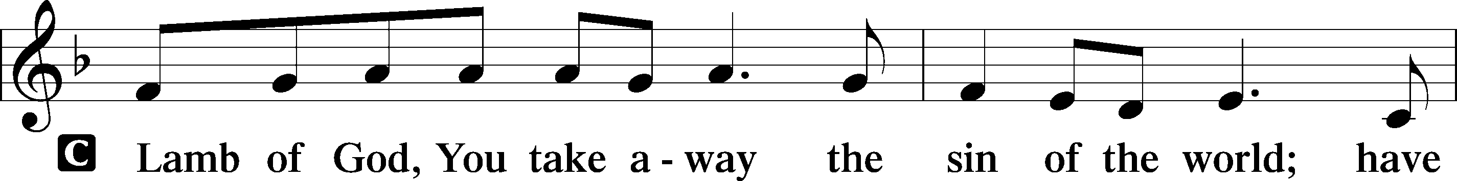
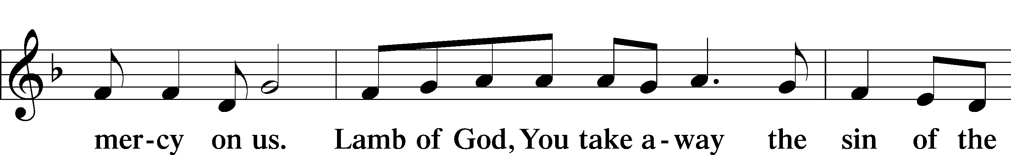
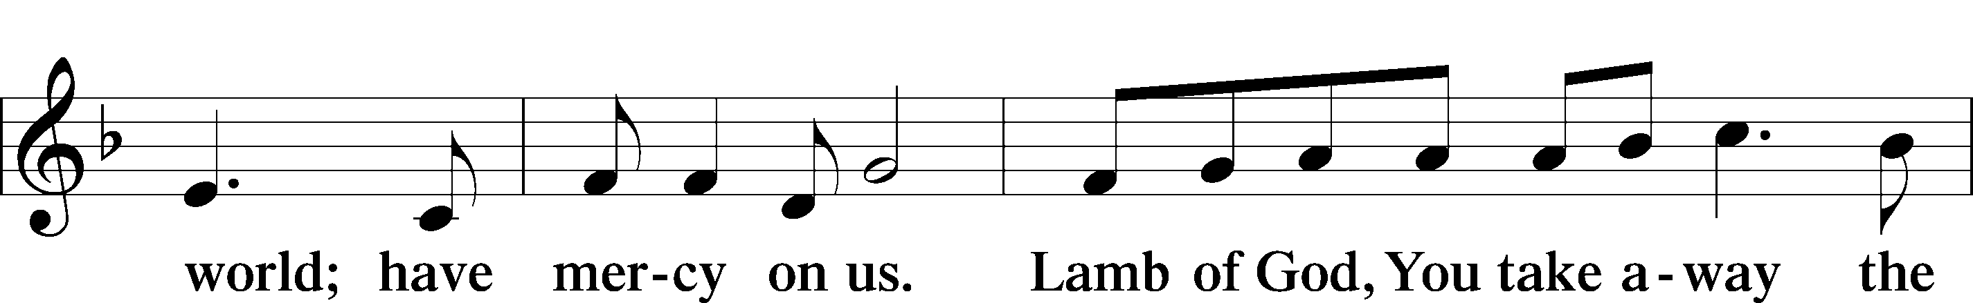
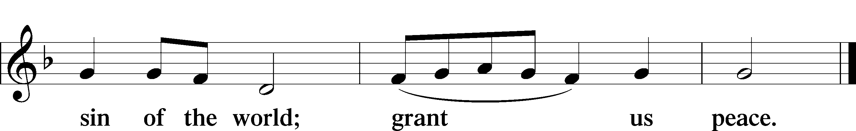

THE DISTRIBUTION
As Lutherans, in joyful obedience to the clear teaching of Lord Jesus, we now invite to His table those who trust His Word, repent of their sins, and set aside refusal to forgive and love just as we have been loved and forgiven by God. You will receive the host and then will have a choice of either the individual cups or the common cup. If you would like the common cup, place your hands FLAT on the rail while the individual cups are offered. This way Pastor will know that you desire the common cup. If for medical or other reasons you would prefer a non-alcoholic individual cup, they are located in the center of each tray. If you would like to receive communion in the pew, please inform an Usher and what your preference would be – either common or individual cup. Thank you.

HYMNS DURING THE DISTRIBUTION

“Beautiful Savior” LSB 537
“Alleluia! Sing to Jesus” LSB 821
“Christ, Whose Glory Fills the Skies” LSB 873
“O Word of God Incarnate LSB 523
“O Savior, Precious Savior LSB 527

POST-COMMUNION COLLECT

P Let us pray. We give thanks to You, almighty God, that You have refreshed us through this salutary gift, and we implore You that of Your mercy You would strengthen us through the same in faith toward You and in fervent love toward one another; through Jesus Christ, Your Son, our Lord, who lives and reigns with You and the Holy Spirit, one God, now and forever.
C Amen.

BENEDICTION

P Let us bless the Lord.
C Thanks be to God.

P The Lord bless you and keep you. The Lord make His face shine on you and be gracious to you. The Lord look upon you with favor and + give you peace.
C Amen.

P Go in Peace. Serve the Lord.
C Thanks be to God!

CLOSING HYMN “O Bless the Lord, My Soul” LSB 814, vs. 1, 4, 5, 6

POSTLUDE
Acknowledgments Divine Service, Setting One from Lutheran Service Book. Unless otherwise indicated, all scripture quotations are from Holy Bible, English Standard Version, copyright © 2001 by Crossway Bibles, a division of Good News Publishers. Used by permission. All rights reserved. Created by Lutheran Service Builder © 2023 Concordia Publishing House

6“As for me, I have set my King on Zion, my holy hill.”
7I will tell of the decree: The Lord said to me, “You are my
Son; today I have begotten you. Ask of me, and I will make the nations your heritage, and the ends of the earth your possession. 9You shall break them with a rod of iron
P
S
A
L
M

2
:
6
-
12
and dash them in pieces like a potter’s vessel.”
10Now therefore, O kings, be wise; be warned,
O rulers of the earth.11Serve the Lord with fear,
and rejoice with trembling. 12Kiss the Son,
lest he be angry, and you perish in the way,
for his wrath is quickly kindled. Blessèd are all
who take refuge in him.

NEXT WEEK’S READINGS :
Genesis 3:1–21, Psalm 32:1–7
Romans 5:12–19, Matthew 4:1–11

COME SEE WHAT GOD IS DOING IN
OUR MIDST; COME GROW WITH US

UPCOMING EVENTS

FEBRUARY
16-Church Council Meeting 6 PM
24- School Board Meeting 5:45 PM
18- Ash Wednesday Service 7 PM “Standing in the Word”
25- Wednesday Lent Service 7 PM “Standing in Prayer”
28-Building Bash 10-2 PM

MARCH
04- Wednesday Lent Service 7PM “Standing Unafraid”
11-Wednesday Lent Service 7 PM “Standing in Suffering”
18-Wednesday Lent Service 7 PM “Standing Through Persecution
25-Wednesday Lent Service 7 PM “Standing in Truth
29-Palm Sunday 9:15 AM “Standing in Humility”
No Fellowship Dinner Scheduled for March
APRIL
2-Maundy Thursday 7 PM “Standing in Faith”
3- Good Friday 7 PM “Standing in Forgiveness”
5- Easter Morning 7:15 AM & 9:15 AM “Standing in Victory”
16- Fellowship Dinner 5:30 PM TBD

ALTAR FLOWERS

We are blessed this week by the beautiful altar flowers, generously given by Otto and Joanne Koelling in celebration of Otto’s 95th birthday.

FEBRUARY BIRTHDAYS

Brian Tippman 02/01
Ralph Scheiwe 02/02
Mary Leeseberg 02/02
Royce Imhoff 02/02
Lori Minor 02/04
Michele Tippman 02/08
Janice LaGorin 02/08

Steve Briggs 02/10
Birgit Crowder-
Swanson 02/17
Otto Koelling 02/17
Paul Duncan 02/21
Megan Rhinehart 02/21
Sarah Crissman 02/22


HAPPY ANNIVERSARY
Earl & Janice LaGorin 02/27 66 Years

MORE WAYS TO GIVE

1st is Joyful Response- sign up from your checking or savings account to the church on a recurring basis. There is no cost for either the member or church to participate in this program.
2nd is Zelle- sign into your bank via your cell phones and initiate an on-time transfer from your account to the church checking account. There is no cost for the members, however,
the church must pay a 1% fee to the bank.

NOTARY SERVICE AVAILABLE
Call Sue at the office 941-3673

WEEK OF FEBRUARY 14-15,2026
TITHES & OFFERING: $ 4695
ATTENDANCE
Saturday 2/14: 21 Sunday 2/15: 113
Please take a moment to review your information in the current directory placed in the Narthex and let us know of any corrections or updates. Your help ensures the directory is accurate and complete. Thank you, Sue







GOODSHEPHERDSARASOTA.ORG

Calendar of Events, Online Giving, Event Photos
School Building Updates, And much more!

