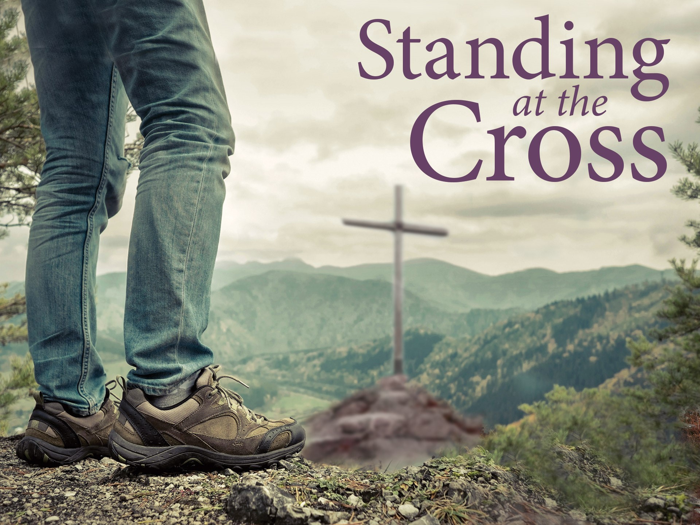

STANDING IN VICTORY



GOOD SHEPHERD LUTHERAN CHURCH
(The Lutheran Church-Missouri Synod)
PASTOR STEVE ANDERSON
5659 Honore Ave., Sarasota, Florida 34233
www.goodshepherdsarasota.com
941-921-3673

4.5.26

Standing at the Cross
Easter Morning
Standing in Victory
April 5, 2026

WELCOME to Good Shepherd Lutheran Church and School! As we come together for worship this glorious day, the cross and now empty tomb of Christ is before us. A special welcome is extended to all guests and visitors today. May you find grace and blessings in the time we spend together in worship.
Why do you seek the living among the dead? He is not here, but has risen.
Luke 24:5-6

The Congregation Stands as You are Able

P Christ is risen! Alleluia!
C He is risen, indeed! Alleluia!

P Death could not hold him.
C Death could not win.

P Our Savior Jesus is victorious!
C God has vindicated him. Jesus is Lord!

P Alleluia! Christ is risen!
C He is risen indeed! Alleluia!

P We know that Christ being raised from the dead will never die again;
C death no longer has dominion over Him.

PROCESSIONAL HYMN “Jesus Christ Is Risen Today” - LSB 457, Printed
Jesus Christ is ris’n today, Alleluia!
Our triumphant holy day, Alleluia!
Who did once upon the cross, Alleluia!
Suffer to redeem our loss. Alleluia!

Hymns of praise then let us sing, Alleluia!
Unto Christ, our heav’nly king, Alleluia!
Who endured the cross and grave, Alleluia!
Sinners to redeem and save. Alleluia!

But the pains which he endured, Alleluia!
Our salvation have procured; Alleluia!
Now above the sky he’s king, Alleluia!
Where the angels ever sing. Alleluia!

Sing we to our God above, Alleluia!
Praise eternal as his love; Alleluia!
Praise him, all ye heav’nly host, Alleluia!
Father, Son and Holy Ghost. Alleluia!

P In the name of the Father and of the + Son and of the Holy Spirit.
C Amen.

P Christ is risen!
C He is risen indeed! Alleluia!

P The stone that the builders rejected has become the cornerstone.
C This is the Lord's doing; it is marvelous in our eyes.

P This is the day that the Lord has made;
C Let us rejoice and be glad in it.

P Let us confess our sins to God and ask forgiveness for the sake of our crucified and risen Savior.
C Almighty God, through Jesus our Lord we have forgiveness and life, yet we often refuse to live as your redeemed people. We sin against you in our thoughts, words and actions. We follow our own sinful desires instead of living according to your Word. Have mercy on us and forgive us for Jesus’ sake.

P God has had mercy on us. He sent his Son to save us. Through the death and resurrection of Jesus we have forgiveness and life. I announce to you that your sins are forgiven in the name of the Father and of the + Son and of the Holy Spirit. Amen. Christ is risen!
C He is risen indeed! Alleluia!

P We pray. Risen Lord, on this day we praise you and give thanks for the living hope that is ours through faith in your name. You suffered and died, taking onto yourself the penalty that we deserved for our sins. You were buried in a borrowed tomb and on the third day you rose in victory, defeating sin, death and the devil. Your victory is our victory, and today, as we stand at the empty tomb, we rejoice in the gift of life and resurrection that you have won for us. Mighty Savior, hear our prayer and accept our thanks and praise.
C Amen.

HYMN RESPONSE “O Sons and Daughters of the King” – LSB 470, verse 1, Printed

O sons and daughters of the King,
Whom heav’nly hosts in glory sing,
Today the grave has lost its sting!
Alleluia, alleluia, alleluia!

The Congregation is Seated

THIS WEEK’S THEME… The Lord Jesus Brings Us Out
of Death into Life with His God and Father in Heaven

FIRST LESSON Hosea 6:1-3

Come, let us return to the Lord; for he has torn us, that he may heal us; he has struck us down, and he will bind us up. After two days he will revive us; on the third day he will raise us up, that we may live before him. Let us know; let us press on to know the Lord; his going out is sure as the dawn; he will come to us as the showers, as the spring rains that water the earth.

L This is the Word of the Lord.
C Thanks be to God.

GSLCS CHOIR ANTHEM “Christ Has Arisen, Alleluia” – LSB 466

SECOND LESSON 1 Corinthians 15:20-28

But in fact Christ has been raised from the dead, the firstfruits of those who have fallen asleep. For as by a man came death, by a man has come also the resurrection of the dead. For as in Adam all die, so also in Christ shall all be made alive. But each in his own order: Christ the firstfruits, then at his coming those who belong to Christ. Then comes the end, when he delivers the kingdom to God the Father after destroying every rule and every authority and power. For he must reign until he has put all his enemies under his feet. The last enemy to be destroyed is death. For “God has put all things in subjection under his feet.” But when it says, “all things are put in subjection,” it is plain that he is excepted who put all things in subjection under him. When all things are subjected to him, then the Son himself will also be subjected to him who put all things in subjection under him, that God may be all in all.

L This is the Word of the Lord.
C Thanks be to God.

The Congregation Stands as You are Able

HOLY GOSPEL Luke 24:1-9

But on the first day of the week, at early dawn, they went to the tomb, taking the spices they had prepared. And they found the stone rolled away from the tomb, but when they went in they did not find the body of the Lord Jesus. While they were perplexed about this, behold, two men stood by them in dazzling apparel. And as they were frightened and bowed their faces to the ground, the men said to them, “Why do you seek the living among the dead? He is not here, but has risen. Remember how he told you, while he was still in Galilee, that the Son of Man must be delivered into the hands of sinful men and be crucified and on the third day rise.” And they remembered his words, and returning from the tomb they told all these things to the eleven and to all the rest.

P This is the Easter Gospel of the Lord.
C Thanks be to God.

The Congregation is Seated

HYMN OF THE DAY “Christ the Lord Is Risen Today” - LSB 469, verses 1-2, 6

“The words, Christ is risen from the dead, we should blazon and
inscribe with letters so large that just one letter would be as
large as a steeple, yes, as heaven and earth, so that we would
see and hear, know and think of, nothing but this article.”
Martin Luther, sermon for Easter Eve, 1532

THE SERMON “Standing in Victory”

The Congregation Stands as You are Able

HYMN RESPONSE “Now All the Vault of Heaven Resounds” - LSB 465, verses 1-2

The Congregation is Seated
THE OFFERING

At the end of each pew you will find a red pad with the “Record of Fellowship” forms. During the offering, please indicate your presence with us by filling in the form and passing the pad on. Thank You!
The Congregation Stands as You are Able

HYMN RESPONSE “We Give Thee But Thine Own” - LSB 781, stanzas 1-2, Printed

We give Thee but Thine own,
What-e’er the gift may be;
All that we have is Thine alone,
a trust, O Lord, from Thee.

May we Thy bounties thus
as stewards true receive
and gladly, as Thou bless-est us,
to Thee our first-fruits give!

THE PRAYERS

P Crucified and risen Savior, the world offers us false hope and peace that is easily lost. In you alone we have a living hope and peace that can never be taken from us. In you alone we have victory over death and the hope and promise of resurrection. Risen Lord,
C In you we have life and victory!

P Crucified and risen Savior, empower us as Easter people, as your servants to carry the good news of salvation to people who are without hope. Help us to bring your comfort and care to those who are filled with despair and fear. Risen Lord,
C In you we have life and victory!

P Crucified and risen Savior, just as you rose bodily from the dead, on the Last Day, at your command, we too will rise, transformed and glorified, to live in your presence forever. With all the saints we will praise you, the Lamb who was slain for us, the King of kings and Lord of lords. Risen Lord,
C In you we have life and victory! Amen.

THE LORD’S PRAYER

Our Father, who art in heaven, hallowed be Thy name, Thy kingdom come, Thy will be done on earth as it is in heaven. Give us this day our daily bread; and forgive us our trespasses as we forgive those who trespass against us; and lead us not into temptation, but deliver us from evil. For Thine is the kingdom and the power and the glory forever and ever. Amen.

P The Lord be with you.
C And also with you.

P Lift up your hearts.
C We lift them to the Lord.

P Let us give thanks to the Lord our God.
C It is right to give Him thanks and praise.

THE WORDS OF INSTITUTION

P The peace of the Lord be with always.
C And also with you.

RESPONSE “Now All the Vault of Heaven Resounds” - LSB 465, verses 3-4

The Congregation is SEATED

THE DISTRIBUTION
We welcome you to the Lord’s Table today. Today we serve the Lord’s Supper by continuous distribution. You will go forward, receive the host, and then take for yourself either the individual cup or the common cup. We have a gluten-free option for the host; please indicate to pastor if you would like the gluten-free option. If for medical or other reasons you would prefer a non-alcoholic individual cup, they are located in the center of each tray. If you would like to receive communion in the pew, please inform an Usher. There will be a common dismissal blessing for all after the Lord’s Supper has been celebrated. Thank you.

THE DISTRIBUTION HYMNS

“Alleluia! Jesus Is Risen” - LSB 474
“Beautiful Savior” - LSB 537
“Jesus Loves Me” - LSB 588
“I Know that My Redeemer Lives” - LSB 461
“Great Is Thy Faithfulness” - LSB 809

The Congregation Stands As You Are Able

P Alleluia! Christ is risen!
C He is risen, indeed! Alleluia!

P And all the creatures of earth shout:
C Amen!

P And all the saints and angels shout:
C Amen!

P And all the restored people of the Lamb shout:
C Amen and Amen!

P Alleluia! Christ is risen!
C He is risen, indeed! Alleluia!

P Alleluia! Christ is risen!
C He is risen, indeed! Alleluia!

THE BENEDICTION Sung to tune of “The Church’s One Foundation” - #644

P The good Lord bless and keep you,
Lift up His smiling face,
With favor look upon you,
and grant eternal peace.
C To Father, Son, and Spirit,
Most gracious One in Three
The church sings Alleluia
Now and eternally! Amen.

P Go in peace. Serve the Lord.
C Thanks be to God!

CLOSING HYMN “He Lives” - Printed
Text and tune: Alfred H. Ackley, Copyright 1961.

I serve a risen Saviour,
He's in the world today;
I know that He is living,
Whatever men may say;
I see His hand of mercy,
I hear His voice of cheer,
And just the time I need Him
He's always near.
He lives, He lives, Christ Jesus lives today!
He walks with me and He talks with me
Along life's narrow way.
He lives, He lives, salvation to impart!
You ask me how I know He lives:
He lives within my heart.
In all the world around me
I see His loving care,
And tho my heart grows weary
I never will despair;
I know that He is leading
Thro' all the stormy blast,
The day of His appearing
Will come at last.
He lives, He lives, Christ Jesus lives today!
He walks with me and He talks with me
Along life's narrow way.
He lives, He lives, salvation to impart!
You ask me how I know He lives:
He lives within my heart.
Rejoice, rejoice, O Christian,
Lift up your voice and sing
Eternal alleluias
To Jesus Christ the King!
The hope of all who seek Him,
The help of all who find,
None other is so loving,
So good and kind.

He lives, He lives, Christ Jesus lives today!
He walks with me and He talks with me
Along life's narrow way.
He lives, He lives, salvation to impart!
You ask me how I know He lives:
He lives within my heart.

POSTLUDE

Good morning to everyone, and happy Easter! He is risen! He is risen indeed! Thank you for making worship at Good Shepherd a part of your Easter celebration, and may the joy of our Lord's resurrection be with you today and always. Thank you to everyone who put forth so much effort to make our Lenten and Holy Week series of worship services possible. There are so many of you who helped make this time special...thank you one and all! Have a blessed Easter, and May God richly bless you today and always!
Pastor Anderson



