

April 12, 2026
Good Shepherd Lutheran Church & School
is a welcoming, Christ-centered family,
dedicated to sharing our love and faith.

GOOD SHEPHERD LUTHERAN CHURCH
(The Lutheran Church-Missouri Synod)
PASTOR STEVE ANDERSON
5659 Honore Ave., Sarasota, Florida 34233
941-921-3673


parishcoord@goodshepherdsarasota.org
pastor@goodshepherdsarasota.org
www.goodshepherdsarasota.org
GOOD SHEPHERD LUTHERAN SCHOOL
941-922-8164
Email: GSLS@comcast.net




April 12, 2026, 9:15 AM

LORD’S SUPPER - As Lutherans, in joyful obedience to the clear teaching of our Lord Jesus, we invite to His table at Good Shepherd those who trust His Word, repent of their sins, and set aside refusal to forgive and love just as we have been loved and forgiven by God. If you are unsure about whether you should commune or not, speak to an usher prior to the service. Thank you and welcome!

PRESERVICE MUSIC

WELCOME AND ANNOUNCEMENTS

OPENING HYMN “He’s Risen, He’s Risen” LSB 480, vs. 1, 3-5

THE SERVICE OF CONFESSION AND ABSOLUTION

P In the name of the Father and of the + Son and of the Holy Spirit.
C Amen.

P Beloved in the Lord! Let us draw near with a true heart and confess our sins unto God our Father, beseeching Him in the name of our Lord Jesus Christ to grant us forgiveness.

P Our help is in the name of the Lord,
C who made heaven and earth.

P I said, I will confess my transgressions unto the Lord,
C and You forgave the iniquity of my sin.
(Silence for reflection on God's Word and for self-examination.)

P O almighty God, merciful Father,
C I, a poor, miserable sinner, confess unto You all my sins and iniquities with which I have ever offended You and justly deserved Your temporal and eternal punishment. But I am heartily sorry for them and sincerely repent of them, and I pray You of Your boundless mercy and for the sake of the holy, innocent, bitter sufferings and death of Your beloved Son, Jesus Christ, to be gracious and merciful to me, a poor, sinful being.

P Upon this your confession, I, by virtue of my office, as a called and ordained servant of the Word, announce the grace of God unto all of you, and in the stead and by the command of my Lord Jesus Christ I forgive you all your sins in the name of the Father and of the Son and of the Holy Spirit.
C Amen

KYRIE LSB 186
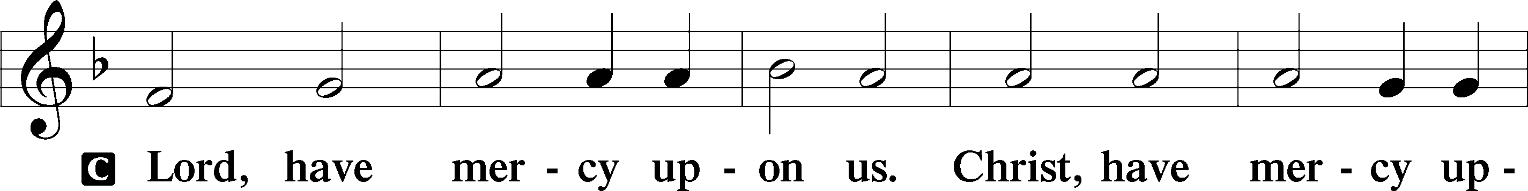
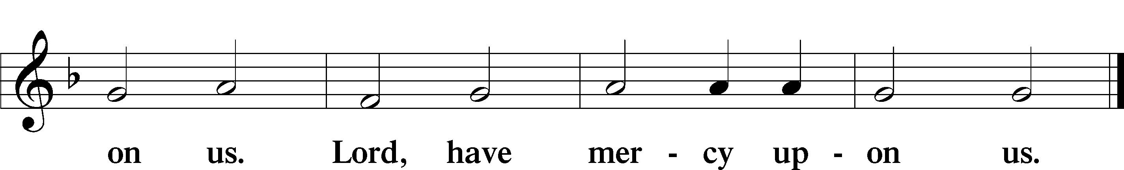

GLORIA IN EXCELSIS LSB 187
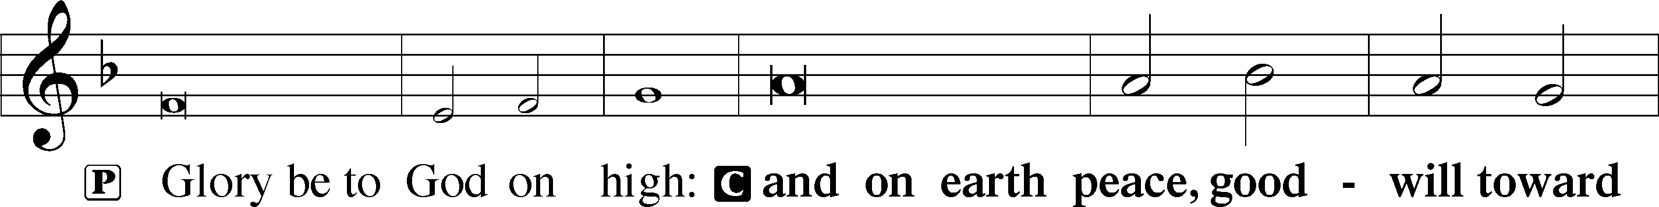
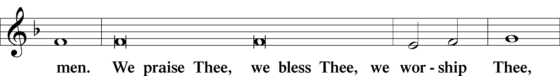
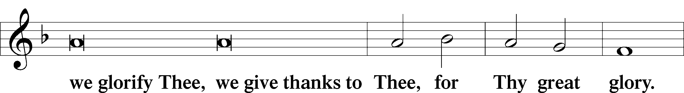
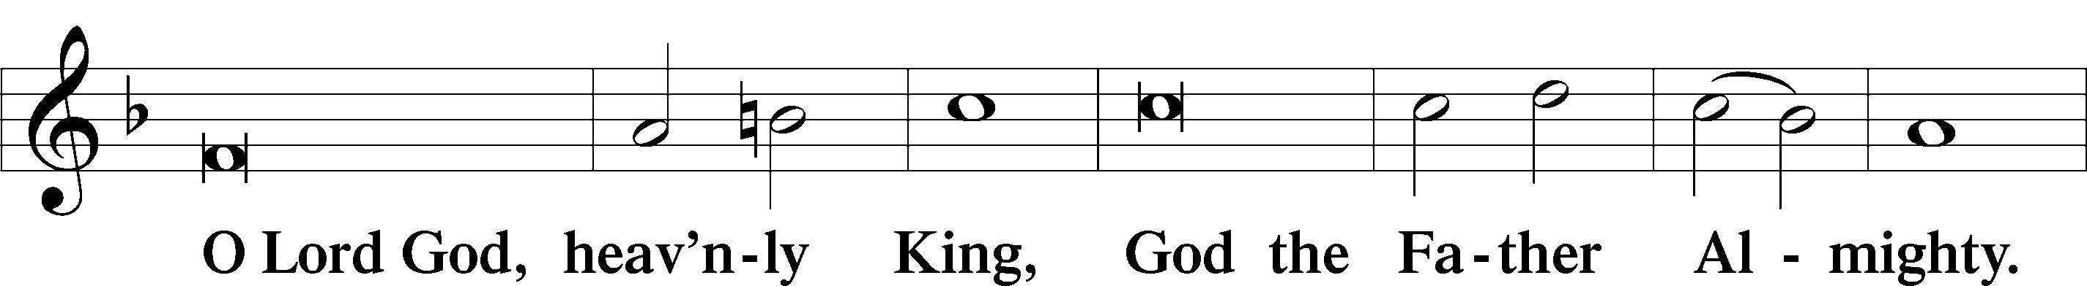
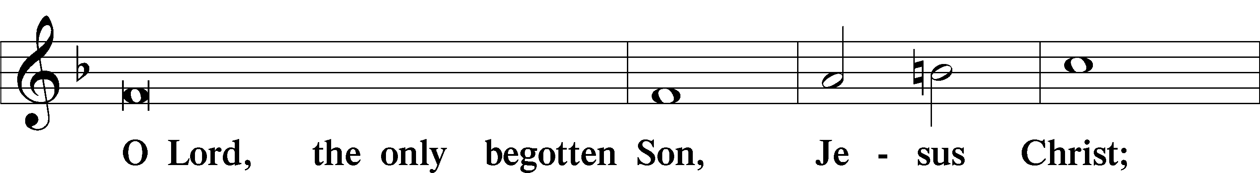
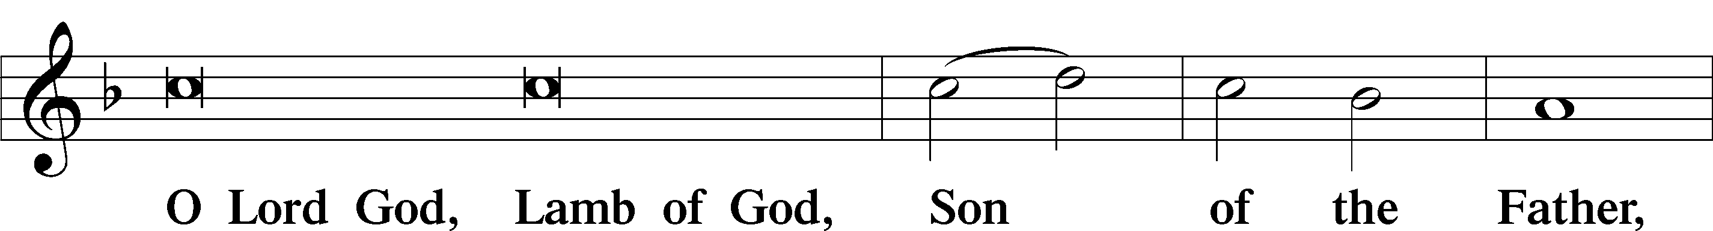
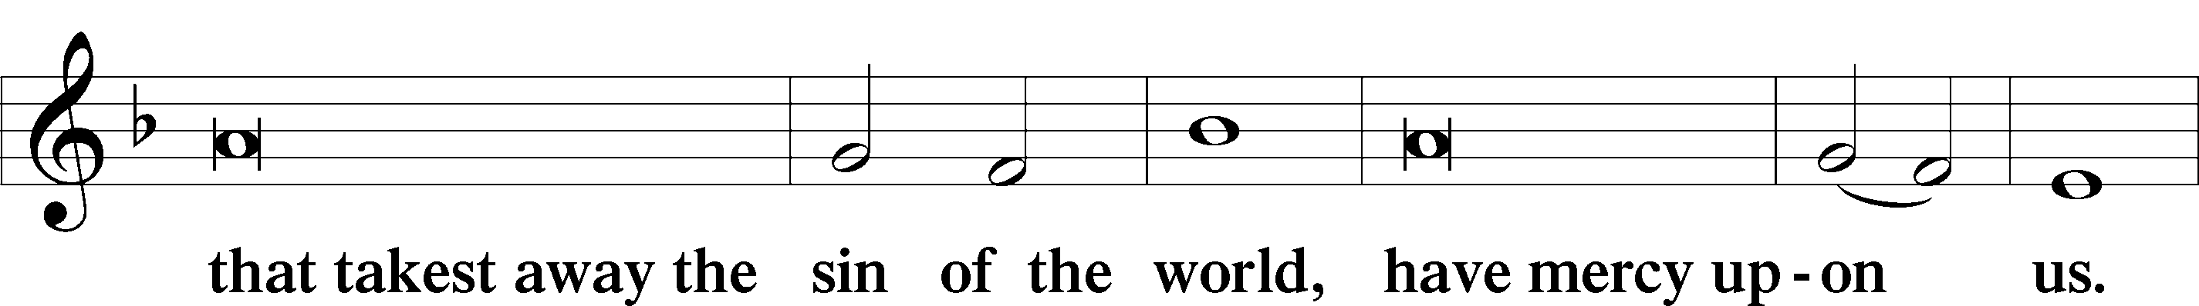
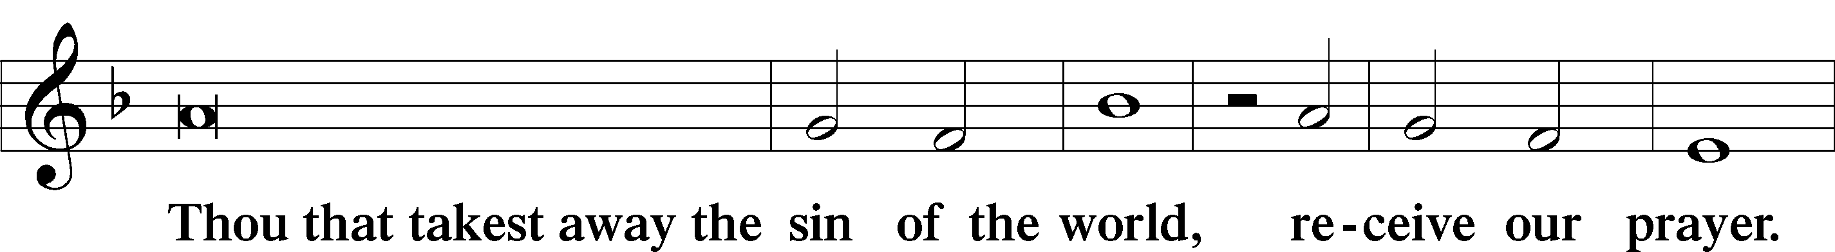
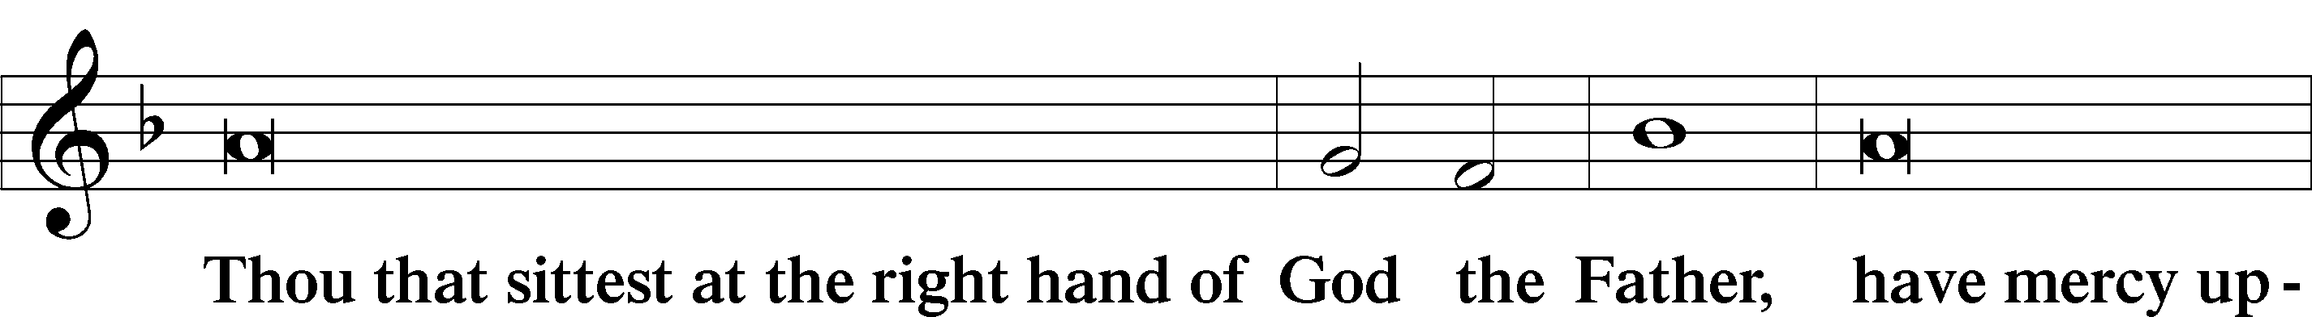
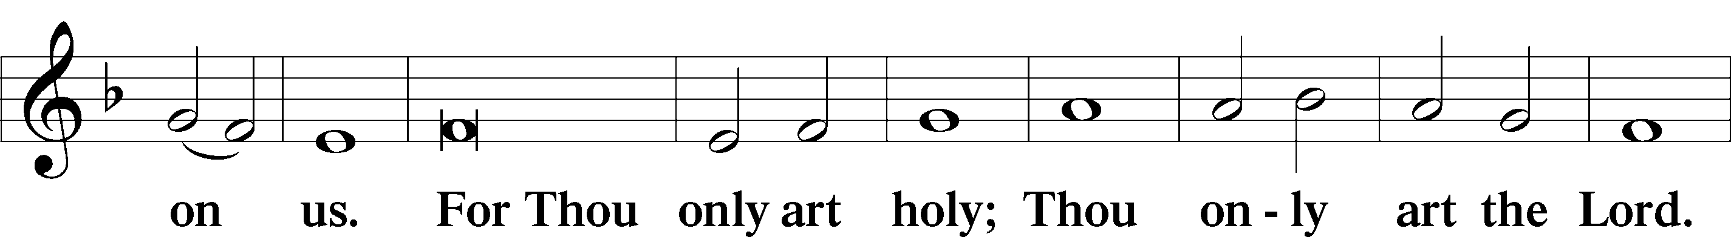
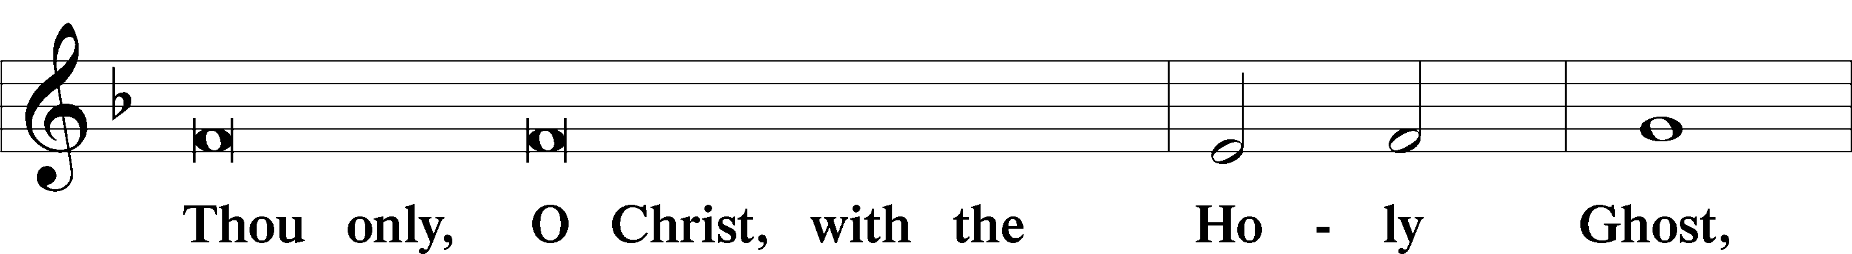
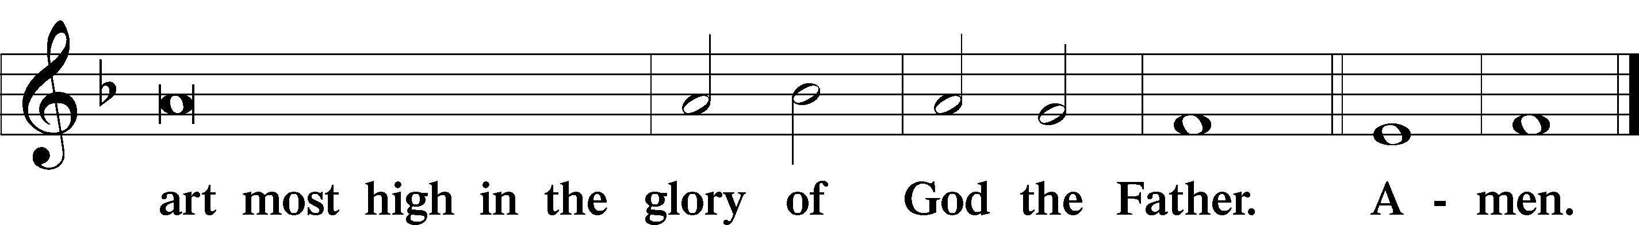

SALUTATION AND COLLECT OF THE DAY
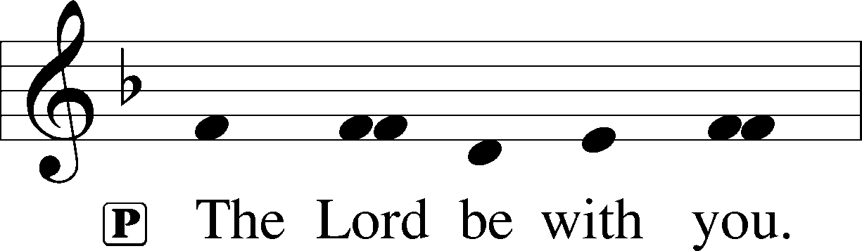
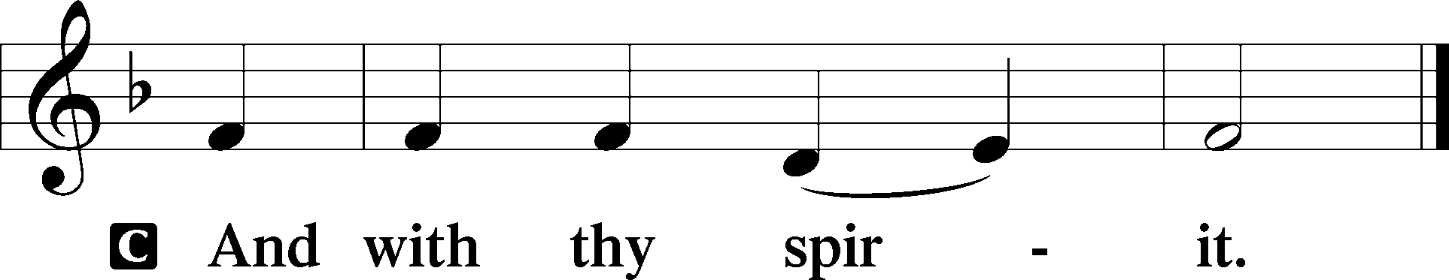
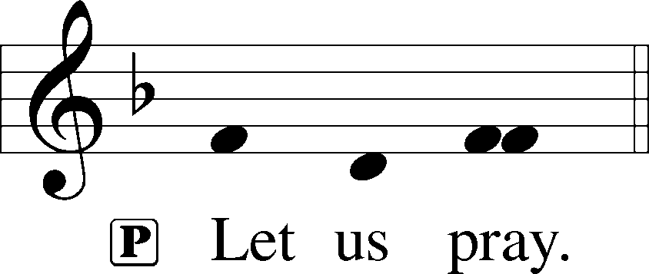

P Almighty God, grant that we who have celebrated the Lord’s resurrection may by Your grace confess in our life and conversation that Jesus is Lord and God; through the same Jesus Christ, Your Son, who lives and reigns with You and the Holy Spirit, one God, now and forever.
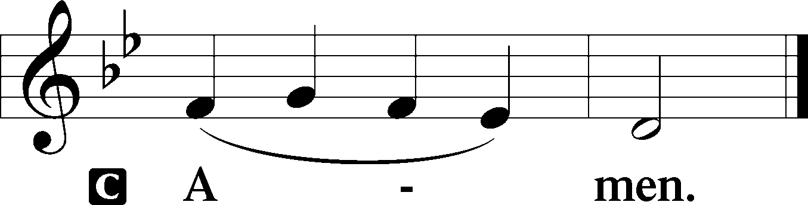

THIS WEEK’S THEME.. Christ Jesus Breathes His Spirit and His Life into Us by the Ministry of the Gospel
FIRST READING Acts 5:29–42

But Peter and the apostles answered, “We must obey God rather than men. The God of our fathers raised Jesus, whom you killed by hanging him on a tree. God exalted him at his right hand as Leader and Savior, to give repentance to Israel and forgiveness of sins. And we are witnesses to these things, and so is the Holy Spirit, whom God has given to those who obey him. ”When they heard this, they were enraged and wanted to kill them. But a Pharisee in the council named Gamaliel, a teacher of the law held in honor by all the people, stood up and gave orders to put the men outside for a little while. And he said to them, “Men of Israel, take care what you are about to do with these men. For before these days Theudas rose up, claiming to be somebody, and a number of men, about four hundred, joined him. He was killed, and all who followed him were dispersed and came to nothing. After him Judas the Galilean rose up in the days of the census and drew away some of the people after him. He too perished, and all who followed him were scattered. So in the present case I tell you, keep away from these men and let them alone, for if this plan or this undertaking is of man, it will fail; but if it is of God, you will not be able to overthrow them. You might even be found opposing God!” So they took his advice, and when they had called in the apostles, they beat them and charged them not to speak in the name of Jesus, and let them go. Then they left the presence of the council, rejoicing that they were counted worthy to suffer dishonor for the name. And every day, in the temple and from house to house, they did not cease teaching and preaching Jesus as the Christ.

L This is the Word of the Lord.
C Thanks be to God.

CHOIR ANTHEM “We Walk by Faith and Not by Sight” LSB 720

EPISTLE 1 Peter 1:3–9

Blessed be the God and Father of our Lord Jesus Christ! According to his great mercy, he has caused us to be born again to a living hope through the resurrection of Jesus Christ from the dead, to an inheritance that is imperishable, undefiled, and unfading, kept in heaven for you, who by God’s power are being guarded through faith for a salvation ready to be revealed in the last time. In this you rejoice, though now for a little while, if necessary, you have been grieved by various trials, so that the tested genuineness of your faith—more precious than gold that perishes though it is tested by fire—may be found to result in praise and glory and honor at the revelation of Jesus Christ. Though you have not seen him, you love him. Though you do not now see him, you believe in him and rejoice with joy that is inexpressible and filled with glory, obtaining the outcome of your faith, the salvation of your souls.

L This is the Word of the Lord.
C Thanks be to God.

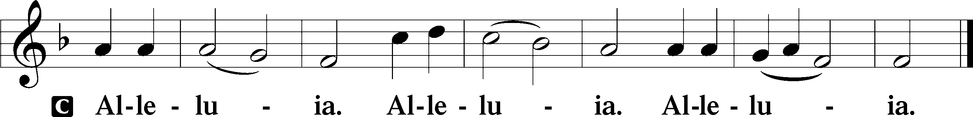
ALLELUIA AND VERSE LSB 190

HOLY GOSPEL John 20:19–31

P The Holy Gospel according to St. John, the twentieth chapter.
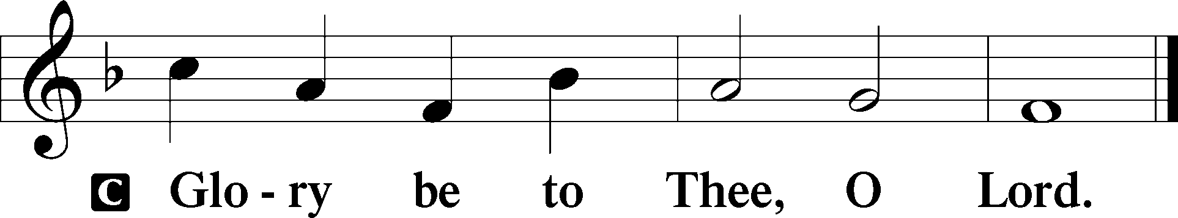

On the evening of that day, the first day of the week, the doors being locked where the disciples were for fear of the Jews, Jesus came and stood among them and said to them, “Peace be with you.” When he had said this, he showed them his hands and his side. Then the disciples were glad when they saw the Lord. Jesus said to them again, “Peace be with you. As the Father has sent me, even so I am sending you.” And when he had said this, he breathed on them and said to them, “Receive the Holy Spirit. If you forgive the sins of anyone, they are forgiven; if you withhold forgiveness from anyone, it is withheld. ”Now Thomas, one of the Twelve, called the Twin, was not with them when Jesus came. So the other disciples told him, “We have seen the Lord.” But he said to them, “Unless I see in his hands the mark of the nails, and place my finger into the mark of the nails, and place my hand into his side, I will never believe. ”Eight days later, his disciples were inside again, and Thomas was with them. Although the doors were locked, Jesus came and stood among them and said, “Peace be with you.” Then he said to Thomas, “Put your finger here, and see my hands; and put out your hand, and place it in my side. Do not disbelieve, but believe.” Thomas answered him, “My Lord and my God!” Jesus said to him, “Have you believed because you have seen me? Blessed are those who have not seen and yet have believed.” Now Jesus did many other signs in the presence of the disciples, which are not written in this book; but these are written so that you may believe that Jesus is the Christ, the Son of God, and that by believing you may have life in his name.

P This is the Gospel of the Lord.
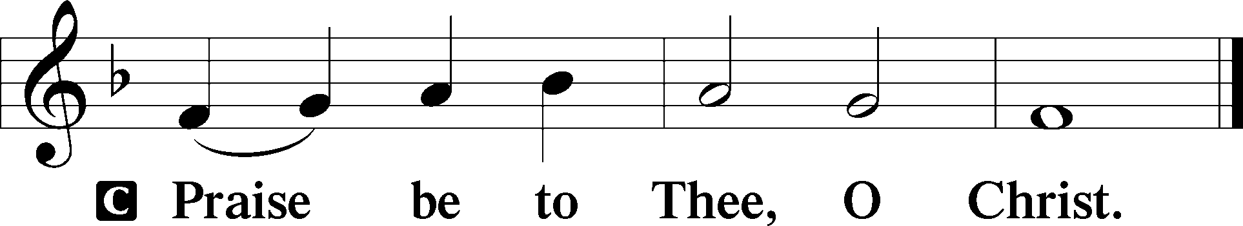

CHILDREN’S CHAPEL

HYMN OF THE DAY “O Sons and Daughters of the King”
LSB 470, vs. 5-8

SERMON John 20:19-31; “The Reality and Result of Easter”

APOSTLES’ CREED

C I believe in God, the Father Almighty, maker of heaven and earth.
And in Jesus Christ, His only Son, our Lord, who was conceived by the Holy Spirit, born of the virgin Mary, suffered under Pontius Pilate, was crucified, died and was buried. He descended into hell. The third day He rose again from the dead. He ascended into heaven and sits at the right hand of God the Father Almighty. From thence He will come to judge the living and the dead. I believe in the Holy Spirit, the holy Christian Church, the communion of saints, the forgiveness of sins, the resurrection of the body, and the life + everlasting. Amen.

PRAYER OF THE CHURCH

Each Petition ends with:

P Lord in Your mercy,
C Hear our Prayer.

THE OFFERING

While we gather the offering today you are invited to fill out the red “Record of Fellowship” forms located at the end of the pew. If you would, please pass the red pad down the pew so everyone can complete the record. Thanks!

+SERVICE OF THE SACRAMENT +

PREFACE LSB 194




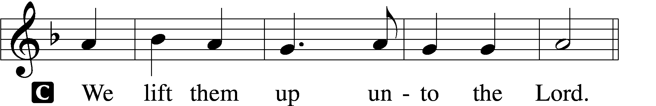

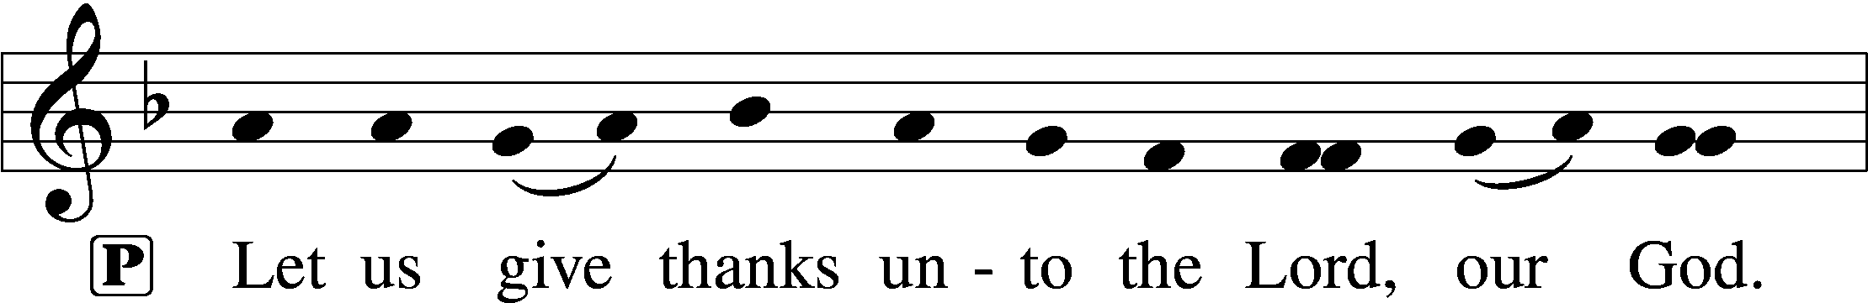
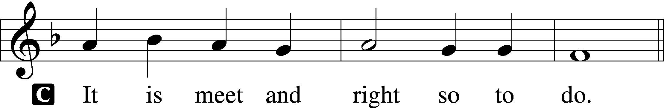

P It is truly good, right, and salutary . . . evermore praising You and saying:

SANCTUS LSB 195
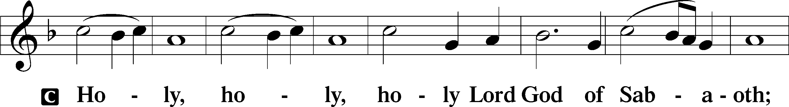
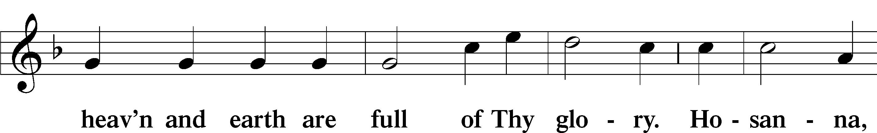
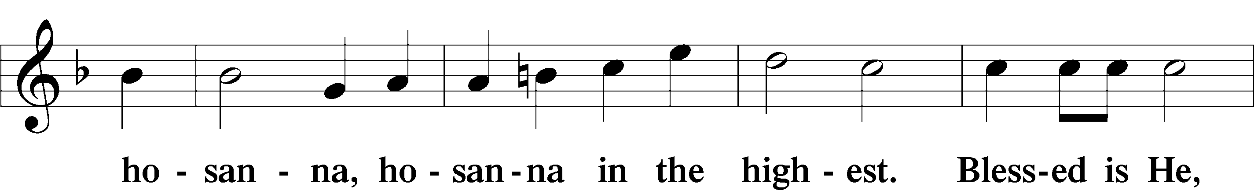
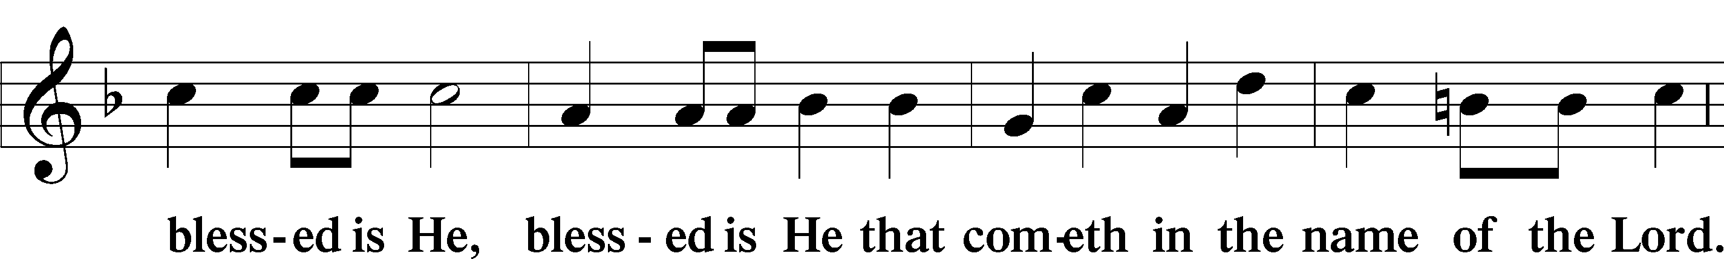
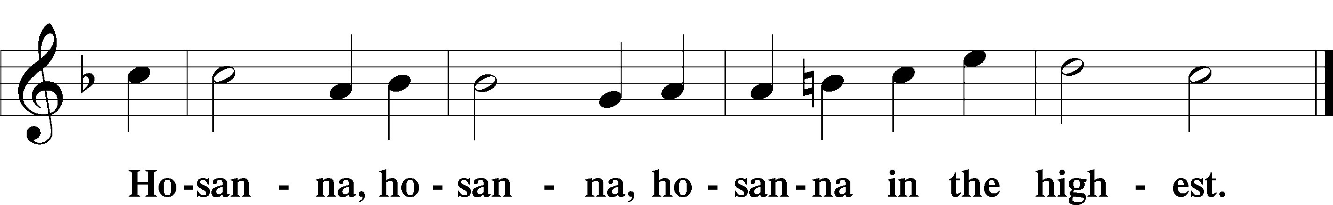

LORD'S PRAYER

P Lord, remember us in Your kingdom and teach us to pray:
C Our Father who art in heaven, hallowed be Thy name, Thy kingdom come, Thy will be done on earth as it is in heaven; give us this day our daily bread; and forgive us our trespasses as we forgive those who trespass against us; and lead us not into temptation, but deliver us from evil. For Thine is the kingdom and the power and the glory forever and ever. Amen.

THE WORDS OF OUR LORD

PAX DOMINI
P The peace of the Lord be with you always.
C And also with you.

AGNUS DEI LSB 198
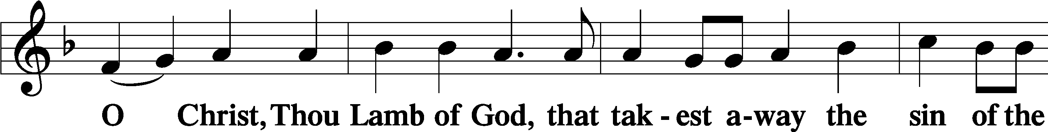
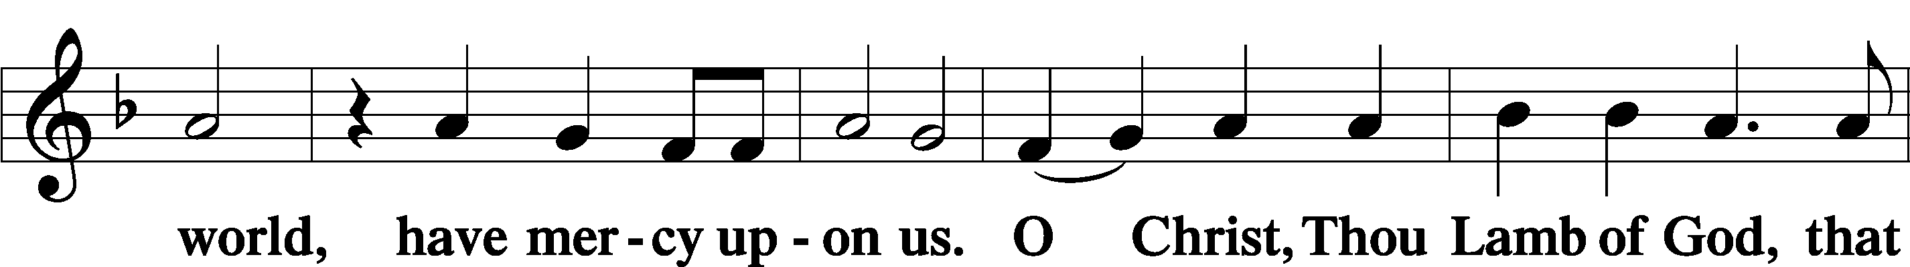
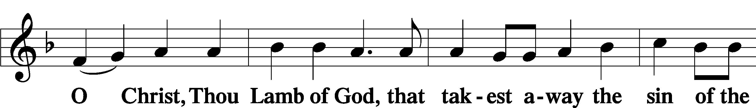
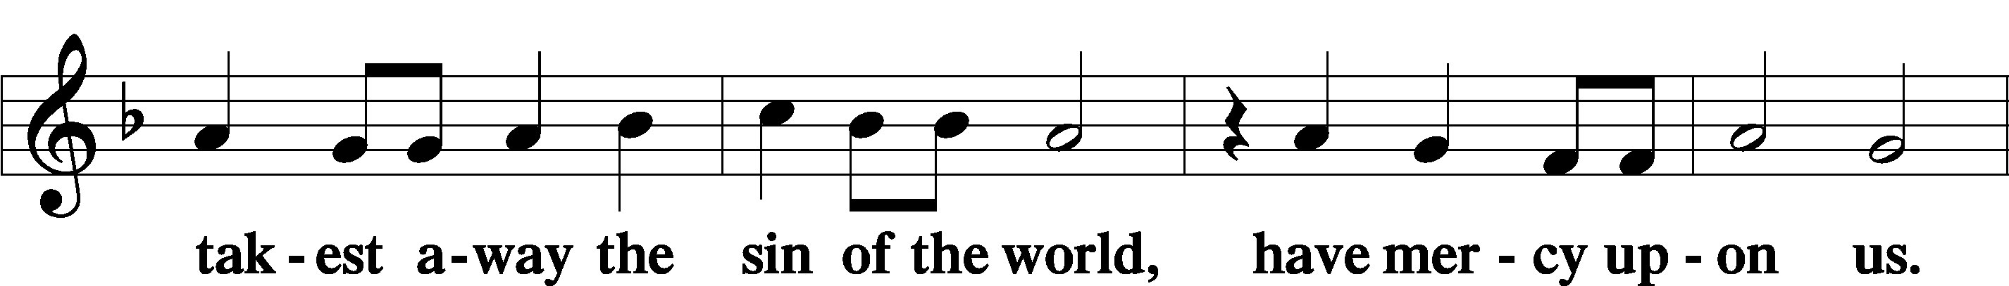



THE DISTRIBUTION

As Lutherans, in joyful obedience to the clear teaching of Lord Jesus, we now invite to His table those who trust His Word, repent of their sins, and set aside refusal to forgive and love just as we have been loved and forgiven by God. You will receive the host and then will have a choice of either the individual cups or the common cup. If you would like the common cup, place your hands FLAT on the rail while the individual cups are offered. This way Pastor will know that you desire the common cup. If for medical or other reasons you would prefer a non-alcoholic individual cup, they are located in the center of each tray. If you would like to receive communion in the pew, please inform an Usher and what your preference would be – either common or individual cup. Thank you.

HYMNS DURING THE DISTRIBUTION

“Come, You Faithful, Raise the Strain” LSB 487
“This Joyful Eastertide” LSB 482
“Jesus Lives! The Victory’s Won” LSB 490
“Awake, My Heart, with Gladness” LSB 467
“O Savior, Precious Savior” LSB 527

NUNC DIMITTIS LSB 199
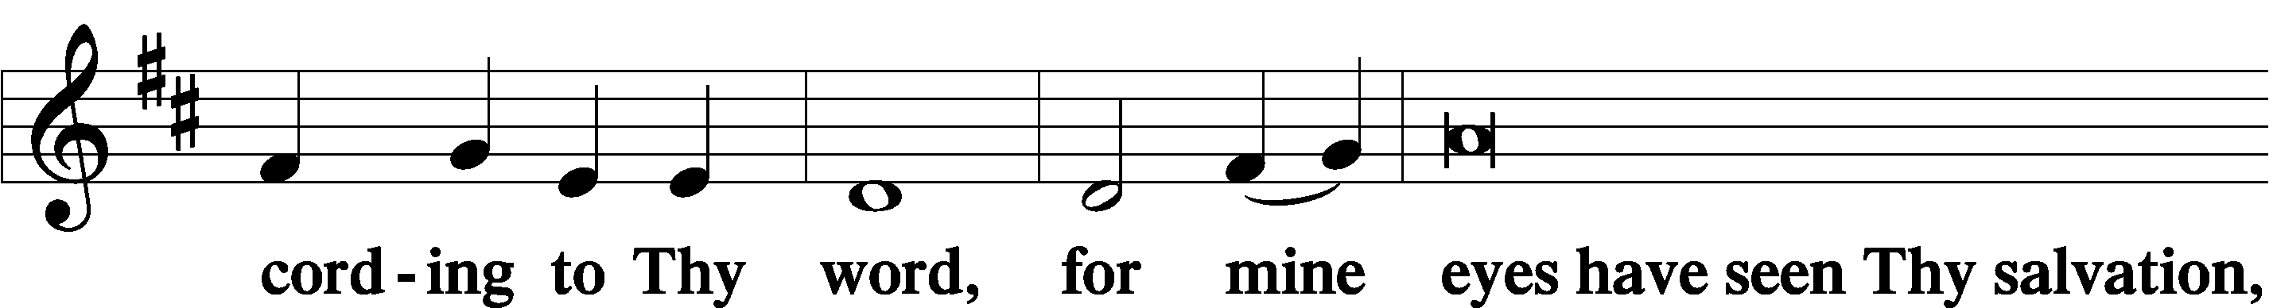
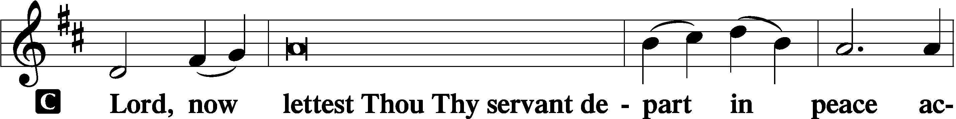

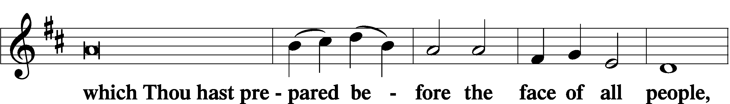
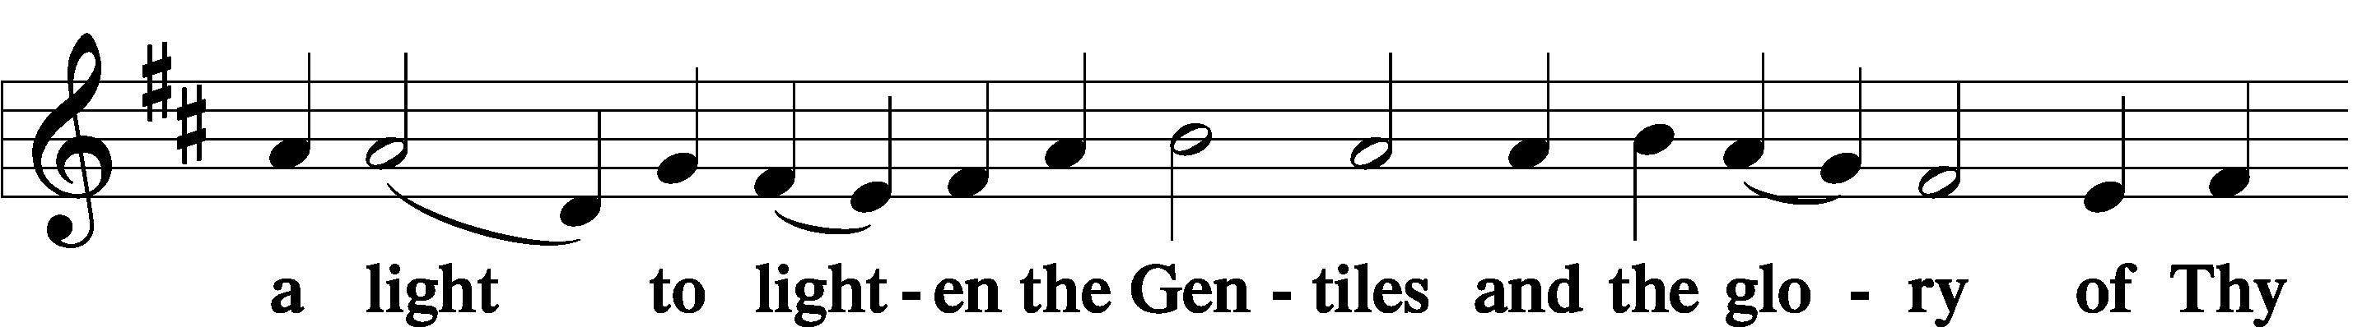
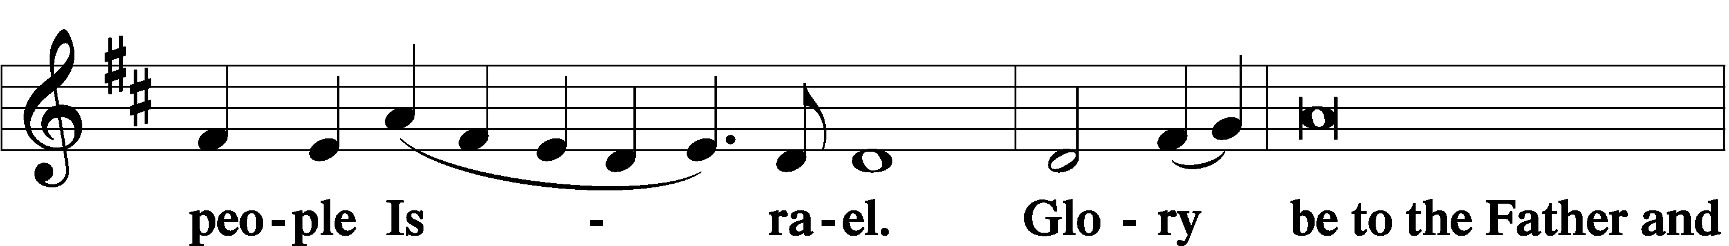
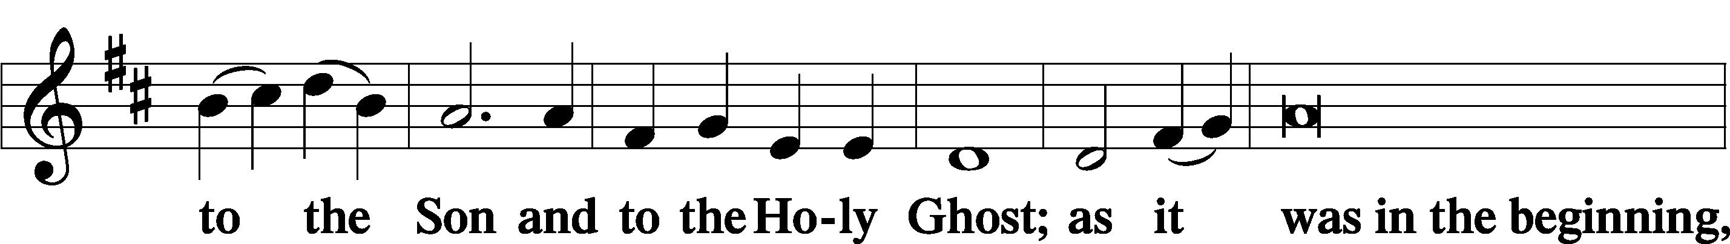
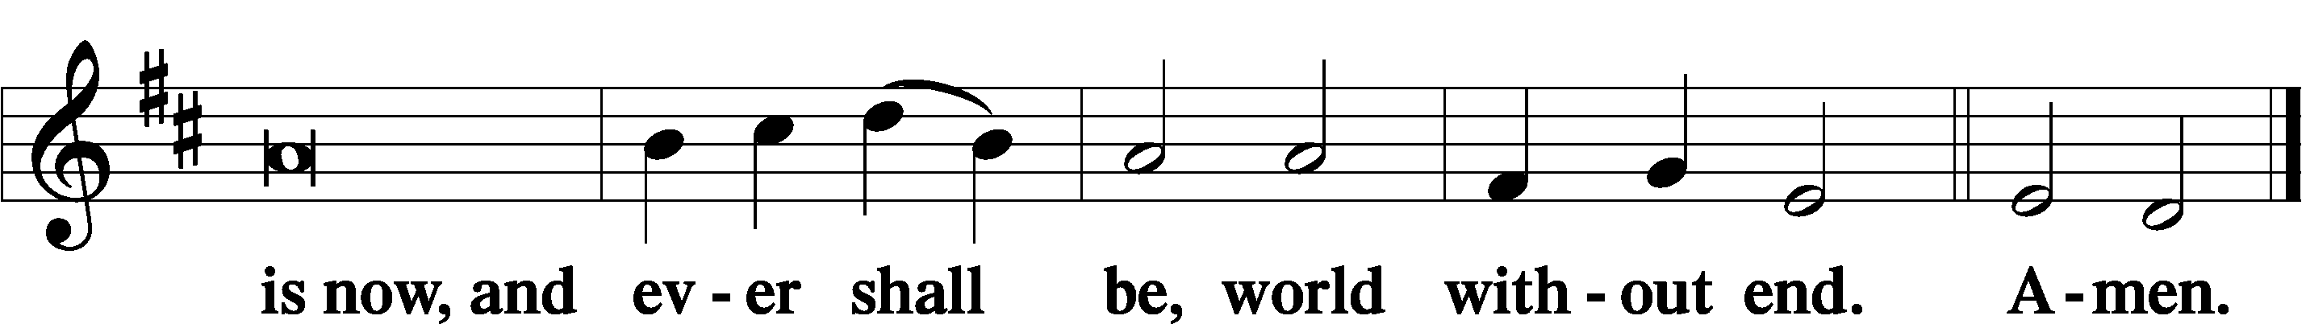

POST-COMMUNION COLLECT

P Let us pray. We give thanks to You, almighty God, that You have refreshed us through this salutary gift, and we implore You that of Your mercy You would strengthen us through the same in faith toward You and in fervent love toward one another; through Jesus Christ, Your Son, our Lord, who lives and reigns with You and the Holy Spirit, one God, now and forever.
C Amen.

BENEDICTION

P Let us bless the Lord.
C Thanks be to God.

P The Lord bless you and keep you. The Lord make His face shine on you and be gracious to you. The Lord look upon you with favor and + give you peace.
C Amen.

P Go in Peace. Serve the Lord.
C Thanks be to God!

CLOSING HYMN “The Strife Is O’er, the Battle Won” LSB 464, vs. 1, 3-5

POSTLUDE

Acknowledgments Divine Service, Setting two from Lutheran Service Book. Unless otherwise indicated, all scripture quotations are from Holy Bible, English Standard Version, copyright © 2001 by Crossway Bibles, a division of Good News Publishers. Used by permission. All rights reserved. Created by Lutheran Service Builder © 2023 Concordia Publishing House


COME SEE WHAT GOD IS DOING INOUR MIDST;
COME GROW WITH US

“FFF” OUTDOOR WORSHIP AND FELLOWSHIP
Friday, April 25 Starting at 5 PM
Join us for a relaxing outdoor worship and fellowship gathering as we spend time together celebrating faith and community.
What to bring:
- Food to grill
- A lawn chair (if you’d like)
- A heart ready for fellowship and growth in faith

Come enjoy good food, meaningful conversation, and time together outdoors as we grow in faith and friendship. All are welcome—bring a friend!

APRIL

16- Fellowship Dinner 5:30 PM TBD
20 Church Council Mtg 6 PM
24-FFF (faith, food, fellowship) 5 PM Outdoor worship, fellowship event
25-26 A.F.F.B All Faiths Food Bank

3rd Thursday Fellowship

Third Thursday Fellowship Dinner will be on Thursday, April 16 at PF CHANG’s 766 S Osprey Ave, Sarasota, FL 34236 at 5:30pm. Wonderful food, GF and they are going to donate 10% of our tab to GSLCS. Sign up will be available after the late Easter Sunday service. Hope you will join us.

APRIL BIRTHDAYS

Phyllis Hoffman 04/01
John Bailey 04/03
Phyllis Buechner 04/04
Cary Preston 04/04
Eric Brown 04/06
Barney Brininstool 04/13
Ernest Dinkel 04/16
Rachel Dermody 04/22
Jeanne Doege 04/22
Brigitte Porwol 04/27
Joan Hartmann 04/28
Ann Gongol 04/30


Steve & Cheryl Anderson
04/23 4 years

WEEK OF APRIL 5, 2026
TITHES & OFFERING: $9009

ATTENDANCE
Maundy Thursday 4/3: 54 Good Friday 4/4: 78
Easter Sunday 4/5 7:15 AM: 49/9:15 AM: 143

GSLCS offers gift cards to those who need them and come to us for help. We offer cards for three businesses: Publix, Walgreen’s, and Wa-Wa (food, medicine, gas). We especially need more gift cards for Publix. The most common amounts the people give are in the $20-$25-dollar range and that is fine. If you are able, please pick up some gift cards and provide them to the church office and we’ll handle it from there. Thanks for your ongoing support of the mission and ministry of GSLCS.

MORE WAYS TO GIVE

1st is Joyful Response- sign up from your checking or savings account to the church on a recurring basis. There is no cost for either the member or church to participate in this program.
2nd is Zelle- sign into your bank via your cell phones and initiate an on-time transfer from your account to the church checking account. There is no cost for the members, however, the church must pay a 1% fee to the bank.

NEXT WEEK’S READINGS
Acts 2:14a, 36–41, Psalm 116:1–14, 1Peter 1:17–25,
Luke 24:13–35

BIBLE STUDY
Wednesdays at 10 AM & Sundays after service

Psalm 148

¹Praise the Lord!
Praise the Lord from the heavens;
praise him in the heights!
²Praise him, all his angels;
praise him, all his hosts!
³Praise him, sun and moon,
praise him, all you shining stars!
⁴Praise him, you highest heavens,
and you waters above the heavens!
⁵Let them praise the name of the Lord!
For he commanded and they were created.
⁶And he established them forever and ever;
he gave a decree, and it shall not pass away.
⁷Praise the Lord from the earth,
you great sea creatures and all deeps,
⁸fire and hail, snow and mist,
stormy wind fulfilling his word!
⁹Mountains and all hills,
fruit trees and all cedars!
¹⁰Beasts and all livestock,
creeping things and flying birds!
¹¹Kings of the earth and all peoples,
princes and all rulers of the earth!
¹²Young men and maidens together,
old men and children!
¹³Let them praise the name of the Lord,
for his name alone is exalted;
his majesty is above earth and heaven.
¹⁴He has raised up a horn for his people,
praise for all his saints,
for the people of Israel who are near to him.
Praise the Lord

