

Good Shepherd Lutheran Church & School
is a welcoming, Christ-centered family,
dedicated to sharing our love and faith.

GOOD SHEPHERD LUTHERAN CHURCH
(The Lutheran Church-Missouri Synod)
PASTOR STEVE ANDERSON
5659 Honore Ave., Sarasota, Florida 34233
941-921-3673



parishcoord@goodshepherdsarasota.org
pastor@goodshepherdsarasota.org
www.goodshepherdsarasota.org
GOOD SHEPHERD LUTHERAN SCHOOL
941-922-8164
Email: GSLS@comcast.net

April 19, 2026




April 19, 2026, 9:15 AM

LORD’S SUPPER - As Lutherans, in joyful obedience to the clear teaching of our Lord Jesus, we invite to His table at Good Shepherd those who trust His Word, repent of their sins, and set aside refusal to forgive and love just as we have been loved and forgiven by God. If you are unsure about whether you should commune or not, speak to an usher prior to the service. Thank you and welcome!

PRESERVICE MUSIC

WELCOME AND ANNOUNCEMENTS

OPENING HYMN “Joyful, Joyful We Adore Thee” LSB 803

THE SERVICE OF CONFESSION AND ABSOLUTION

P In the name of the Father and of the + Son and of the Holy Spirit.
C Amen.

P Beloved in the Lord! Let us draw near with a true heart and confess our sins unto God our Father, beseeching Him in the name of our Lord Jesus Christ to grant us forgiveness.

P Our help is in the name of the Lord,
C who made heaven and earth.

P I said, I will confess my transgressions unto the Lord,
C and You forgave the iniquity of my sin.

(Silence for reflection on God's Word and for self-examination.)

P O almighty God, merciful Father,
C I, a poor, miserable sinner, confess unto You all my sins and iniquities with which I have ever offended You and justly deserved Your temporal and eternal punishment. But I am heartily sorry for them and sincerely repent of them, and I pray You of Your boundless mercy and for the sake of the holy, innocent, bitter sufferings and death of Your beloved Son, Jesus Christ, to be gracious and merciful to me, a poor, sinful being.

P Upon this your confession, I, by virtue of my office, as a called and ordained servant of the Word, announce the grace of God unto all of you, and in the stead and by the command of my Lord Jesus Christ I forgive you all your sins in the name of the Father and of the Son and of the Holy Spirit.
C Amen

KYRIE LSB 186
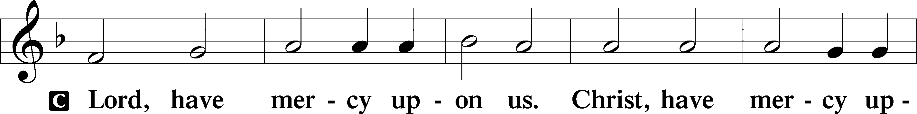
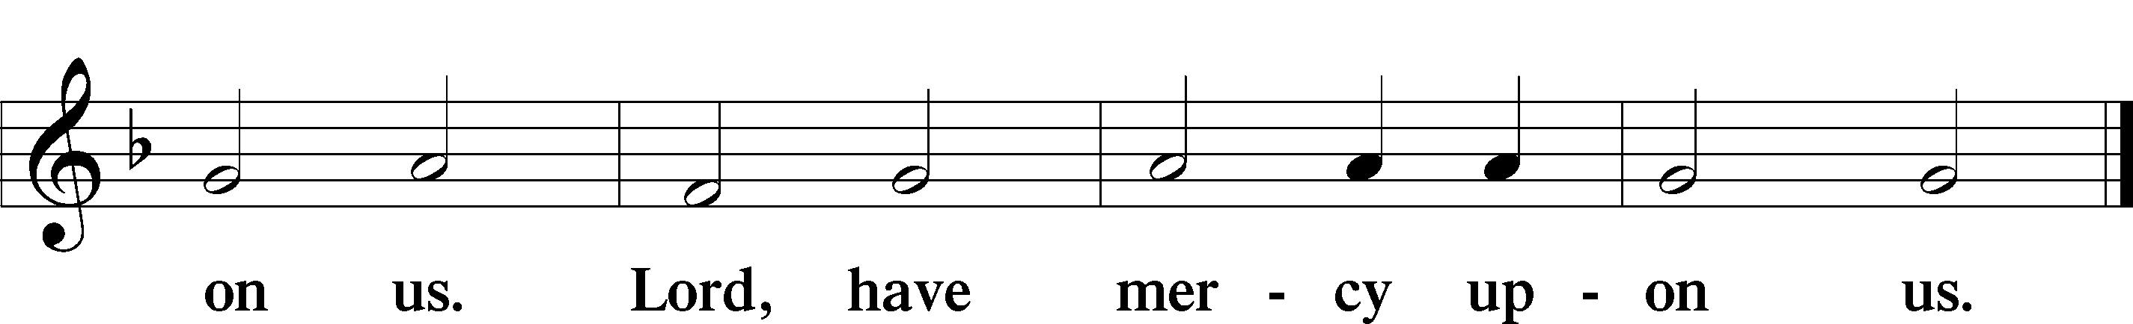

GLORIA IN EXCELSIS LSB 187
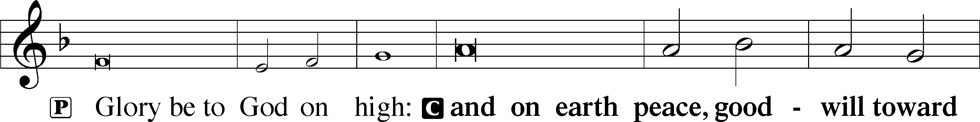
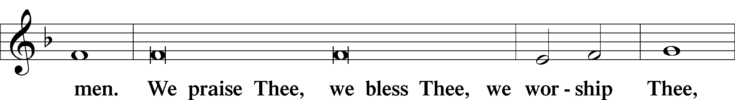
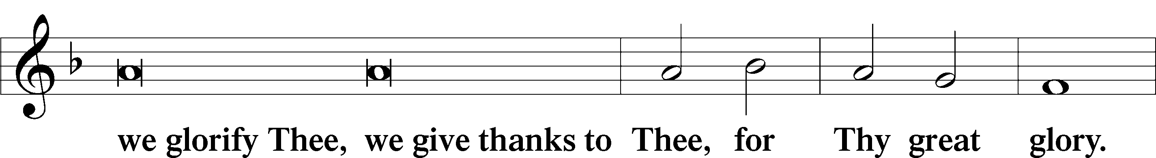
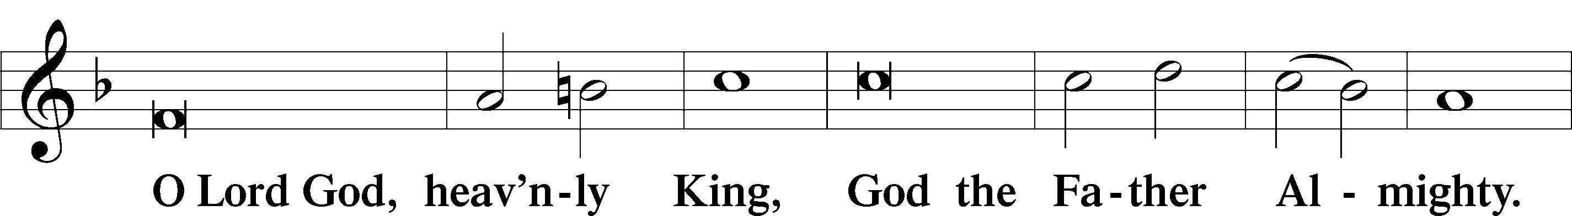
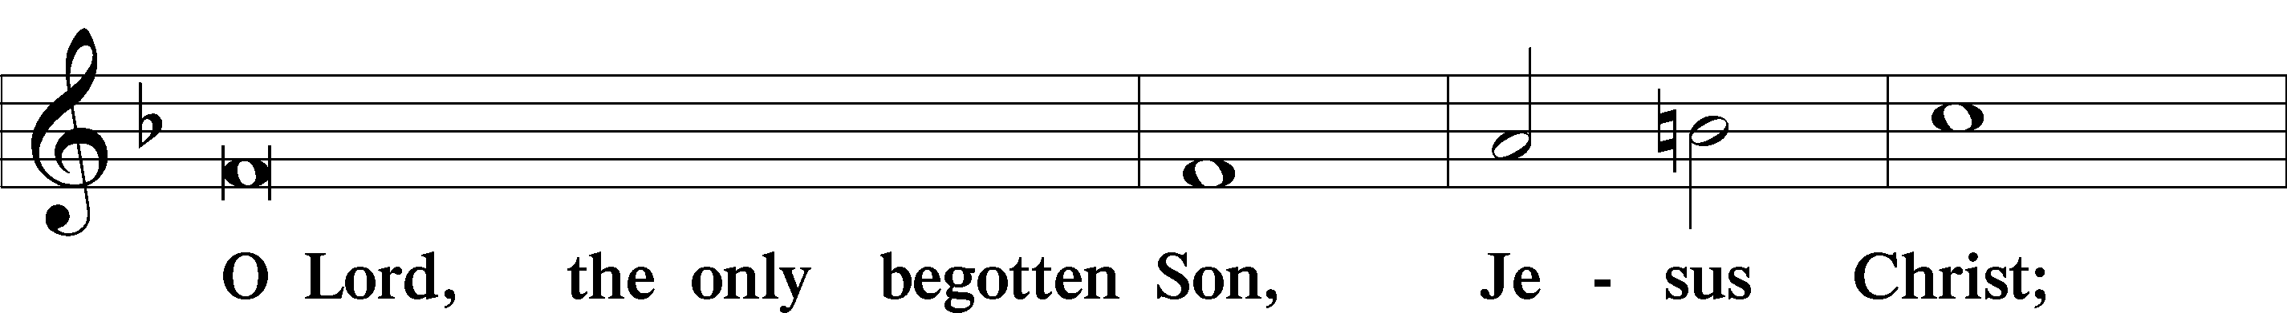
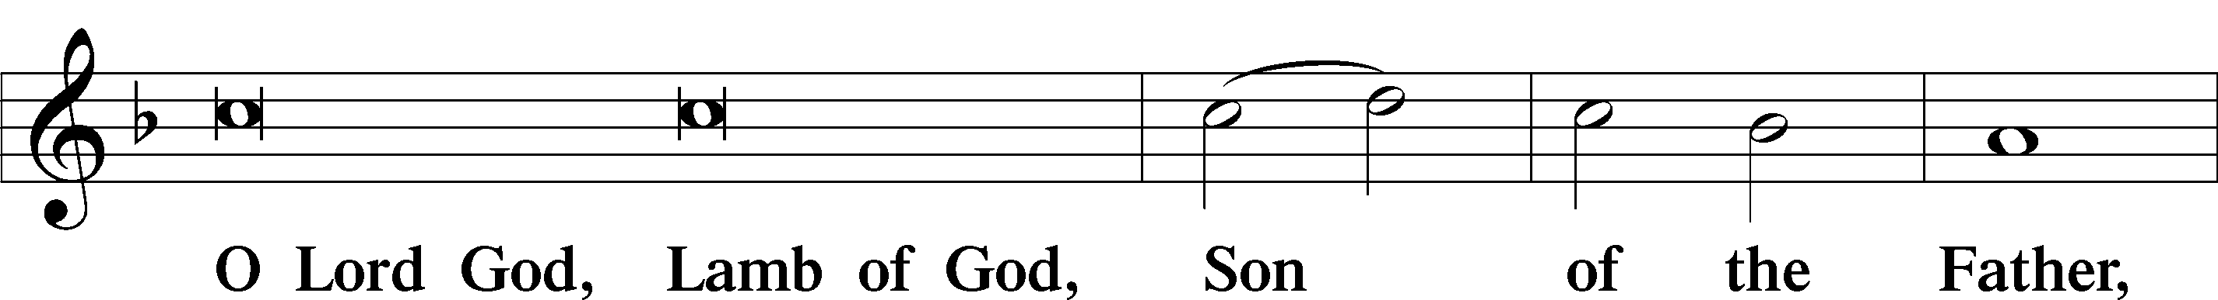
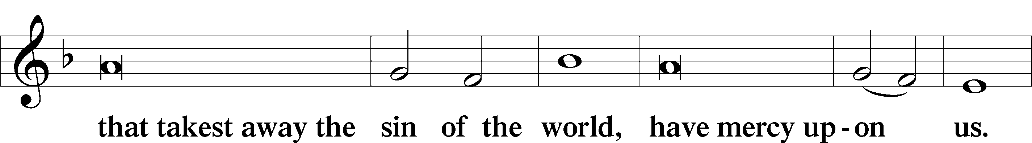
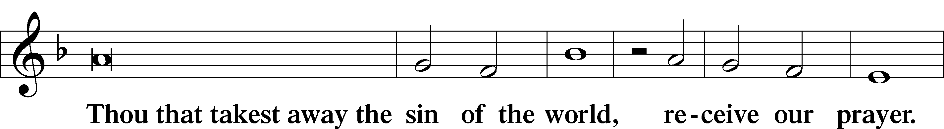
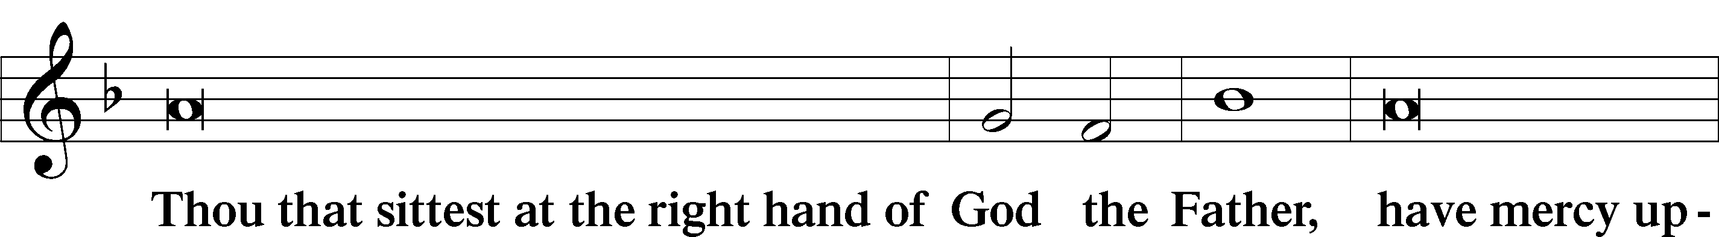
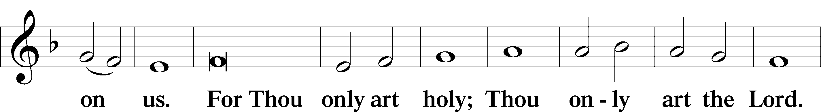
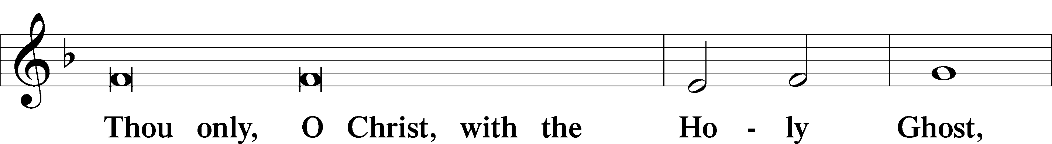
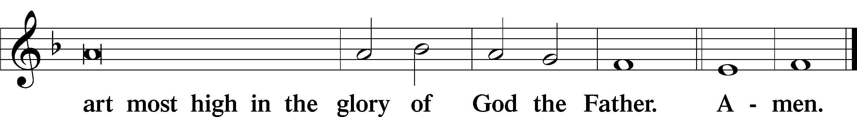

SALUTATION AND COLLECT OF THE DAY
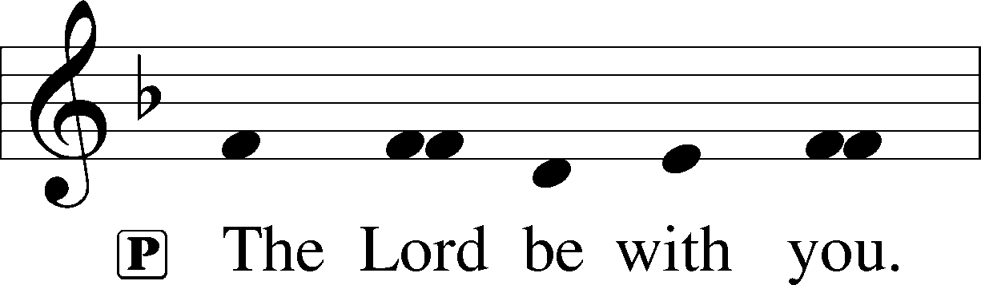
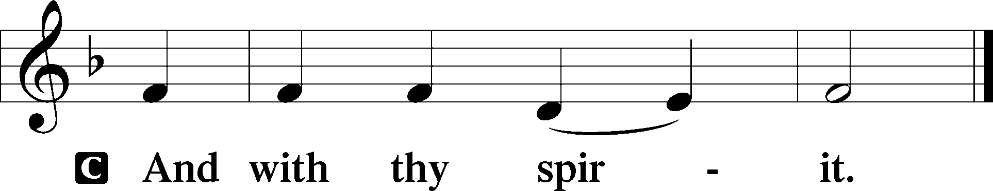
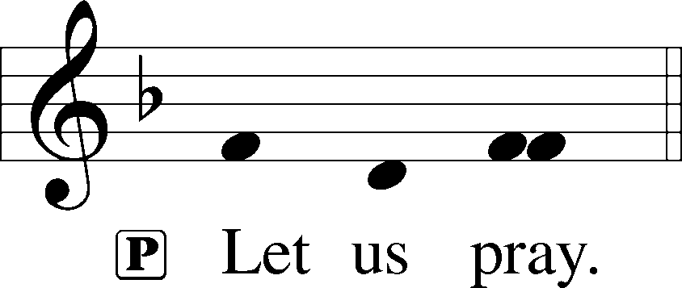

P O God, through the humiliation of Your Son You raised up the fallen world. Grant to Your faithful people, rescued from the peril of everlasting death, perpetual gladness and eternal joys; through Jesus Christ, our Lord, who lives and reigns with You and the Holy Spirit, one God, now and forever.
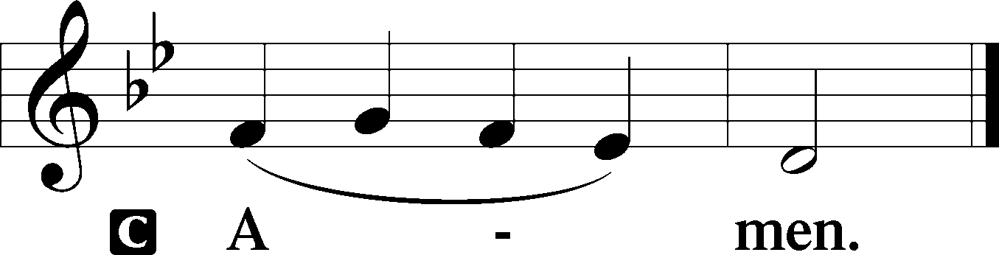

THIS WEEK’S THEME.. The Risen Lord Jesus Is with Us in Holy Baptism and in the Breaking of the Bread
FIRST READING Acts 2:14, 36-41

Peter, standing with the eleven, lifted up his voice and addressed them, . . .Let all the house of Israel therefore know for certain that God has made him both Lord and Christ, this Jesus whom you crucified. ”Now when they heard this they were cut to the heart, and said to Peter and the rest of the apostles, “Brothers, what shall we do?” And Peter said to them, “Repent and be baptized every one of you in the name of Jesus Christ for the forgiveness of your sins, and you will receive the gift of the Holy Spirit. For the promise is for you and for your children and for all who are far off, everyone whom the Lord our God calls to himself.” And with many other words he bore witness and continued to exhort them, saying, “Save yourselves from this crooked generation.” So those who received his word were baptized, and there were added that day about three thousand souls.

L This is the Word of the Lord.
C Thanks be to God.

CHOIR ANTHEM “Stay with Us” LSB 879

EPISTLE 1 Peter 1:17-25

If you call on him as Father who judges impartially according to each one’s deeds, conduct yourselves with fear throughout the time of your exile, knowing that you were ransomed from the futile ways inherited from your forefathers, not with perishable things such as silver or gold, but with the precious blood of Christ, like that of a lamb without blemish or spot. He was foreknown before the foundation of the world but was made manifest in the last times for your sake, who through him are believers in God, who raised him from the dead and gave him glory, so that your faith and hope are in God. Having purified your souls by your obedience to the truth for a sincere brotherly love, love one another earnestly from a pure heart, since you have been born again, not of perishable seed but of imperishable, through the living and abiding word of God; for “All flesh is like grass and all its glory like the flower of grass. The grass withers, and the flower falls, but the word of the Lord remains forever.” And this word is the good news that was preached to you.

L This is the Word of the Lord.
C Thanks be to God.

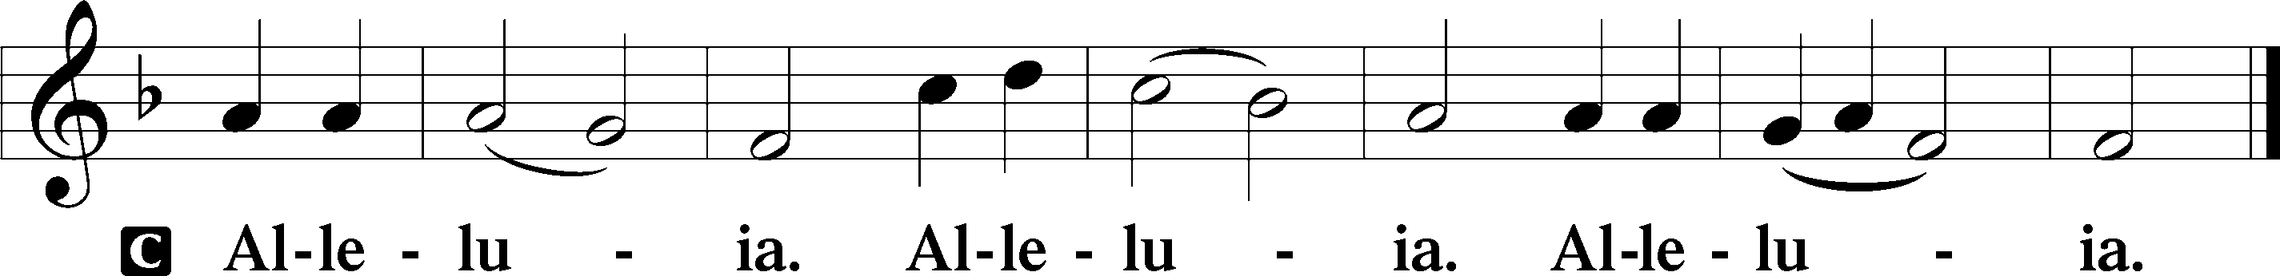
ALLELUIA AND VERSE LSB 190

HOLY GOSPEL John 24:13–35

P The Holy Gospel according to St. John, the twenty fourth chapter.
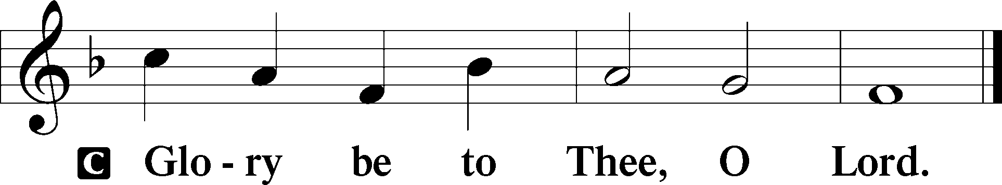

That very day two of them were going to a village named Emmaus, about seven miles from Jerusalem, and they were talking with each other about all these things that had happened. While they were talking and discussing together, Jesus himself drew near and went with them. But their eyes were kept from recognizing him. And he said to them, “What is this conversation that you are holding with each other as you walk?” And they stood still, looking sad. Then one of them, named Cleopas, answered him, “Are you the only visitor to Jerusalem who does not know the things that have happened there in these days?” And he said to them, “What things?” And they said to him, “Concerning Jesus of Nazareth, a man who was a prophet mighty in deed and word before God and all the people, and how our chief priests and rulers delivered him up to be condemned to death, and crucified him. But we had hoped that he was the one to redeem Israel. Yes, and besides all this, it is now the third day since these things happened. Moreover, some women of our company amazed us. They were at the tomb early in the morning, and when they did not find his body, they came back saying that they had even seen a vision of angels, who said that he was alive. Some of those who were with us went to the tomb and found it just as the women had said, but him they did not see.” And he said to them, “O foolish ones, and slow of heart to believe all that the prophets have spoken! Was it not necessary that the Christ should suffer these things and enter into his glory?” And beginning with Moses and all the Prophets, he interpreted to them in all the Scriptures the things concerning himself. So they drew near to the village to which they were going. He acted as if he were going farther, but they urged him strongly, saying, “Stay with us, for it is toward evening and the day is now far spent.” So he went in to stay with them. When he was at table with them, he took the bread and blessed and broke it and gave it to them. And their eyes were opened, and they recognized him. And he vanished from their sight. They said to each other, “Did not our hearts burn within us while he talked to us on the road, while he opened to us the Scriptures?” And they rose that same hour and returned to Jerusalem. And they found the eleven and those who were with them gathered together, saying, “The Lord has risen indeed, and has appeared to Simon!” Then they told what had happened on the road, and how he was known to them in the breaking of the bread.

P This is the Gospel of the Lord.
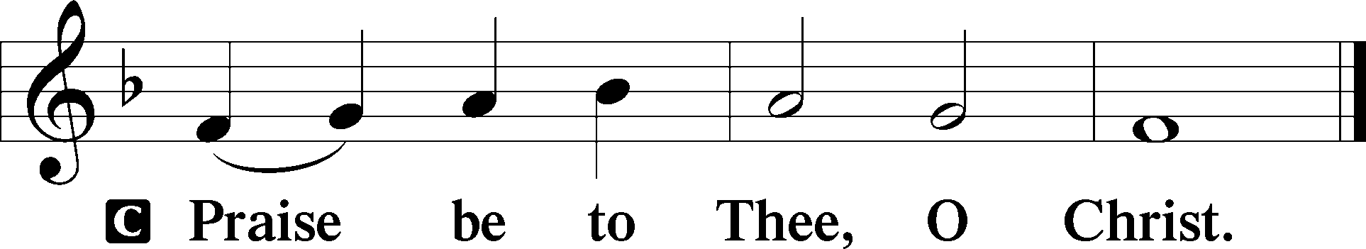

CHILDREN’S CHAPEL

HYMN OF THE DAY “Alleluia! Jesus Is Risen” LSB 474 vs 1-4

SERMON Luke 24:13-35; “A Funny Thing Happened on the Way to Emmaus”

APOSTLES’ CREED

C I believe in God, the Father Almighty, maker of heaven and earth.
And in Jesus Christ, His only Son, our Lord, who was conceived by the Holy Spirit, born of the virgin Mary, suffered under Pontius Pilate, was crucified, died and was buried. He descended into hell. The third day He rose again from the dead. He ascended into heaven and sits at the right hand of God the Father Almighty. From thence He will come to judge the living and the dead. I believe in the Holy Spirit, the holy Christian Church, the communion of saints, the forgiveness of sins, the resurrection of the body, and the life + everlasting. Amen.

PRAYER OF THE CHURCH

Each Petition ends with:

P Lord in Your mercy,
C Hear our Prayer.

THE OFFERING

While we gather the offering today you are invited to fill out the red “Record of Fellowship” forms located at the end of the pew. If you would, please pass the red pad down the pew so everyone can complete the record. Thanks!

+SERVICE OF THE SACRAMENT +

PREFACE LSB 194




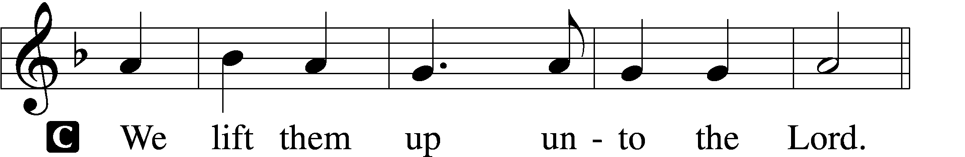

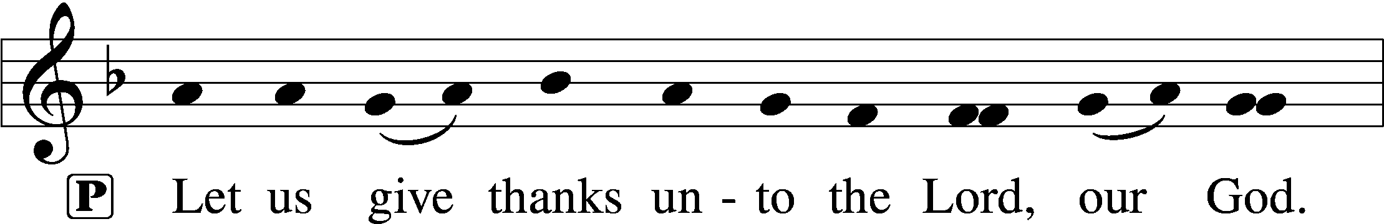
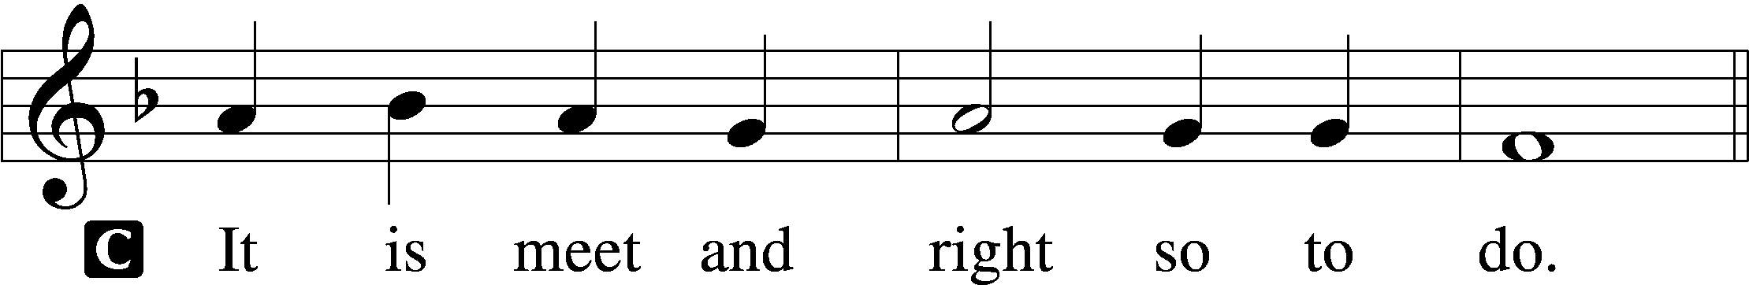

P It is truly good, right, and salutary . . . evermore praising You and saying:

SANCTUS LSB 195
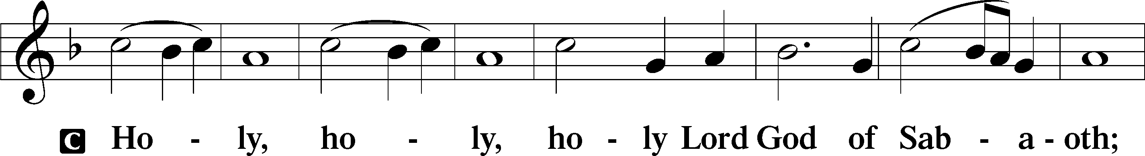
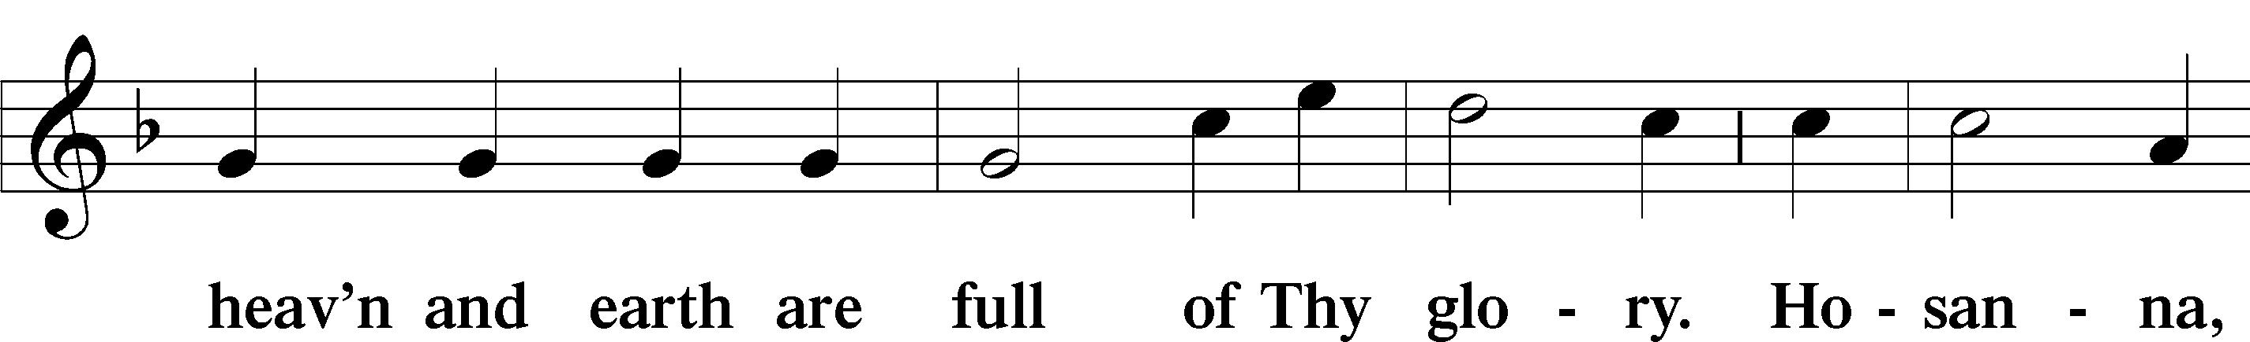
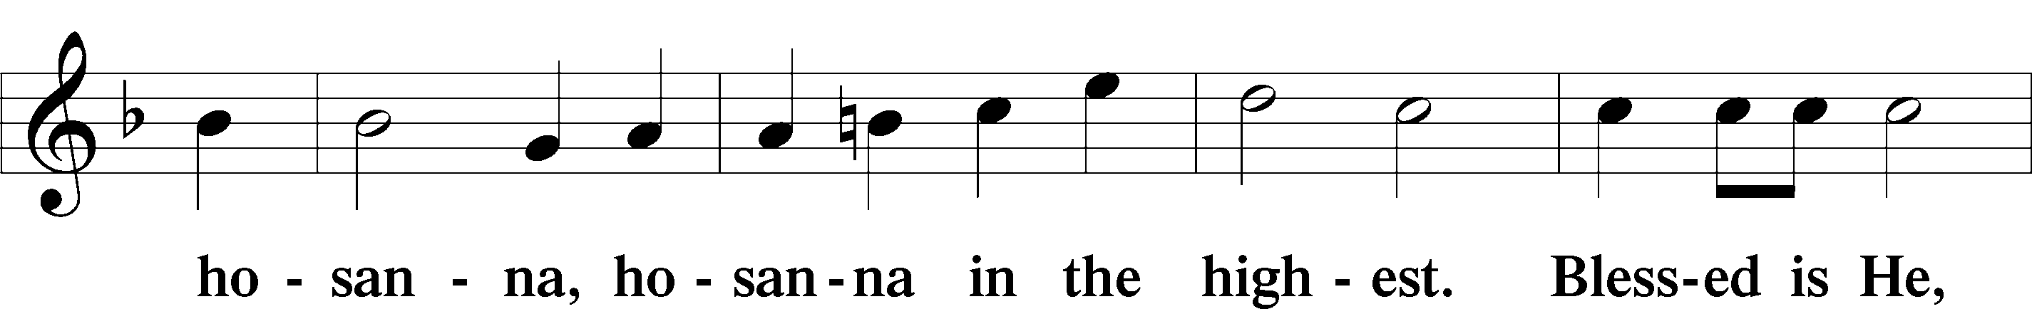
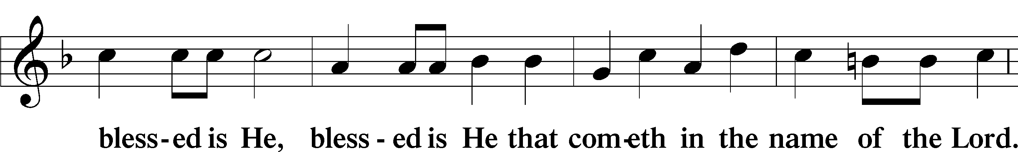
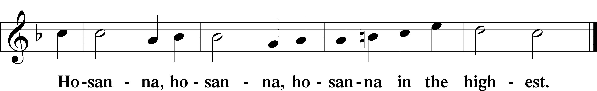

LORD'S PRAYER

P Lord, remember us in Your kingdom and teach us to pray:
C Our Father who art in heaven, hallowed be Thy name, Thy kingdom come, Thy will be done on earth as it is in heaven; give us this day our daily bread; and forgive us our trespasses as we forgive those who trespass against us; and lead us not into temptation, but deliver us from evil. For Thine is the kingdom and the power and the glory forever and ever. Amen.

THE WORDS OF OUR LORD

PAX DOMINI
P The peace of the Lord be with you always.
C And also with you.

AGNUS DEI LSB 198
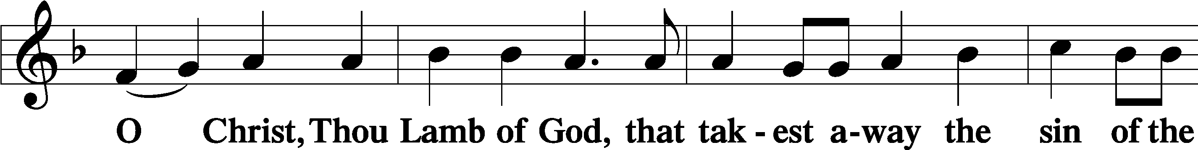
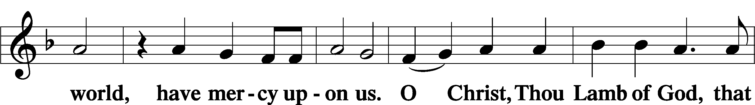
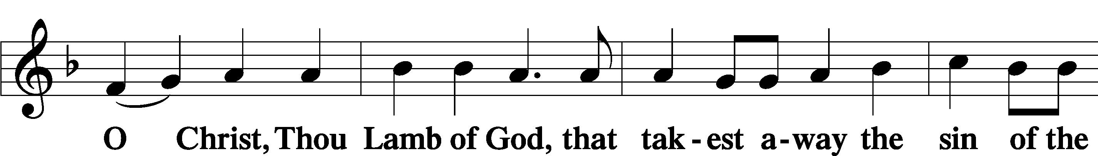
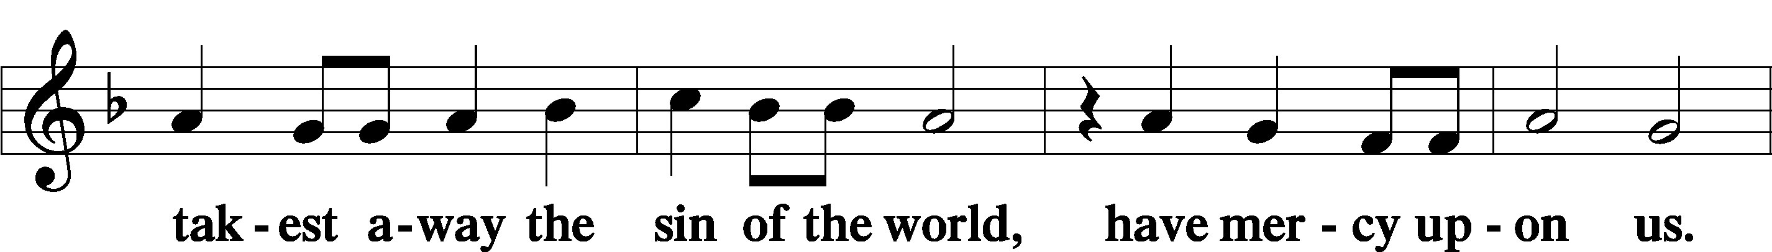



THE DISTRIBUTION

As Lutherans, in joyful obedience to the clear teaching of Lord Jesus, we now invite to His table those who trust His Word, repent of their sins, and set aside refusal to forgive and love just as we have been loved and forgiven by God. You will receive the host and then will have a choice of either the individual cups or the common cup. If you would like the common cup, place your hands FLAT on the rail while the individual cups are offered. This way Pastor will know that you desire the common cup. If for medical or other reasons you would prefer a non-alcoholic individual cup, they are located in the center of each tray. If you would like to receive communion in the pew, please inform an Usher and what your preference would be – either common or individual cup. Thank you.

HYMNS DURING THE DISTRIBUTION

“Guide Me, O Thou Great Redeemer” LSB 918
“The Church’s One Foundation” LSB 644
“Lord, Keep Us Steadfast in Your Word” LSB 655
“Thy Strong Word” LSB 578
“I Know That My Redeemer Lives” LSB 461

NUNC DIMITTIS LSB 199
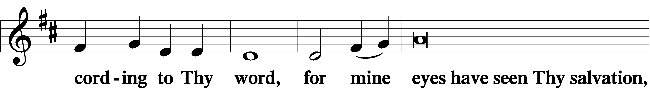
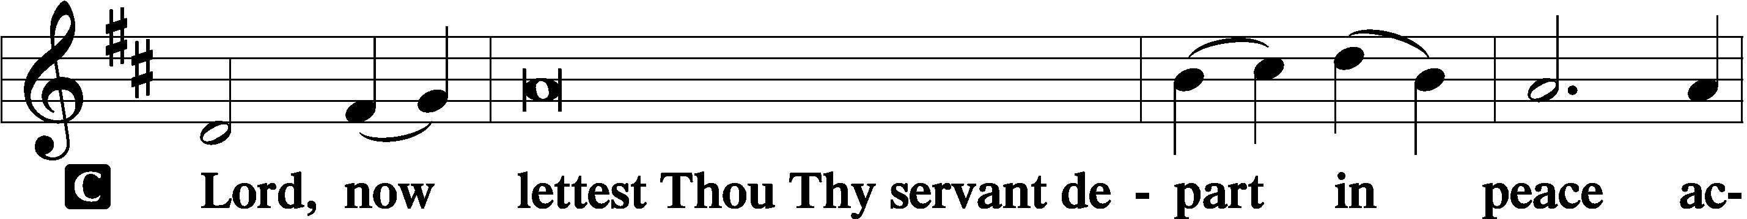

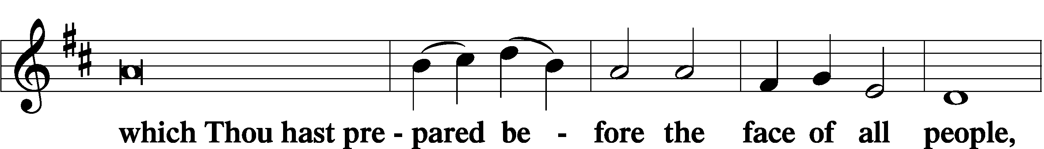
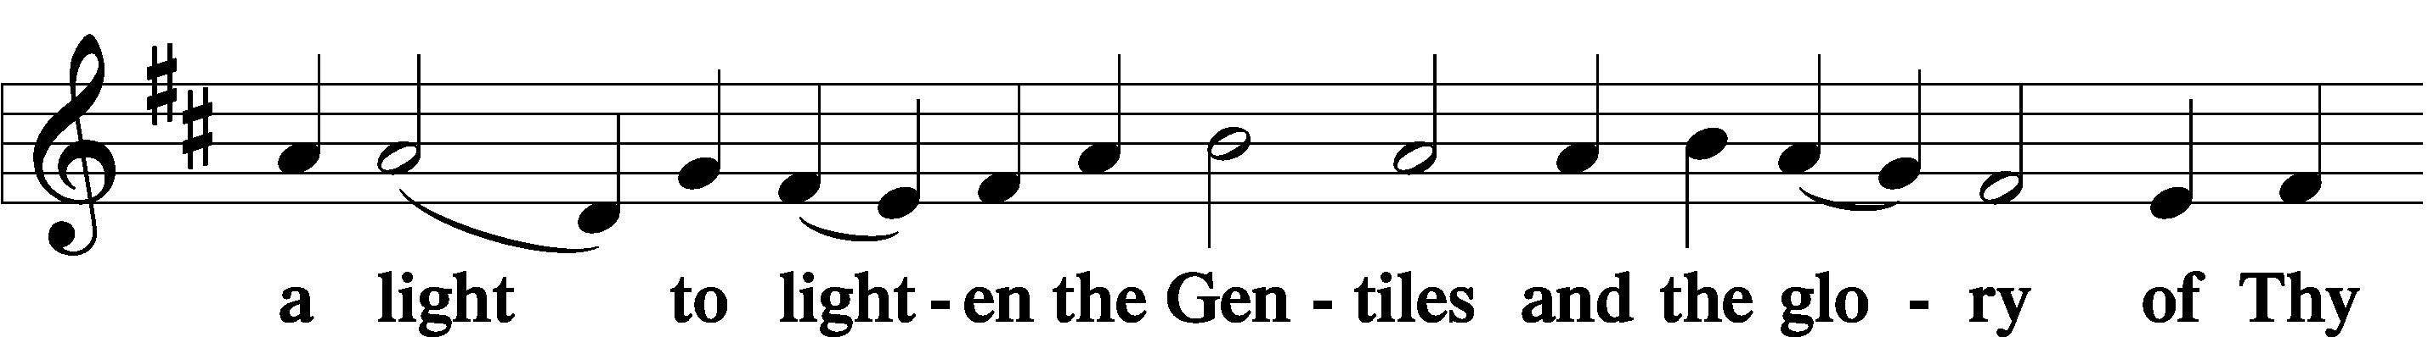
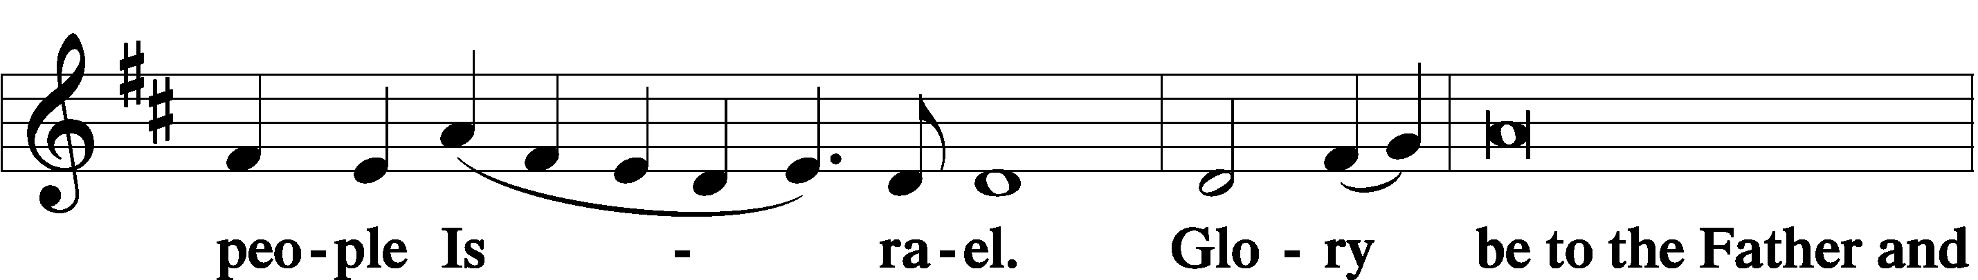
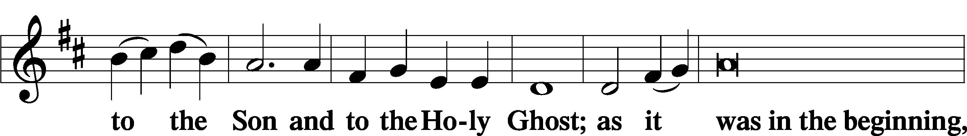
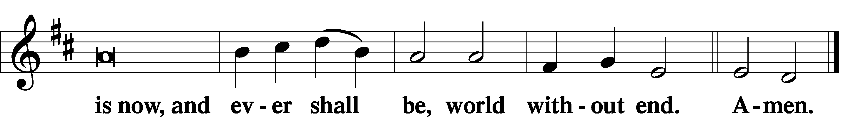

POST-COMMUNION COLLECT

P Let us pray. We give thanks to You, almighty God, that You have refreshed us through this salutary gift, and we implore You that of Your mercy You would strengthen us through the same in faith toward You and in fervent love toward one another; through Jesus Christ, Your Son, our Lord, who lives and reigns with You and the Holy Spirit, one God, now and forever.
C Amen.

BENEDICTION

P Let us bless the Lord.
C Thanks be to God.

P The Lord bless you and keep you. The Lord make His face shine on you and be gracious to you. The Lord look upon you with favor and + give you peace.
C Amen.

P Go in Peace. Serve the Lord.
C Thanks be to God!

CLOSING HYMN “Almighty Father, Bless the Word” LSB 923

POSTLUDE

Acknowledgments Divine Service, Setting two from Lutheran Service Book. Unless otherwise indicated, all scripture quotations are from Holy Bible, English Standard Version, copyright © 2001 by Crossway Bibles, a division of Good News Publishers. Used by permission. All rights reserved. Created by Lutheran Service Builder © 2023 Concordia Publishing House



COME SEE WHAT GOD IS DOING INOUR MIDST;
COME GROW WITH US

“FFF” OUTDOOR WORSHIP AND FELLOWSHIP
Friday, April 24 Starting at 5 PM

Join us for a relaxing outdoor worship and fellowship gathering as we spend time together celebrating
faith and community.
What to bring:
- Food to grill
- A lawn chair (if you’d like)
- A heart ready for fellowship and growth in faith

Come enjoy good food, meaningful conversation, and time together outdoors as we grow in faith and friendship. All are welcome—bring a friend!

APRIL

20 Church Council Mtg 6 PM
24-FFF (faith, food, fellowship) 5 PM Outdoor worship, fellowship event
25-26 A.F.F.B All Faiths Food Bank
MAY
12- School Board Mtg 5:45 PM
Altar Flowers
This week’s beautiful altar flowers are a generous gift from Cheryl and Pastor, given in joyful celebration of their wedding anniversary.

APRIL BIRTHDAYS

Phyllis Hoffman 04/01
John Bailey 04/03
Phyllis Buechner 04/04
Cary Preston 04/04
Eric Brown 04/06
Barney Brininstool 04/13
Ernest Dinkel 04/16
Rachel Dermody 04/22
Jeanne Doege 04/22
Brigitte Porwol 04/27
Joan Hartmann 04/28
Ann Gongol 04/30



Steve & Cheryl Anderson
04/23 4 years

WEEK OF APRIL 12, 2026
TITHES & OFFERING: $6261

ATTENDANCE
Saturday 4/11:17
Sunday 4/12: 95

GSLCS offers gift cards to those who need them and come to us for help. We offer cards for three businesses: Publix, Walgreen’s, and Wa-Wa (food, medicine, gas). We especially need more gift cards for Publix. The most common amounts the people give are in the $20-$25-dollar range and that is fine. If you are able, please pick up some gift cards and provide them to the church office and we’ll handle it from there. Thanks for your ongoing support of the mission and ministry of GSLCS.

MORE WAYS TO GIVE

1st is Joyful Response- sign up from your checking or savings account to the church on a recurring basis. There is no cost for either the member or church to participate in this program.
2nd is Zelle- sign into your bank via your cell phones and initiate an on-time transfer from your account to the church checking account. There is no cost for the members, however, the church must pay a 1% fee to the bank.

NEXT WEEK’S READINGS
Acts 2:42–47, Psalm 23, 1 Peter 2:19–25,
John 10:1–10

BIBLE STUDY
Wednesdays at 10 AM & Sundays after service

LAST WEDNESDAY BIBLE STUDY MAY 6

Psalm 116:1-14

1 I love the Lord, because he has heardmy voice and my pleas for mercy.2 Because he inclined his ear to me, therefore I will call on him as long as I live.3 The snares of death encompassed me;the pangs of Sheol laid hold on me; I suffered distress and anguish.4 Then I called on the name of the Lord:“O Lord, I pray, deliver my soul! ”5 Gracious is the Lord, and righteous;our God is merciful. 6 The Lord preserves the simple; when I was brought low, he saved me. 7 Return, O my soul, to your rest;for the Lord has dealt bountifully with you.8For you have delivered my soul from death,my eyes from tears,my feet from stumbling;9 I will walk before the Lordin the land of the living.10 I believed, even when I spoke,“I am greatly afflicted”;11 I said in my alarm,“All mankind are liars.” 12 What shall I render to the Lordfor all his benefits to me?13 I will lift up the cup of salvationand call on the name of the Lord,14 I will pay my vows to the Lordin the presence of all his people.

