

Good Shepherd Lutheran Church & School
is a welcoming, Christ-centered family,
dedicated to sharing our love and faith.

GOOD SHEPHERD LUTHERAN CHURCH
(The Lutheran Church-Missouri Synod)
PASTOR STEVE ANDERSON
5659 Honore Ave., Sarasota, Florida 34233
941-921-3673

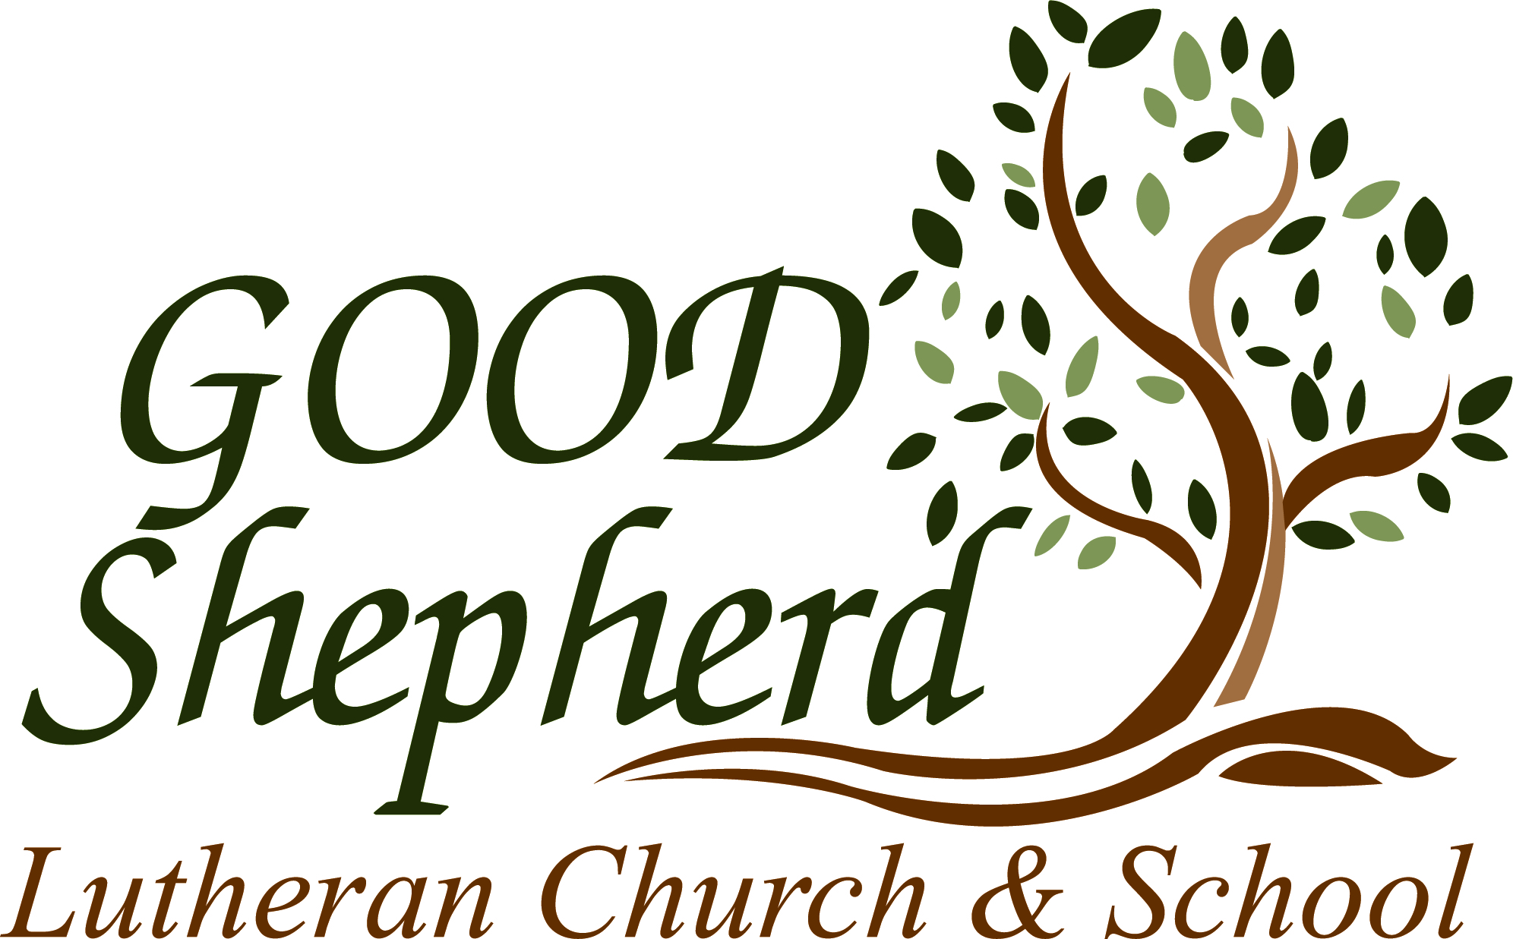

parishcoord@goodshepherdsarasota.org
pastor@goodshepherdsarasota.org
www.goodshepherdsarasota.org
GOOD SHEPHERD LUTHERAN SCHOOL
941-922-8164
Email: GSLS@comcast.net

April 26, 2026


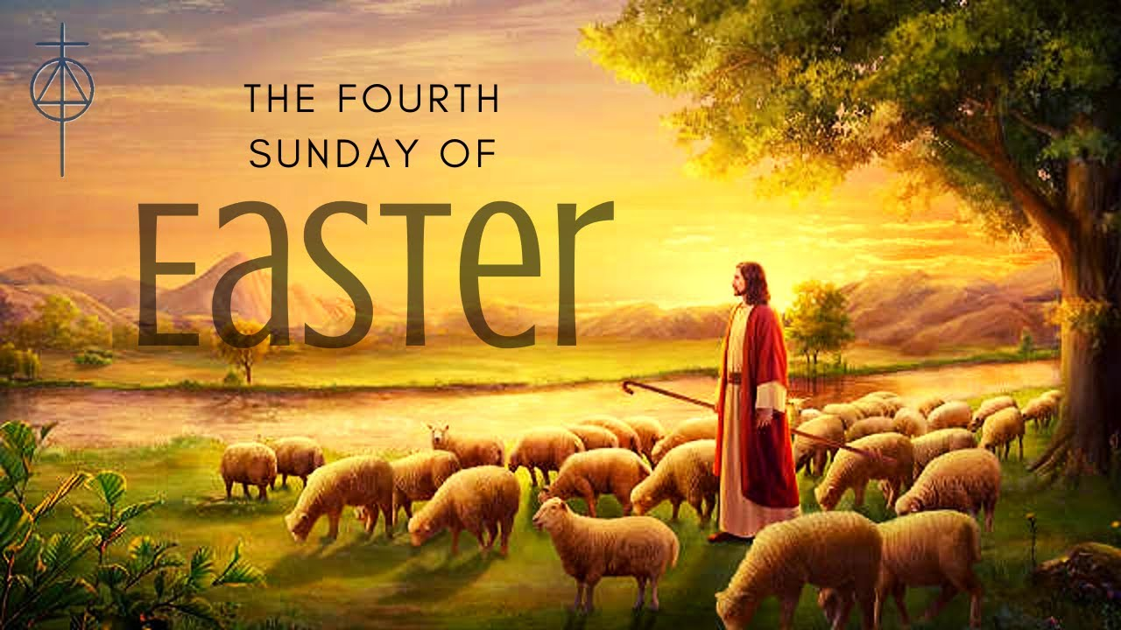

April 26, 2026, 9:15 AM

LORD’S SUPPER - As Lutherans, in joyful obedience to the clear teaching of our Lord Jesus, we invite to His table at Good Shepherd those who trust His Word, repent of their sins, and set aside refusal to forgive and love just as we have been loved and forgiven by God. If you are unsure about whether you should commune or not, speak to an usher prior to the service. Thank you and welcome!

PRESERVICE MUSIC

WELCOME AND ANNOUNCEMENTS

OPENING HYMN “Praise to You and Adoration” LSB 692

THE SERVICE OF CONFESSION AND ABSOLUTION

P In the name of the Father and of the + Son and of the Holy Spirit.
C Amen.

P Beloved in the Lord! Let us draw near with a true heart and confess our sins unto God our Father, beseeching Him in the name of our Lord Jesus Christ to grant us forgiveness.

P Our help is in the name of the Lord,
C who made heaven and earth.

P I said, I will confess my transgressions unto the Lord,
C and You forgave the iniquity of my sin.

(Silence for reflection on God's Word and for self-examination.)
P O almighty God, merciful Father,
C I, a poor, miserable sinner, confess unto You all my sins and iniquities with which I have ever offended You and justly deserved Your temporal and eternal punishment. But I am heartily sorry for them and sincerely repent of them, and I pray You of Your boundless mercy and for the sake of the holy, innocent, bitter sufferings and death of Your beloved Son, Jesus Christ, to be gracious and merciful to me, a poor, sinful being.

P Upon this your confession, I, by virtue of my office, as a called and ordained servant of the Word, announce the grace of God unto all of you, and in the stead and by the command of my Lord Jesus Christ I forgive you all your sins in the name of the Father and of the Son and of the Holy Spirit.
C Amen

KYRIE LSB 186
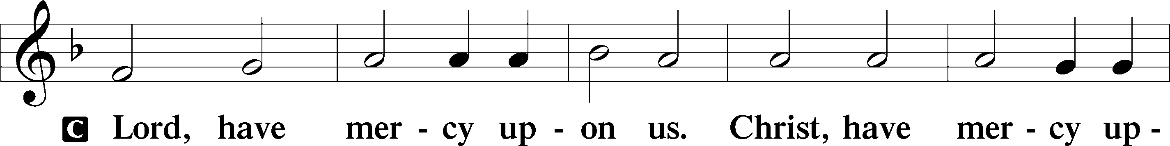
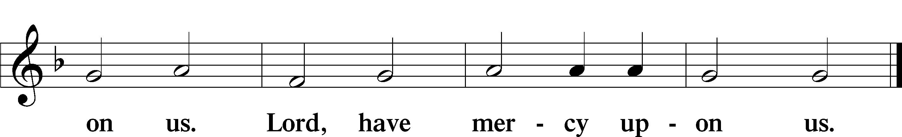

GLORIA IN EXCELSIS LSB 187
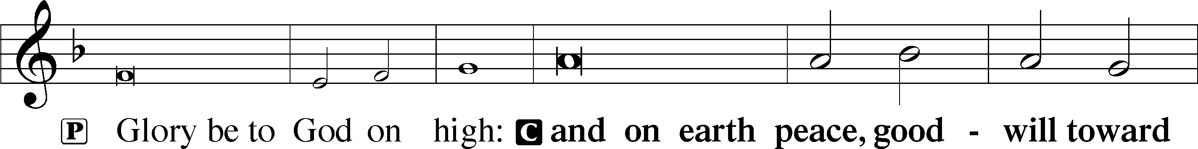
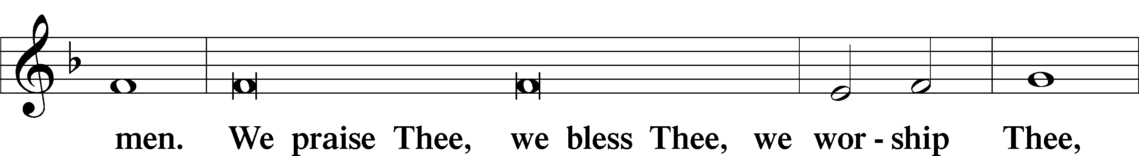
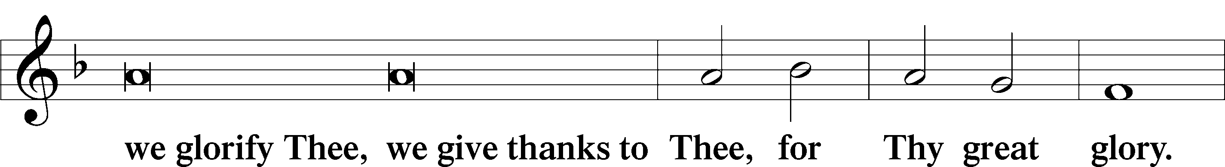
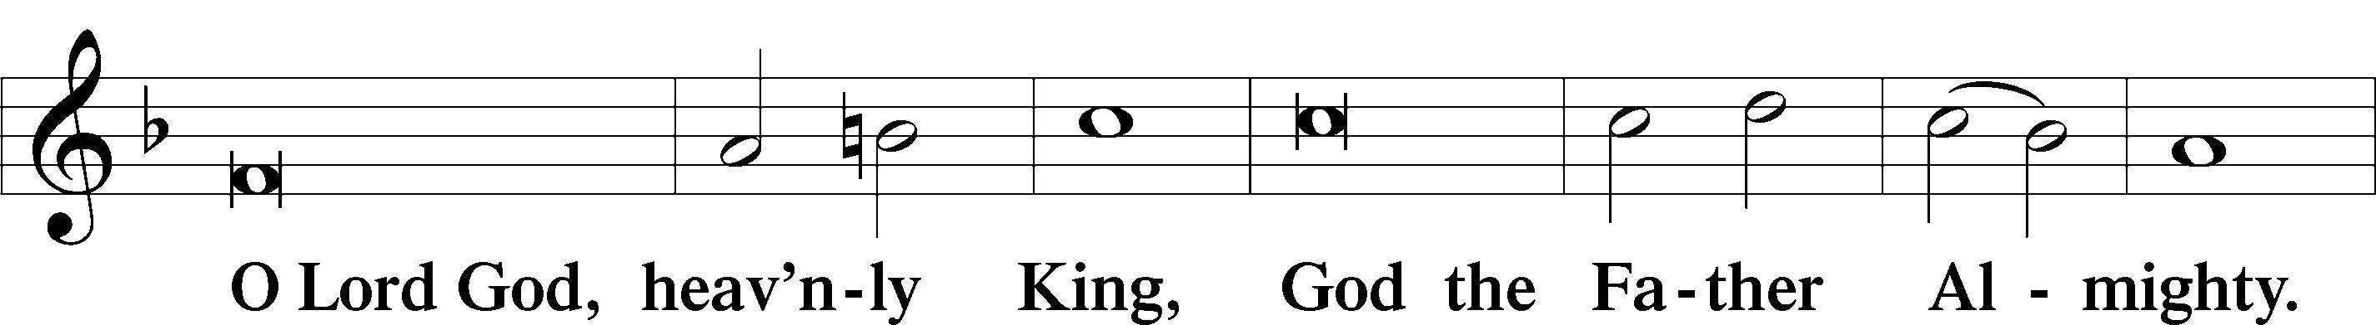
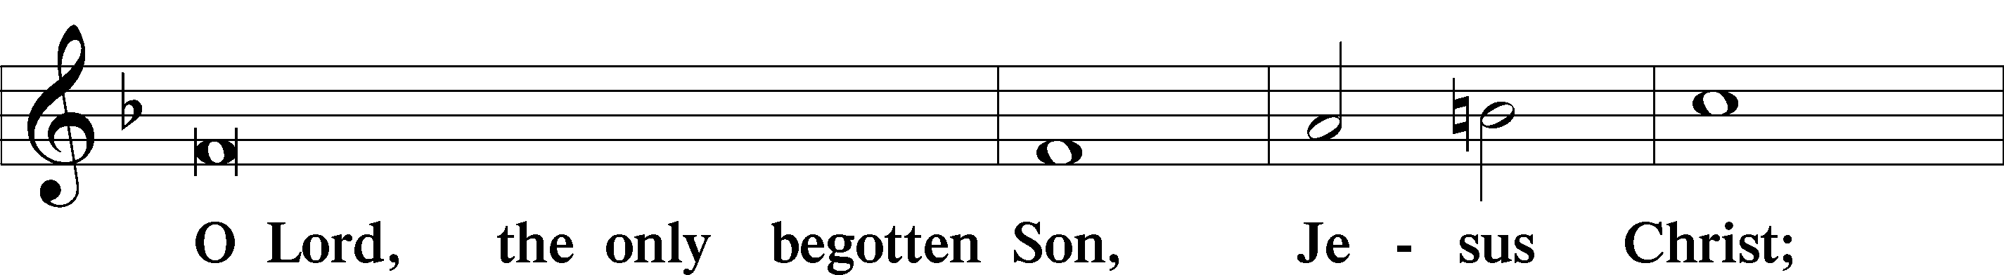
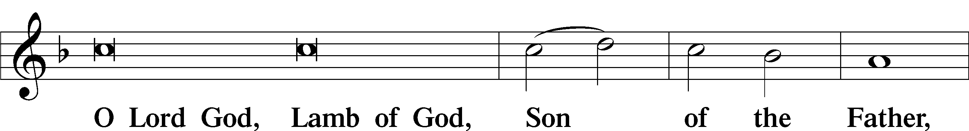
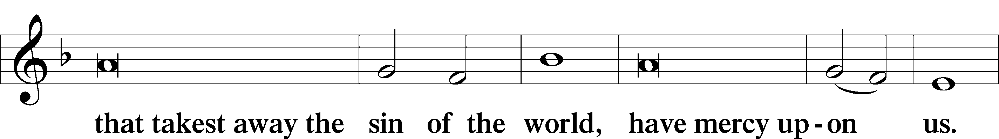
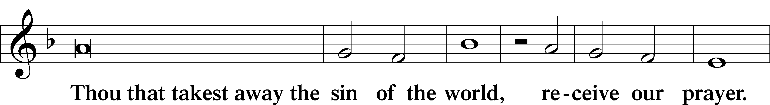
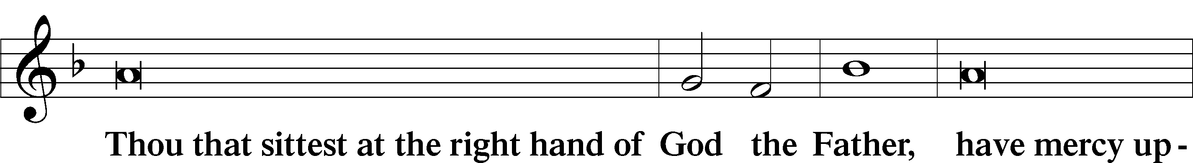
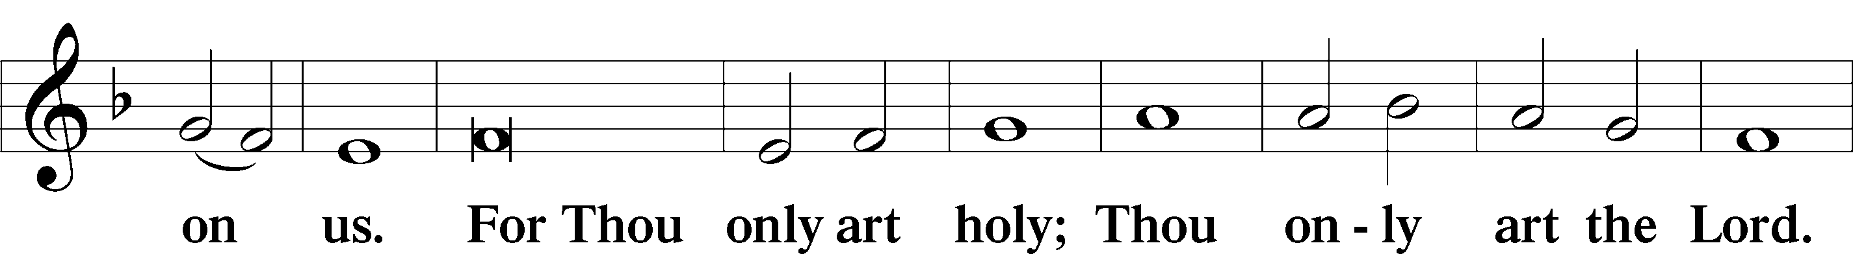
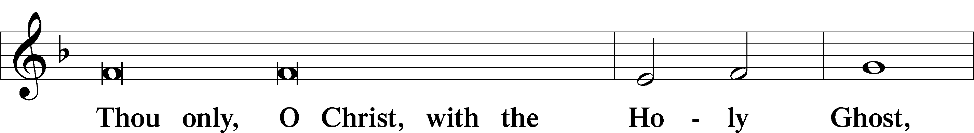
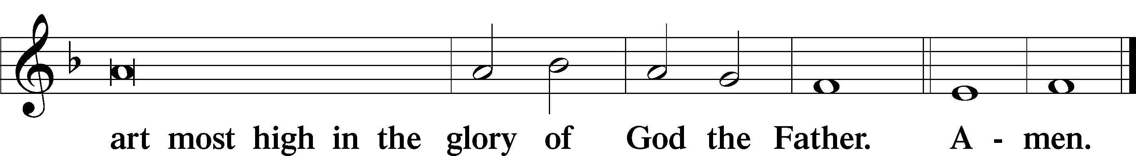

SALUTATION AND COLLECT OF THE DAY
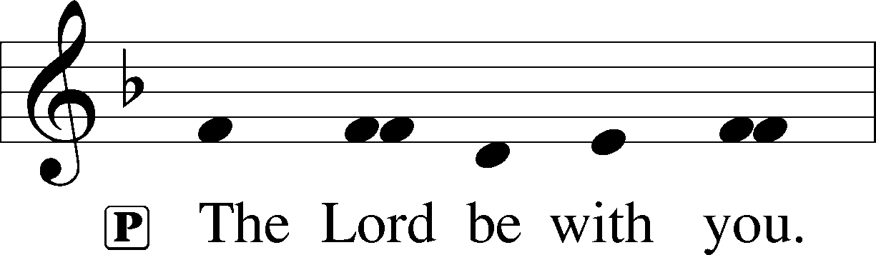
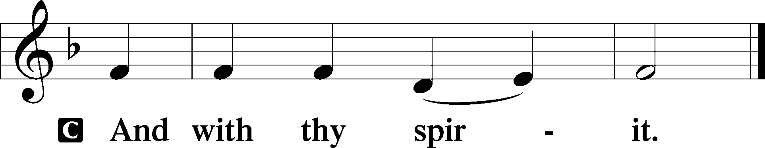
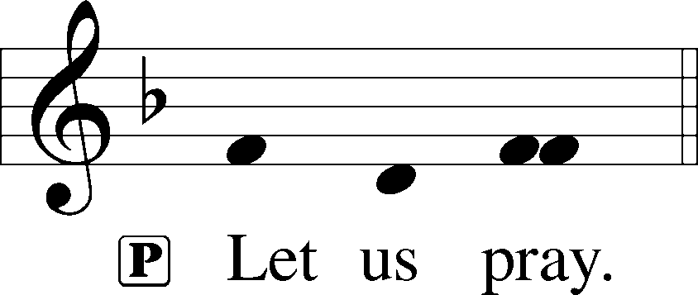

P Almighty God, merciful Father, since You have wakened from death the Shepherd of Your sheep, grant us Your Holy Spirit that when we hear the voice of our Shepherd we may know Him who calls us each by name and follow where He leads; through the same Jesus Christ, Your Son, our Lord, who lives and reigns with You and the Holy Spirit, one God, now and forever.
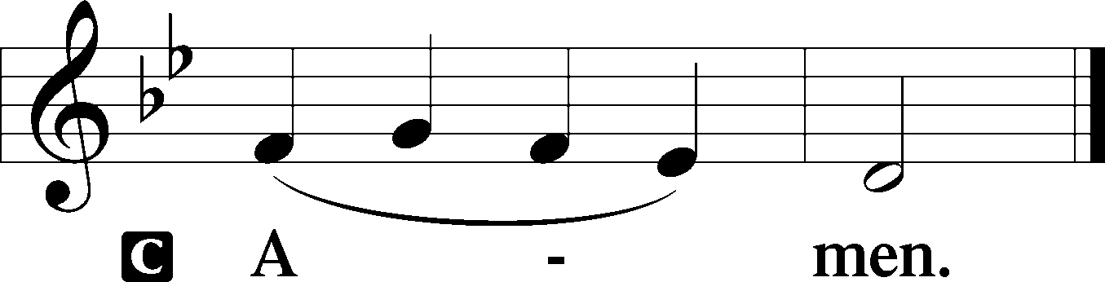

THIS WEEK’S THEME… The Crucified and Risen Lord Jesus Christ Is Our Good Shepherd
FIRST READING Acts 2:42-47

They devoted themselves to the apostles’ teaching and fellowship, to the breaking of bread and the prayers. And awe came upon every soul, and many wonders and signs were being done through the apostles. And all who believed were together and had all things in common. And they were selling their possessions and belongings and distributing the proceeds to all, as any had need. And day by day, attending the temple together and breaking bread in their homes, they received their food with glad and generous hearts, praising God and having favor with all the people. And the Lord added to their number day by day those who were being saved.

L This is the Word of the Lord.
C Thanks be to God.

CHOIR ANTHEM “The Lord My Faithful Shepherd Is”- Jack Noble White

EPISTLE 1 Peter 2:19-25

This is a gracious thing, when, mindful of God, one endures sorrows while suffering unjustly. For what credit is it if, when you sin and are beaten for it, you endure? But if when you do good and suffer for it you endure, this is a gracious thing in the sight of God. For to this you have been called, because Christ also suffered for you, leaving you an example, so that you might follow in his steps. He committed no sin, neither was deceit found in his mouth. When he was reviled, he did not revile in return; when he suffered, he did not threaten, but continued entrusting himself to him who judges justly. He himself bore our sins in his body on the tree, that we might die to sin and live to righteousness. By his wounds you have been healed. For you were straying like sheep, but have now returned to the Shepherd and Overseer of your souls.

L This is the Word of the Lord.
C Thanks be to God.

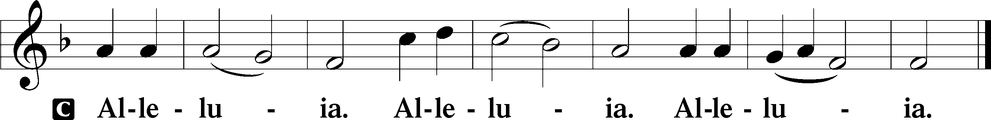
ALLELUIA AND VERSE LSB 190

HOLY GOSPEL John 10:1–10

P The Holy Gospel according to St. John, the tenth chapter.
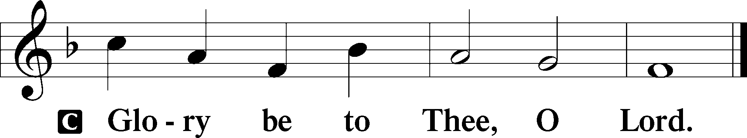

[Jesus said:] “Truly, truly, I say to you, he who does not enter the sheepfold by the door but climbs in by another way, that man is a thief and a robber. But he who enters by the door is the shepherd of the sheep. To him the gatekeeper opens. The sheep hear his voice, and he calls his own sheep by name and leads them out. When he has brought out all his own, he goes before them, and the sheep follow him, for they know his voice. A stranger they will not follow, but they will flee from him, for they do not know the voice of strangers.” This figure of speech Jesus used with them, but they did not understand what he was saying to them. So Jesus again said to them, “Truly, truly, I say to you, I am the door of the sheep. All who came before me are thieves and robbers, but the sheep did not listen to them. I am the door. If anyone enters by me, he will be saved and will go in and out and find pasture. The thief comes only to steal and kill and destroy. I came that they may have life and have it abundantly.”

P This is the Gospel of the Lord.
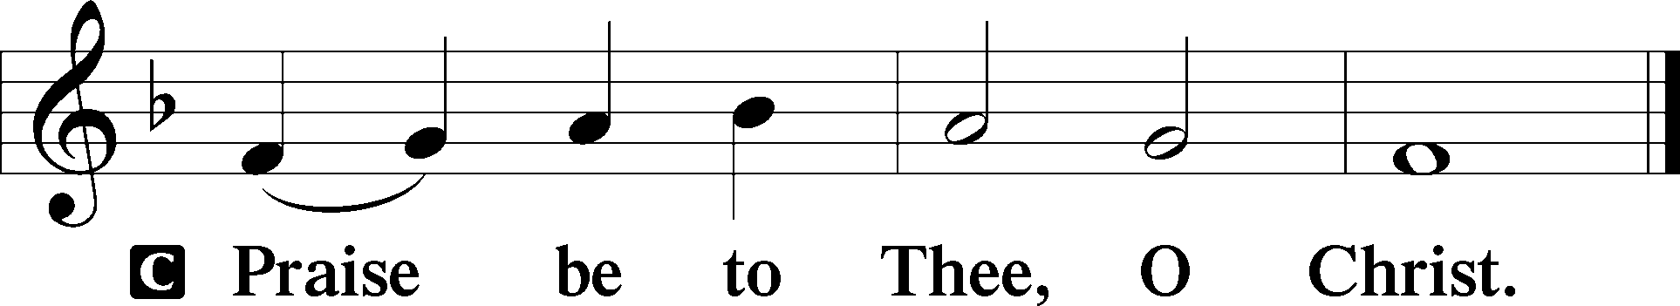

CHILDREN’S CHAPEL

HYMN OF THE DAY “The King of Love My Shepherd Is” LSB 709, vs 1-2, 5-6

SERMON Acts 2:42-47; “So THAT’S What the Church Looks Like”

APOSTLES’ CREED

C I believe in God, the Father Almighty, maker of heaven and earth.
And in Jesus Christ, His only Son, our Lord, who was conceived by the Holy Spirit, born of the virgin Mary, suffered under Pontius Pilate, was crucified, died and was buried. He descended into hell. The third day He rose again from the dead. He ascended into heaven and sits at the right hand of God the Father Almighty. From thence He will come to judge the living and the dead. I believe in the Holy Spirit, the holy Christian Church, the communion of saints, the forgiveness of sins, the resurrection of the body, and the life + everlasting. Amen.

PRAYER OF THE CHURCH

Each Petition ends with:

P Lord in Your mercy,
C Hear our Prayer.

THE OFFERING

While we gather the offering today you are invited to fill out the red “Record of Fellowship” forms located at the end of the pew. If you would, please pass the red pad down the pew so everyone can complete the record. Thanks!

+SERVICE OF THE SACRAMENT +

PREFACE LSB 194

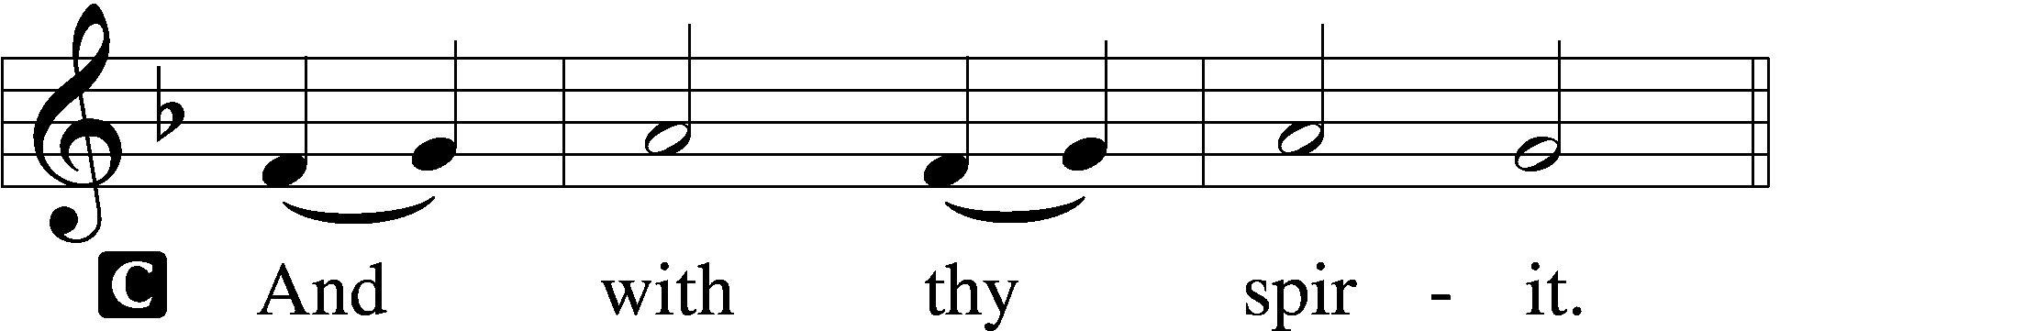


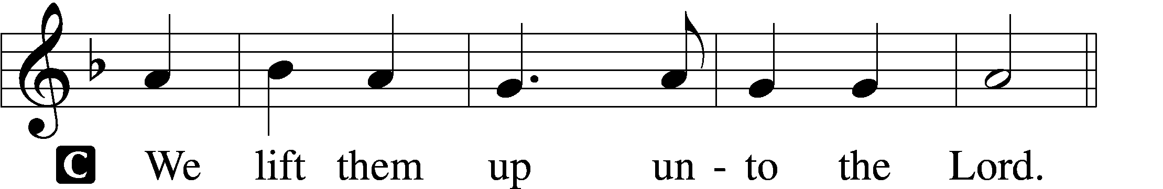

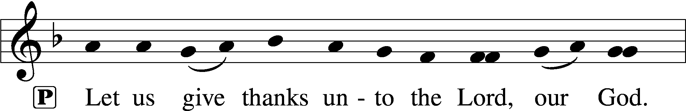
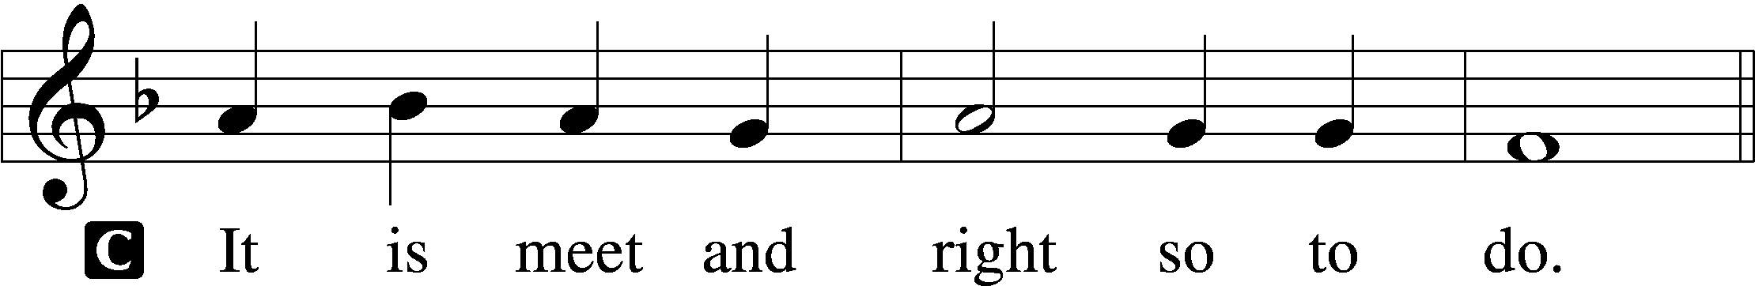

P It is truly good, right, and salutary . . . evermore praising You and saying:

SANCTUS LSB 195
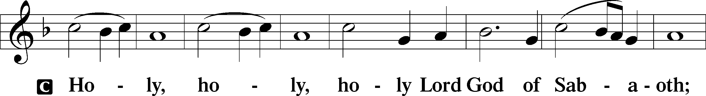
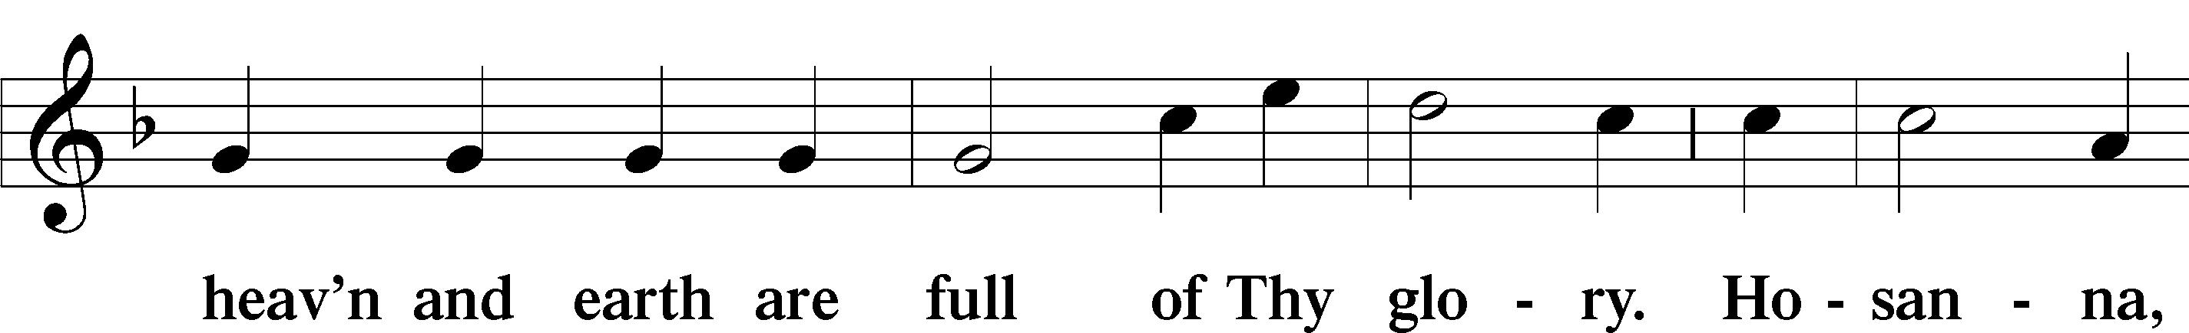
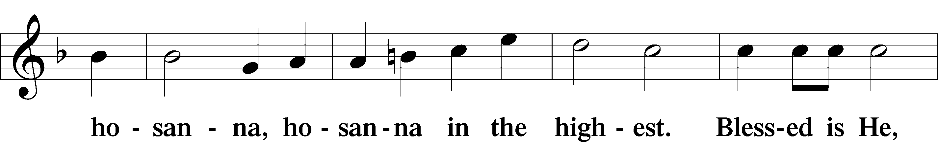
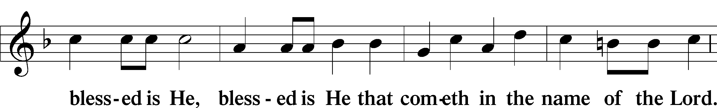
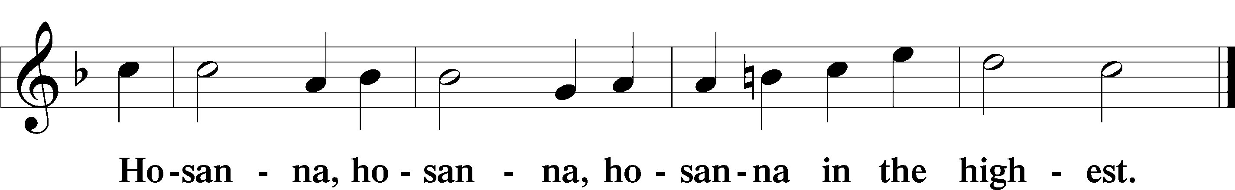

LORD'S PRAYER

P Lord, remember us in Your kingdom and teach us to pray:
C Our Father who art in heaven, hallowed be Thy name, Thy kingdom come, Thy will be done on earth as it is in heaven; give us this day our daily bread; and forgive us our trespasses as we forgive those who trespass against us; and lead us not into temptation, but deliver us from evil. For Thine is the kingdom and the power and the glory forever and ever. Amen.

THE WORDS OF OUR LORD

PAX DOMINI
P The peace of the Lord be with you always.
C And also with you.

AGNUS DEI LSB 198
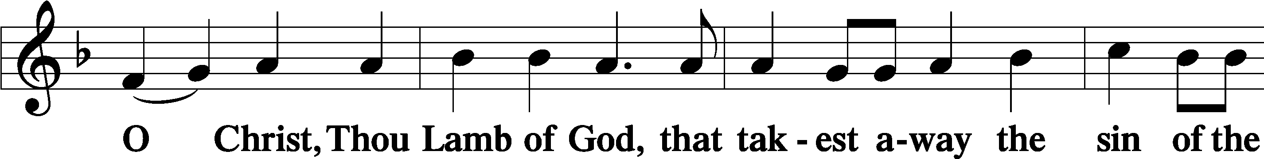
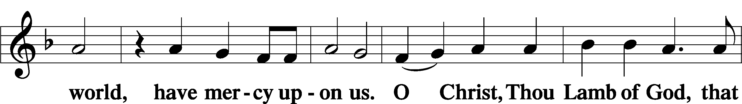
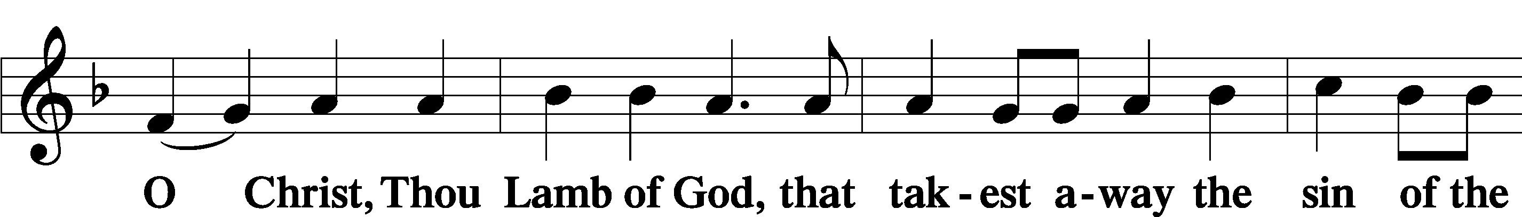
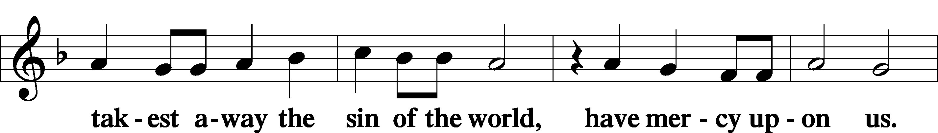

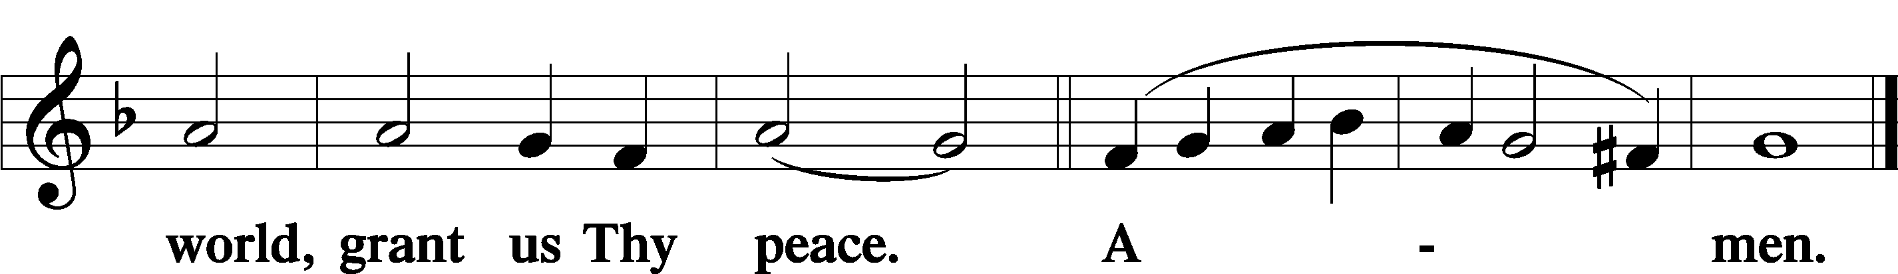

THE DISTRIBUTION

As Lutherans, in joyful obedience to the clear teaching of Lord Jesus, we now invite to His table those who trust His Word, repent of their sins, and set aside refusal to forgive and love just as we have been loved and forgiven by God. You will receive the host and then will have a choice of either the individual cups or the common cup. If you would like the common cup, place your hands FLAT on the rail while the individual cups are offered. This way Pastor will know that you desire the common cup. If for medical or other reasons you would prefer a non-alcoholic individual cup, they are located in the center of each tray. If you would like to receive communion in the pew, please inform an Usher and what your preference would be – either common or individual cup. Thank you.

HYMNS DURING THE DISTRIBUTION

“The Lord’s My Shepherd, I’ll Not Want” LSB 710
“Savior, like a Shepherd Lead Us” LSB 711
“What a Friend We Have in Jesus” LSB 770
“Lord of Glory, You Have Bought Us” LSB 851
“Where Charity and Love Prevail” LSB 845
NUNC DIMITTIS LSB 199
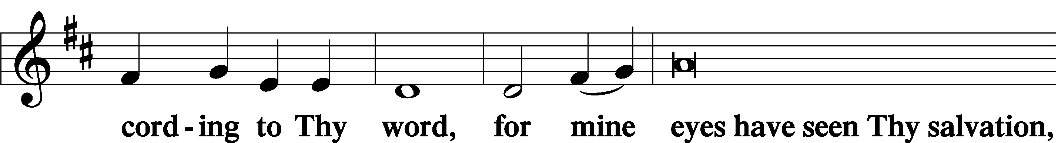
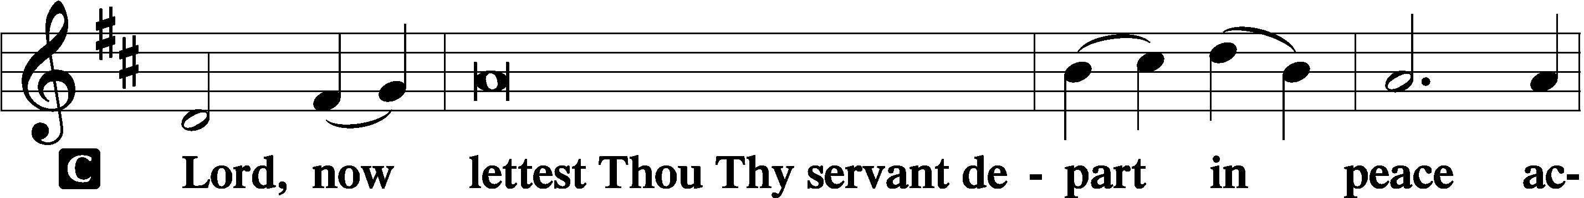

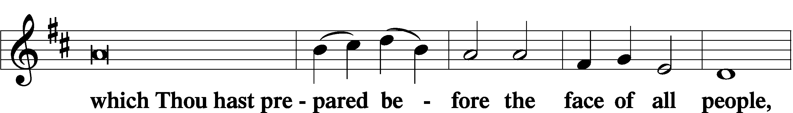
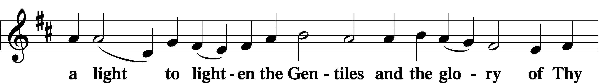
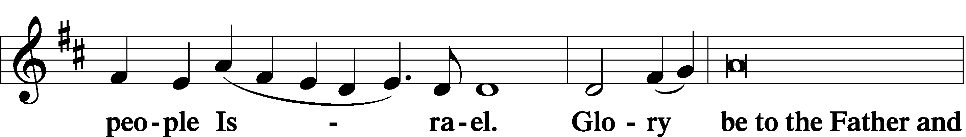
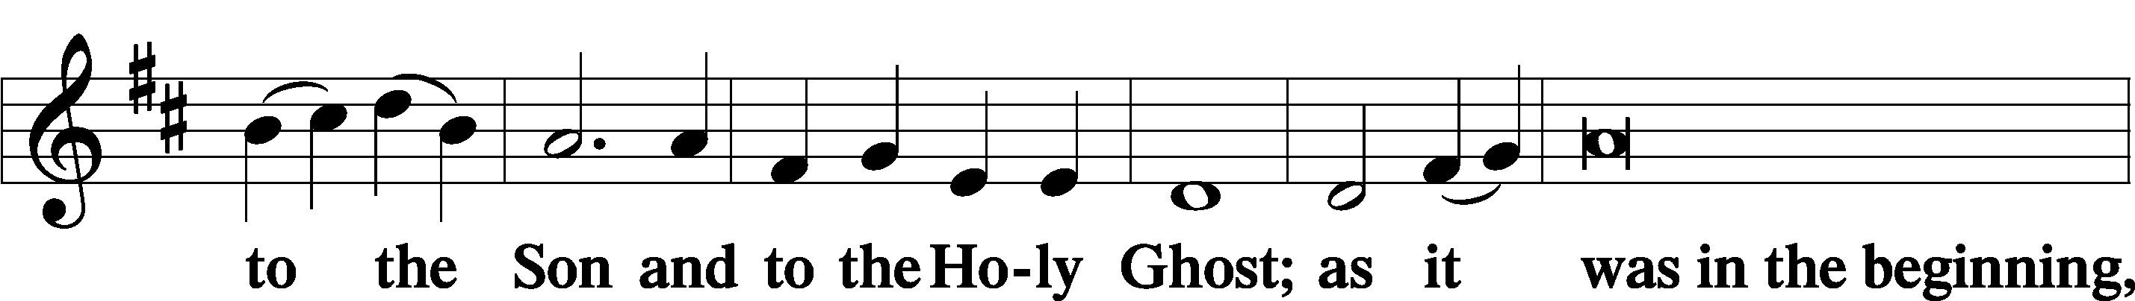
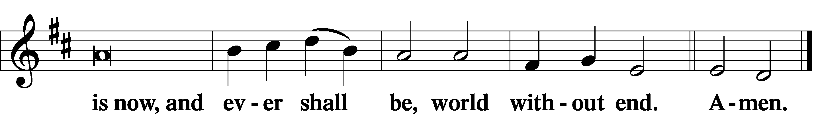

POST-COMMUNION COLLECT

P Let us pray. We give thanks to You, almighty God, that You have refreshed us through this salutary gift, and we implore You that of Your mercy You would strengthen us through the same in faith toward You and in fervent love toward one another; through Jesus Christ, Your Son, our Lord, who lives and reigns with You and the Holy Spirit, one God, now and forever.
C Amen.

BENEDICTION

P Let us bless the Lord.
C Thanks be to God.

P The Lord bless you and keep you. The Lord make His face shine on you and be gracious to you. The Lord look upon you with favor and + give you peace.
C Amen.

P Go in Peace. Serve the Lord.
C Thanks be to God!

CLOSING HYMN “Forth in the Peace of Christ We Go” LSB 920

POSTLUDE

Acknowledgments Divine Service, Setting two from Lutheran Service Book. Unless otherwise indicated, all scripture quotations are from Holy Bible, English Standard Version, copyright © 2001 by Crossway Bibles, a division of Good News Publishers. Used by permission. All rights reserved. Created by Lutheran Service Builder © 2023 Concordia Publishing House





COME SEE WHAT GOD IS DOING IN OUR MIDST;
COME GROW WITH US

APRIL
26- A.F.F.B All Faiths Food Bank
MAY
12-School Board Mtg 5:45 PM
18-Church Council Mtg 6 PM


Diane Gonzalez 5/18
Jerry McDermott 5/18
Linda Petersen 5/18
Kyle Buchholz 5/24
Glenn Hankison 5/29
Robert Nauss 5/31
Carl Bayne 5/2
John Teller 5/2
Kenneth Allen 5/10
Joan Johnson 5/11
Richard Pohlman 5/16
Sandy Dion 5/18



Kyle & Emily Buchholz
5/05 14 yrs
Corey & Megan Rhinehart
5/17 18 yrs
William & Barbara Christensen
5/22 55 yrs

MORE WAYS TO GIVE
1st is Joyful Response- sign up from your checking or savings
account to the church on a recurring basis. There is no cost
for either the member or church to participate in this
program.
2nd is Zelle- sign into your bank via your cell phones and
initiate an on-time transfer from your account to the church
checking account. There is no cost for the members,
however, the church must pay a 1% fee to the bank.

NOTARY SERVICE AVAILABLE

Call Sue at the office 941-3673

ALTAR FLOWERS

The Altar Flowers this week are given by Terri
Schlater, celebrating the wedding of her son,
Dakota, and his bride, Chelsea.

WEEK OF APRIL 19, 2026

TITHES & OFFERING: $4818
ATTENDANCE Sunday 4/18:16 Saturday 4/19: 73

VIST OUR WEBSITE:
GOODSHEPHERDSARASOTA.ORG

NEXT WEEK’S READINGS
Acts 6:1–9; 7:2a, 51–60, Psalm 146,
1 Peter 2:2-10, John 14:1–14
BIBLE STUDY
Wednesdays at 10 AM & Sundays after service
May 6
LAST WEDNESDAY BIBLE STUDY
GSLCS offers gift cards to those who need them and come to us for help. We offer cards for three businesses: Publix, Walgreen’s, and Wa-Wa (food, medicine, gas). We especially need more gift cards for Publix. The most common amounts the people give are in the $20-$25-dollar range and that is fine. If you are able, please pick up some gift cards and provide them to the church office and we’ll handle it from there. Thanks for your ongoing support of the mission and ministry of GSLCS.

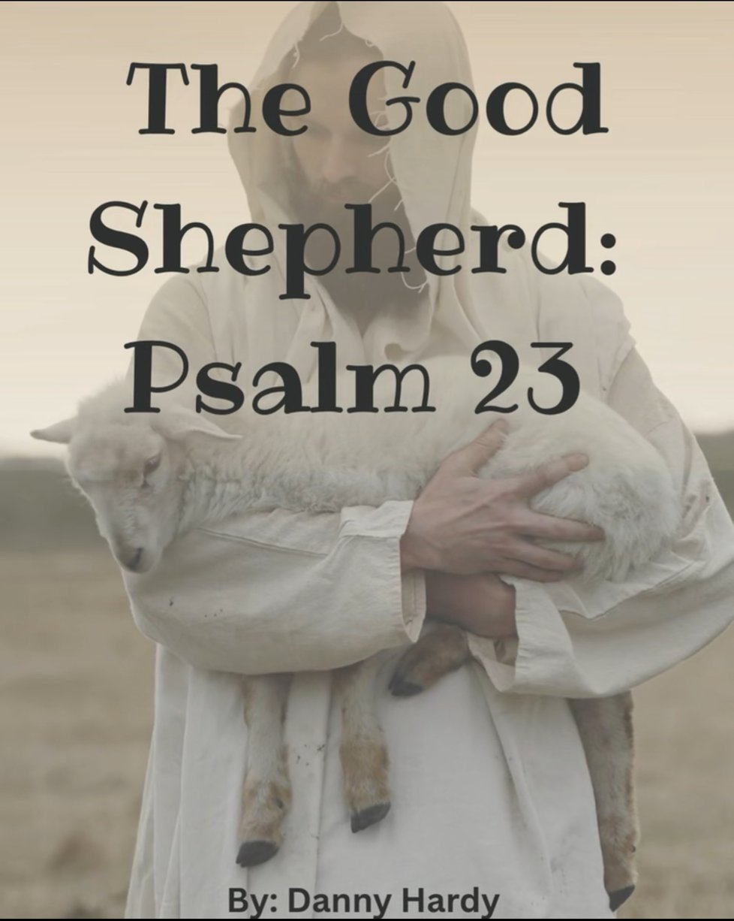

¹The Lord is my shepherd;I shall not want.²He makes me lie down in green pastures. He leads me beside still waters.³He restores my soul.He leads me in paths of righteousness for his name’s sake.⁴Even though I walk through the valley of the shadow of death,I will fear no evil, for you are with me;your rod and your staff, they comfort me.⁵You prepare a table before me in the presence of my enemies; you anoint my head with oil; my cup overflows.⁶Surely goodnesand mercy shall follow me all the days of my life, and I shall dwell in the house of the Lord forever.

