

Good Shepherd Lutheran Church & School
is a welcoming, Christ-centered family,
dedicated to sharing our love and faith.

GOOD SHEPHERD LUTHERAN CHURCH
(The Lutheran Church-Missouri Synod)
PASTOR STEVE ANDERSON
5659 Honore Ave., Sarasota, Florida 34233
941-921-3673

parishcoord@goodshepherdsarasota.org
pastor@goodshepherdsarasota.org
www.goodshepherdsarasota.org
GOOD SHEPHERD LUTHERAN SCHOOL
941-922-8164
Email: GSLS@comcast.net

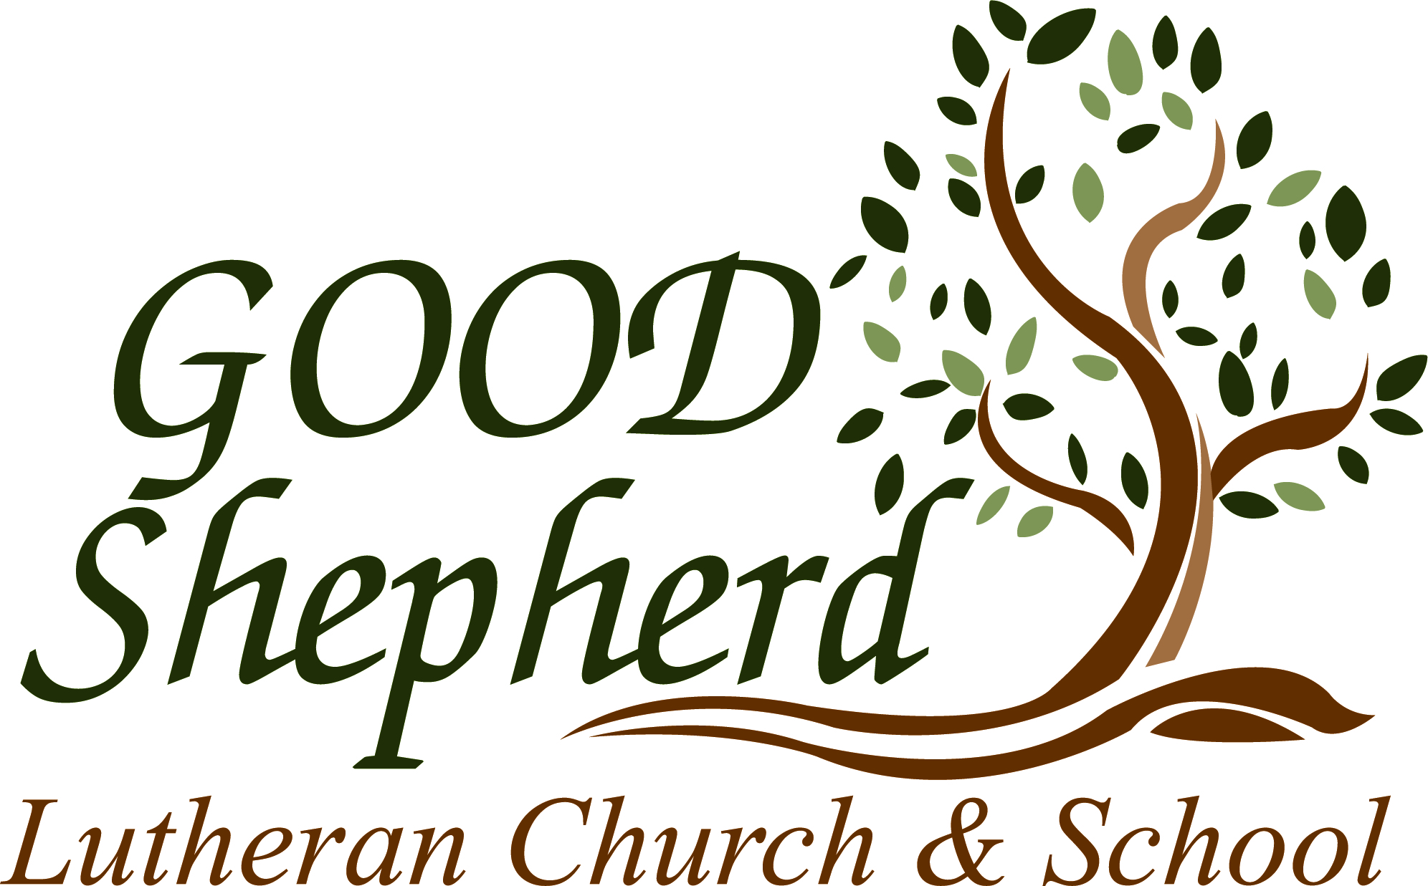

May 3, 2026

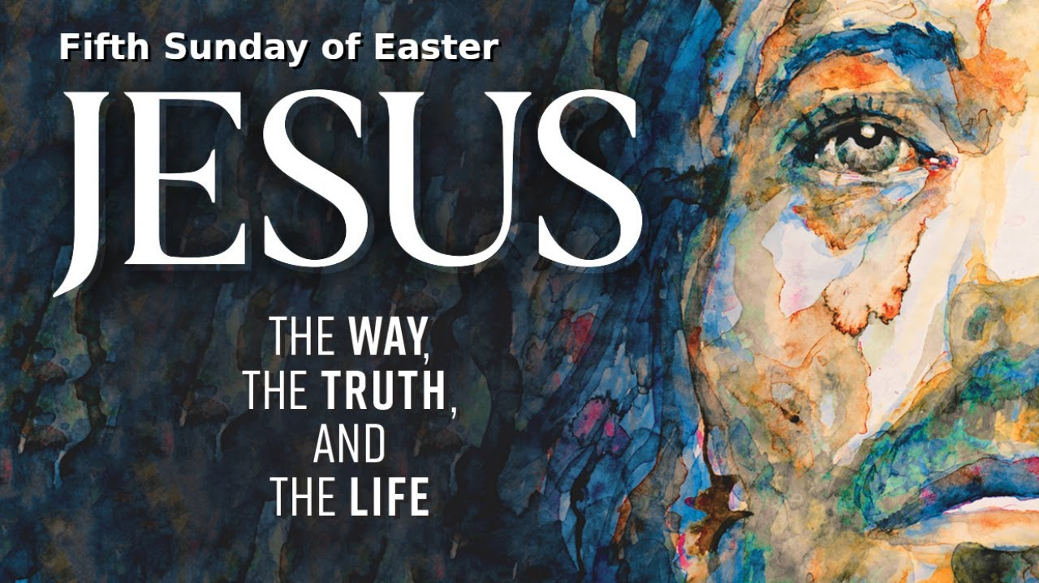



LORD’S SUPPER - As Lutherans, in joyful obedience to the clear teaching of our Lord Jesus, we invite to His table at Good Shepherd those who trust His Word, repent of their sins, and set aside refusal to forgive and love just as we have been loved and forgiven by God. If you are unsure about whether you should commune or not, speak to an usher prior to the service. Thank you and welcome!

PRESERVICE MUSIC

WELCOME AND ANNOUNCEMENTS

OPENING HYMN “Anniversary Hymn”
(Tune is LSB #816; text by Rev. Ed Rehwaldt and Rev. Steven Anderson)

Vs. 1: Congregation, Vs. 2: All Women, Vs. 3: Choir, Vs. 4: All Men, Vs 5: Choir, Vs. 6: Congregation

1.We have assembled in this place
Connecting those who live by grace.
Alleluia, Alleluia!
Now all you people here today
Declare your joy once more and say
Alleluia, Alleluia, Alleluia, Alleluia, Alleluia!

2.To God, our great Eternal Lord
Let songs be sung, and praise outpoured.
Alleluia, Alleluia!
Year after year His grace He gave
a living faith given to save.
Alleluia, Alleluia, Alleluia, Alleluia, Alleluia!

3.Into this place for us God sent
His Holy Word and Sacrament.
Alleluia, Alleluia!
He gathered us that we might be
All blessed within one family.
Alleluia, Alleluia, Alleluia, Alleluia, Alleluia!

4.Now joined together with the Son
we by the Spirit are made one.
Alleluia, Alleluia!
In Jesus Christ we will preserve
United, let us gladly serve.
Alleluia, Alleluia, Alleluia, Alleluia, Alleluia!

5.In all our sorrows, joys, and tears,
We have come for these many years!
Alleluia, Alleluia!
His own will never cease to meet,
until we walk on golden streets.
Alleluia, Alleluia, Alleluia, Alleluia, Alleluia!

6.For us the blessing of His love
poured down these years from high above.
Alleluia, Alleluia!
Go forth you people tell His name,
Salvation for all souls proclaim!
Alleluia, Alleluia, Alleluia, Alleluia, Alleluia!

THE SERVICE OF CONFESSION AND ABSOLUTION

P In the name of the Father and of the + Son and of the Holy Spirit.
C Amen.

P Our help is in the name of the Lord,
C who made heaven and earth.

P If You, O Lord, kept a record of sins, O Lord, who could stand?
C But with You there is forgiveness; therefore You are feared.

P Since we are gathered to hear God’s Word, call upon Him in prayer and praise, and receive the body and blood of our Lord Jesus Christ in the fellowship of this altar, let us first consider our unworthiness and confess before God and one another that we have sinned in thought, word, and deed, and that we cannot free ourselves from our sinful condition. Together as His people let us take refuge in the infinite mercy of God, our heavenly Father, seeking His grace for the sake of Christ, and saying: God, be merciful to me, a sinner.
C Almighty God, have mercy upon us, forgive us our sins, and lead us to everlasting life. Amen.

P Almighty God in His mercy has given His Son to die for you and for His sake forgives you all your sins. As a called and ordained servant of Christ, and by His authority, I therefore forgive you all your sins in the name of the Father and of the + Son and of the Holy Spirit.
C Amen.

SALUTATION AND COLLECT OF THE DAY

P The Lord be with you.
C And also with you.

P Let us pray. O God, You make the minds of Your faithful to be of one will. Grant that we may love what You have commanded and desire what You promise, that among the many changes of this world our hearts may be fixed where true joys are found; through Jesus Christ, Your Son, our Lord, who lives and reigns with You and the Holy Spirit, one God, now and forever.
C Amen.

THIS WEEK’S THEME…The Lord Jesus Christ Is the Way, the Truth and the Life

PREAMBLE, NAME, CONFESSION OF FAITH AND VISION STATEMENT

FIRST READING Acts 6:1–9; 7:2a, 51–60

Now in these days when the disciples were increasing in number, a complaint by the Hellenists arose against the Hebrews because their widows were being neglected in the daily distribution. And the twelve summoned the full number of the disciples and said, “It is not right that we should give up preaching the word of God to serve tables. Therefore, brothers, pick out from among you seven men of good repute, full of the Spirit and of wisdom, whom we will appoint to this duty. But we will devote ourselves to prayer and to the ministry of the word.” And what they said pleased the whole gathering, and they chose Stephen, a man full of faith and of the Holy Spirit, and Philip, and Prochorus, and Nicanor, and Timon, and Parmenas, and Nicolaus, a proselyte of Antioch. These they set before the apostles, and they prayed and laid their hands on them. And the word of God continued to increase, and the number of the disciples multiplied greatly in Jerusalem, and a great many of the priests became obedient to the faith. And Stephen, full of grace and power, was doing great wonders and signs among the people. Then some of those who belonged to the synagogue of the Freedmen (as it was called), and of the Cyrenians, and of the Alexandrians, and of those from Cilicia and Asia, rose up and disputed with Stephen. . . .And Stephen said: “Brothers and fathers, hear me. . . .You stiff-necked people, uncircumcised in heart and ears, you always resist the Holy Spirit. As your fathers did, so do you. Which of the prophets did not your fathers persecute? And they killed those who announced beforehand the coming of the Righteous One, whom you have now betrayed and murdered, you who received the law as delivered by angels and did not keep it.” Now when they heard these things they were enraged, and they ground their teeth at him. But he, full of the Holy Spirit, gazed into heaven and saw the glory of God, and Jesus standing at the right hand of God. And he said, “Behold, I see the heavens opened, and the Son of Man standing at the right hand of God.” But they cried out with a loud voice and stopped their ears and rushed together at him. Then they cast him out of the city and stoned him. And the witnesses laid down their garments at the feet of a young man named Saul. And as they were stoning Stephen, he called out, “Lord Jesus, receive my spirit.” And falling to his knees he cried out with a loud voice, “Lord, do not hold this sin against them.” And when he had said this, he fell asleep.

L This is the Word of the Lord.
C Thanks be to God.

CHOIR ANTHEM “Christ Be My Leader” LSB 861

CALLED PASTORS OF GSLCS

EPISTLE 1 Peter 2:2–10

Like newborn infants, long for the pure spiritual milk, that by it you may grow up to salvation— if indeed you have tasted that the Lord is good. As you come to him, a living stone rejected by men but in the sight of God chosen and precious, you yourselves like living stones are being built up as a spiritual house, to be a holy priesthood, to offer spiritual sacrifices acceptable to God through Jesus Christ. For it stands in Scripture: “Behold, I am laying in Zion a stone, a cornerstone chosen and precious, and whoever believes in him will not be put to shame.” So the honor is for you who believe, but for those who do not believe, “The stone that the builders rejected has become the cornerstone,” and “A stone of stumbling, and a rock of offense.” They stumble because they disobey the word, as they were destined to do. But you are a chosen race, a royal priesthood, a holy nation, a people for his own possession, that you may proclaim the excellencies of him who called you out of darkness into his marvelous light. Once you were not a people, but now you are God’s people; once you had not received mercy, but now you have received mercy.

L This is the Word of the Lord.
C Thanks be to God.

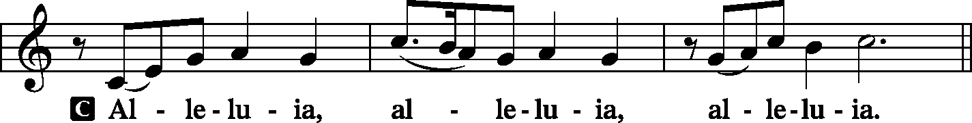
ALLELUIA AND VERSE

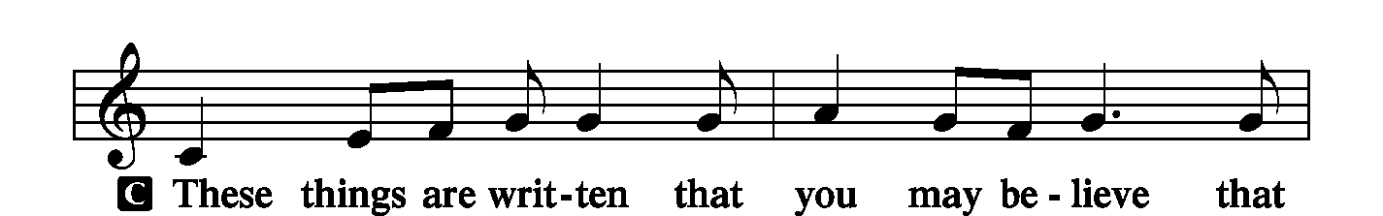

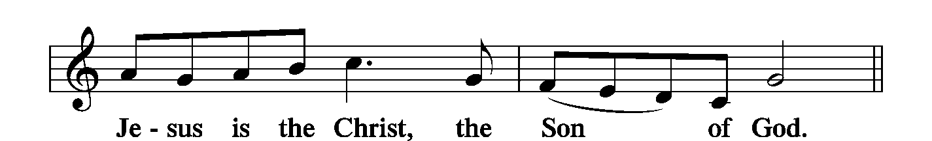

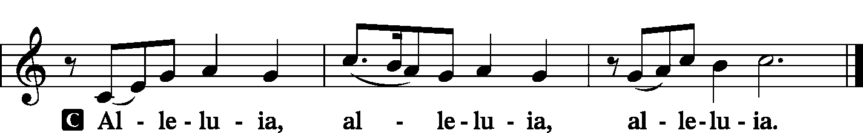

HOLY GOSPEL John 14:1–14
P The Holy Gospel according to St. John, the fourteenth chapter.
C Glory to You, O Lord.

[Jesus said:] “Let not your hearts be troubled. Believe in God; believe also in me. In my Father’s house are many rooms. If it were not so, would I have told you that I go to prepare a place for you? And if I go and prepare a place for you, I will come again and will take you to myself, that where I am you may be also. And you know the way to where I am going.” Thomas said to him, “Lord, we do not know where you are going. How can we know the way?” Jesus said to him, “I am the way, and the truth, and the life. No one comes to the Father except through me. If you had known me, you would have known my Father also. From now on you do know him and have seen him.” 8Philip said to him, “Lord, show us the Father, and it is enough for us.” Jesus said to him, “Have I been with you so long, and you still do not know me, Philip? Whoever has seen me has seen the Father. How can you say, ‘Show us the Father’? Do you not believe that I am in the Father and the Father is in me? The words that I say to you I do not speak on my own authority, but the Father who dwells in me does his works. Believe me that I am in the Father and the Father is in me, or else believe on account of the works themselves. “Truly, truly, I say to you, whoever believes in me will also do the works that I do; and greater works than these will he do, because I am going to the Father. Whatever you ask in my name, this I will do, that the Father may be glorified in the Son. If you ask me anything in my name, I will do it.”

P This is the Gospel of the Lord.
C Praise to You, O Christ.

NICENE CREED LSB 206

C I believe in one God, the Father Almighty, maker of heaven and earth and of all things visible and invisible. And in one Lord Jesus Christ, the only-begotten Son of God, begotten of His Father before all worlds, God of God, Light of Light, very God of very God, begotten, not made, being of one substance with the Father, by whom all things were made; who for us men and for our salvation came down from heaven and was incarnate by the Holy Spirit of the virgin Mary and was made man; and was crucified also for us under Pontius Pilate. He suffered and was buried. And the third day He rose again according to the Scriptures and ascended into heaven and sits at the right hand of the Father. And He will come again with glory to judge both the living and the dead, whose kingdom will have no end. And I believe in the Holy Spirit, the Lord and giver of life, who proceeds from the Father and the Son, who with the Father and the Son together is worshiped and glorified, who spoke by the prophets. And I believe in one holy Christian and apostolic Church, I acknowledge one Baptism for the remission of sins, and I look for the resurrection of the dead and the life + of the world to come. Amen.
HYMN OF THE DAY “Sins Praise to God, the Highest Good” LSB 819, vs 1-4

SERMON John 14:1-14 “How Can We Know the Way?”

THE PRAYERS OF THE CHURCH

Each prayer petition concludes:

P Lord, in Your mercy,
C Hear our prayer.

THE OFFERING

While we gather the offering today you are invited to fill out the red “Record of Fellowship” forms located at the end of the pew. If you would, please pass the red pad down the pew so everyone can complete the record. Thanks!

PREFACE LSB 208

P The Lord be with you.
C And also with you.

P Lift up your hearts.
C We lift them to the Lord.

P Let us give thanks to the Lord our God.
C It is right to give Him thanks and praise.

P It is truly good, right, and salutary . . . evermore praising You and saying:

SANCTUS LSB 208
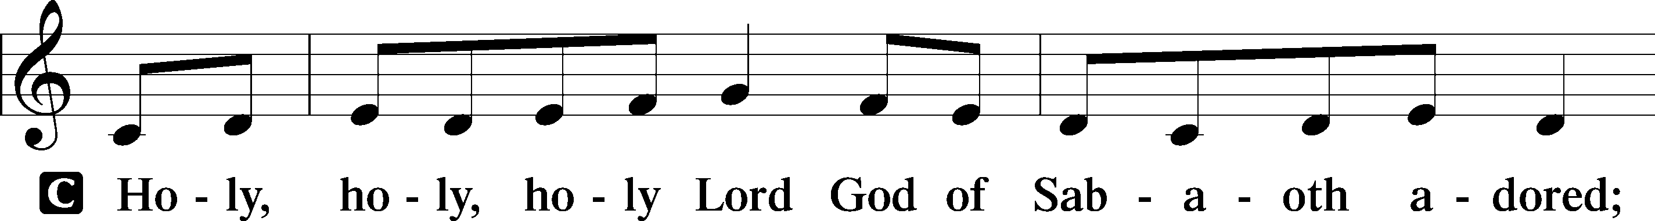
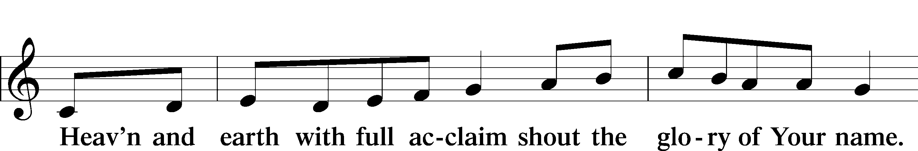

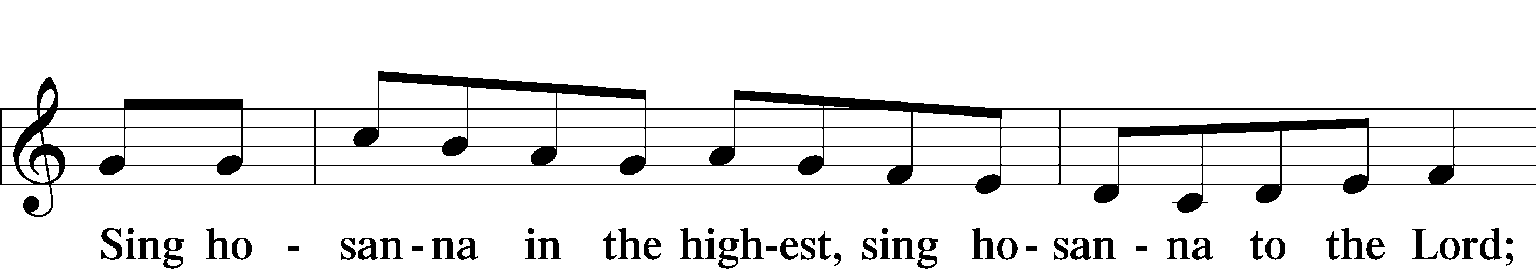
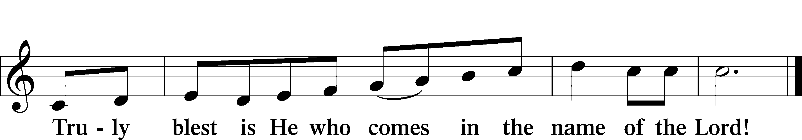

LORD'S PRAYER LSB 209

P Lord, remember us in Your kingdom and teach us to pray:
C Our Father who art in heaven, hallowed be Thy name, Thy kingdom come, Thy will be done on earth as it is in heaven; give us this day our daily bread; and forgive us our trespasses as we forgive those who trespass against us; and lead us not into temptation, but deliver us from evil. For Thine is the kingdom and the power and the glory forever and ever. Amen.

THE WORDS OF OUR LORD

PAX DOMINI LSB 209

P The peace of the Lord be with you always.
C And also with you.

AGNUS DEI LSB 210
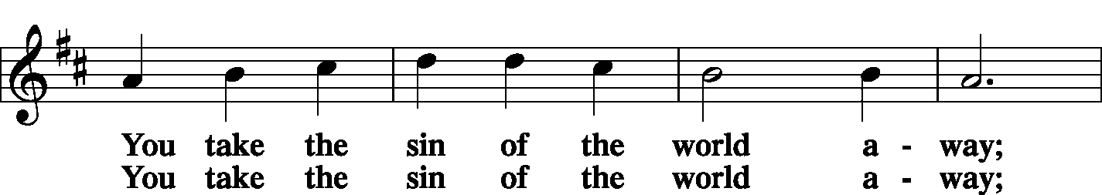
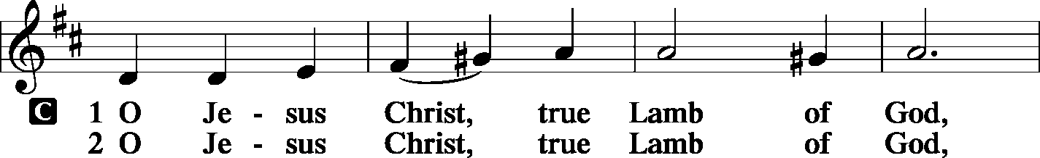

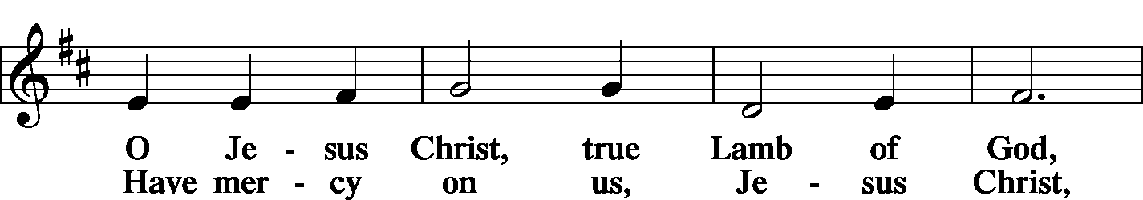

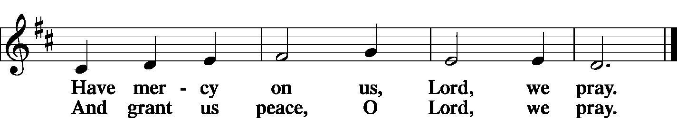

THE DISTRIBUTION

As Lutherans, in joyful obedience to the clear teaching of Lord Jesus, we now invite to His table those who trust His Word, repent of their sins, and set aside refusal to forgive and love just as we have been loved and forgiven by God. You will receive the host and then will have a choice of either the individual cups or the common cup. If you would like the common cup, place your hands FLAT on the rail while the individual cups are offered. This way Pastor will know that you desire the common cup. If for medical or other reasons you would prefer a non-alcoholic individual cup, they are located in the center of each tray. If you would like to receive communion in the pew, please inform an Usher and what your preference would be – either common or individual cup. Thank you.

HYMNS DURING THE DISTRIBUTION

“At the Lamb’s High Feast We Sing” LSB 633
“I Come, O Savior, to Thy Table” LSB 618
“I Know That’s My Redeemer Lives” LSB 461
“ The Church’s One Foundation” LSB 644

POST-COMMUNION COLLECT

P Let us pray.
O God, our Maker and Redeemer, You wonderfully created us and in the incarnation of Your Son yet more wondrously restored our human nature. Grant that we may ever be alive in Him who made Himself to be like us; through Jesus Christ, our Lord, who lives and reigns with You and the Holy Spirit, one God, now and forever.
C Amen.

BENEDICTION

P Let us bless the Lord.
C Thanks be to God.

P The Lord bless you and keep you. The Lord make His face shine on you and be gracious to you. The Lord look upon you with favor and + give you peace.
C Amen.

P Go in Peace. Serve the Lord.
C Thanks be to God!

CLOSING HYMN “Built on The Rock” LSB 645

POSTLUDE

Acknowledgments Divine Service, Setting four from Lutheran Service Book. Unless otherwise indicated, all scripture quotations are from Holy Bible, English Standard Version, copyright © 2001 by Crossway Bibles, a division of Good News Publishers. Used by permission. All rights reserved. Created by Lutheran Service Builder © 2023 Concordia Publishing House.







COME SEE WHAT GOD IS DOING IN OUR MIDST;
COME GROW WITH US

MAY
2-24 AFFB Food Drive
3- Good Shepherd 44th Anniversary
11- Mother’s Day
12- School Board Mtg 5:45 PM
18- Church Council Mtg 6:00 PM
25- Memorial Day
27- Men’s Group 7:00 PM
MAY BIRTHDAYS
Carl Bayne 5/02
John Teller 5/02
Kenneth Allen 5/10
Joan Johnson 5/11
Richard Pohlman 5/16
Sandy Dion 5/18

Diane Gonzalez 5/18
Jerry McDermott 5/18
Linda Petersen 5/18
Kyle Buchholz 5/24
Glenn Hankison 5/29
Robert Nauss 5/31

ANNIVERSARIES


Kyle & Emily Buchholz 05/05 14 yrs
Corey & Megan Rhinehart 05/17 18 yrs
William & Barbara
Christensen 05/22 55 yrs

NOTARY SERVICE AVAILABLE
Call Sue at the office 941-3673

NEXT WEEK’S READINGS
Acts 17:16–31, Psalm 66:8–20,1 Peter 3:13–22, John 14:15–21



MORE WAYS TO GIVE
1st is Joyful Response- sign up from your checking or savings
account to the church on a recurring basis. There is no cost
for either the member or church to participate in this
program.
2nd is Zelle- sign into your bank via your cell phones and
initiate an on-time transfer from your account to the church
checking account. There is no cost for the members,
however, the church must pay a 1% fee to the bank.

WEEK OF APRIL 26, 2026

TITHES & OFFERING: $5171
Attendance: Saturday 4/25: 21 ~ Sunday 4/26: 85



MAY 2-24
Church will be hosting a food drive and emphasize financial support from May 2nd through May 24th for All Faiths Food Bank to support hungry kids over the summer months when school is not in session.



BIBLE STUDY
Wednesdays at 10 AM
Sundays After Service

Last Wednesday Bible Study May 6



GSLCS offers gift cards to those who need them and come to us for help. We offer cards for three businesses: Publix, Walgreen’s, and Wa-Wa (food, medicine, gas). We especially need more gift cards for Publix. The most common amounts the people give are in the $20-$25-dollar range and that is fine. If you are able, please pick up some gift cards and provide them to the church office and we’ll handle it from there. Thanks for your ongoing support of the mission and ministry of GSLCS.

VIST OUR WEBSITE:
GOODSHEPHERDSARASOTA.ORG



