
Welcome

Good Shepherd Lutheran Church & School
is a welcoming, Christ-centered family,
dedicated to sharing our love and faith.

GOOD SHEPHERD LUTHERAN CHURCH
(The Lutheran Church-Missouri Synod)
PASTOR STEVE ANDERSON
5659 Honore Ave., Sarasota, Florida 34233
941-921-3673

parishcoord@goodshepherdsarasota.org
pastor@goodshepherdsarasota.org
www.goodshepherdsarasota.org
GOOD SHEPHERD LUTHERAN SCHOOL
941-922-8164
Email: GSLS@comcast.net

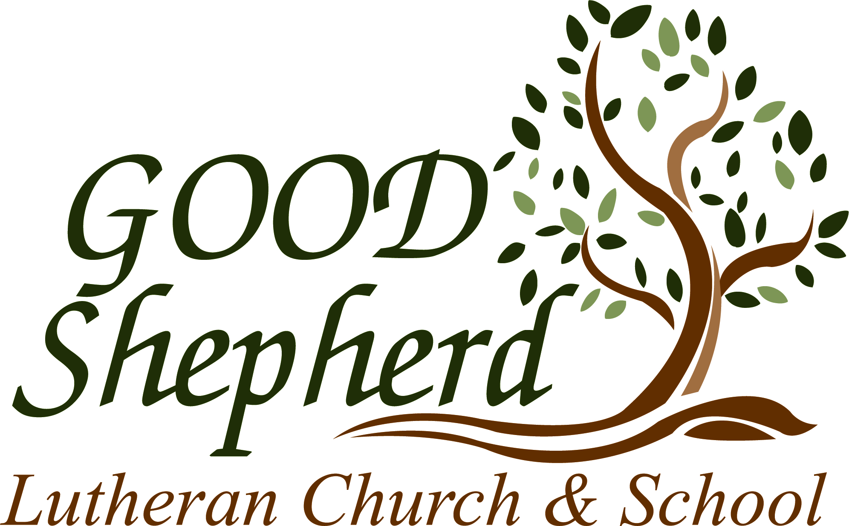


May 10, 2026



Sunday, May 10, 2026

LORD’S SUPPER - As Lutherans, in joyful obedience to the clear teaching of our Lord Jesus, we invite to His table at Good Shepherd those who trust His Word, repent of their sins, and set aside refusal to forgive and love just as we have been loved and forgiven by God. If you are unsure about whether you should commune or not, speak to an usher prior to the service. Thank you and welcome!

P RESERVICE MUSIC

WELCOME AND ANNOUNCEMENTS

OPENING HYMN “Immortal, Invisible, God Only Wise”
LSB 802

THE SERVICE OF CONFESSION AND ABSOLUTION

P In the name of the Father and of the + Son and of the Holy Spirit.
C Amen.

P Our help is in the name of the Lord,
C who made heaven and earth.

P If You, O Lord, kept a record of sins, O Lord, who could stand?
C But with You there is forgiveness; therefore You are feared.

P Since we are gathered to hear God’s Word, call upon Him in prayer and praise, and receive the body and blood of our Lord Jesus Christ in the fellowship of this altar, let us first consider our unworthiness and confess before God and one another that we have sinned in thought, word, and deed, and that we cannot free ourselves from our sinful condition. Together as His people let us take refuge in the infinite mercy of God, our heavenly Father, seeking His grace for the sake of Christ, and saying: God, be merciful to me, a sinner.
C Almighty God, have mercy upon us, forgive us our sins, and lead us to everlasting life. Amen.

P Almighty God in His mercy has given His Son to die for you and for His sake forgives you all your sins. As a called and ordained servant of Christ, and by His authority, I therefore forgive you all your sins in the name of the Father and of the + Son and of the Holy Spirit.
C Amen.

GLORIA IN EXCELSIS
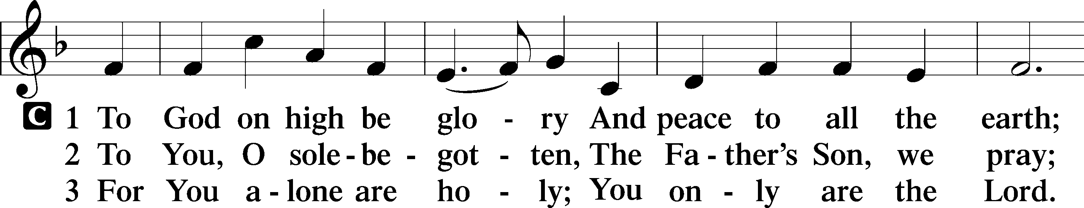
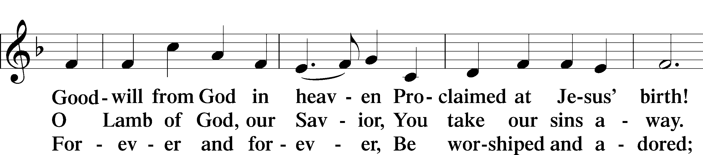
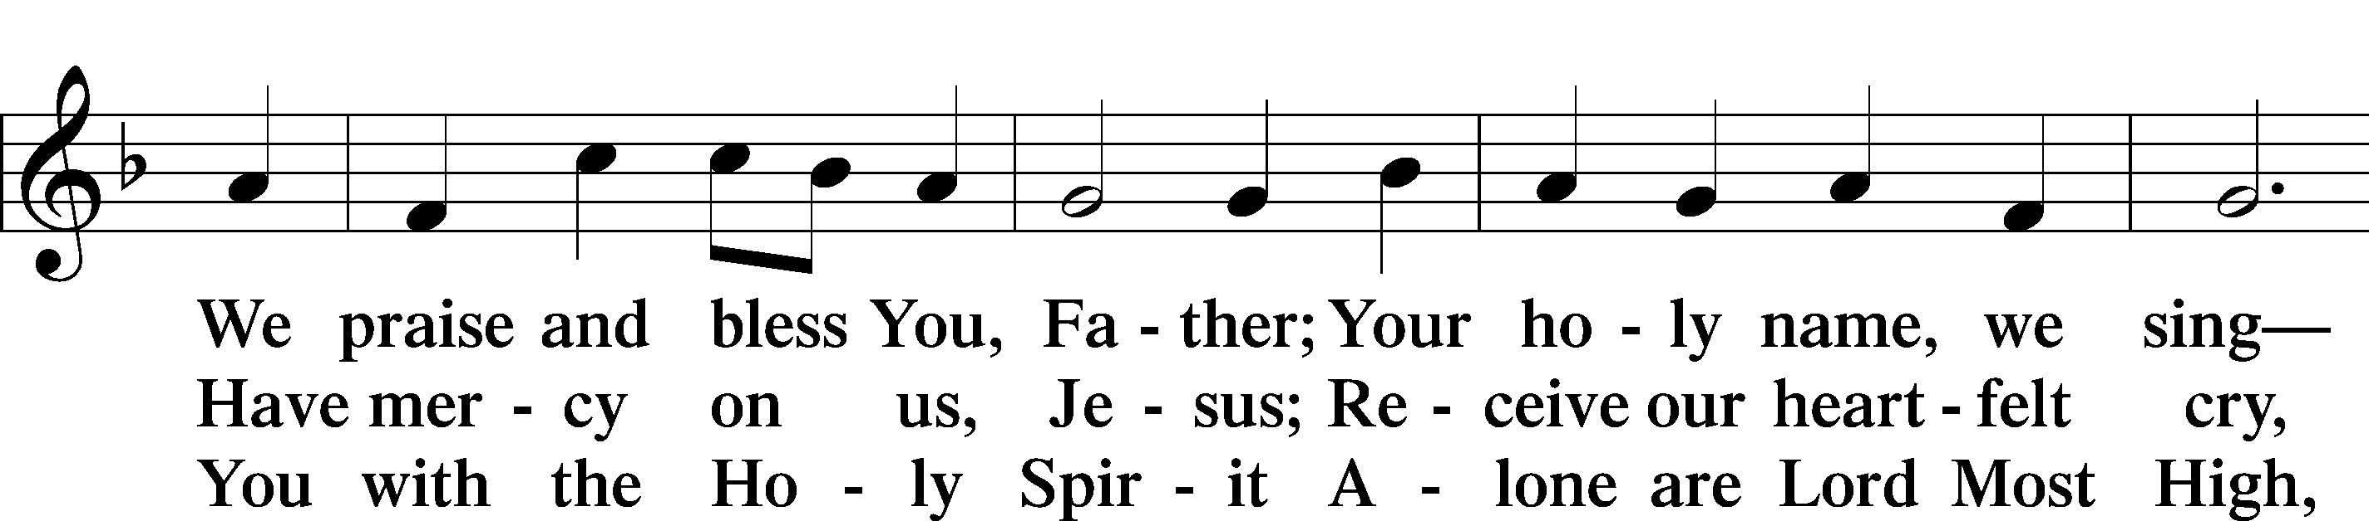
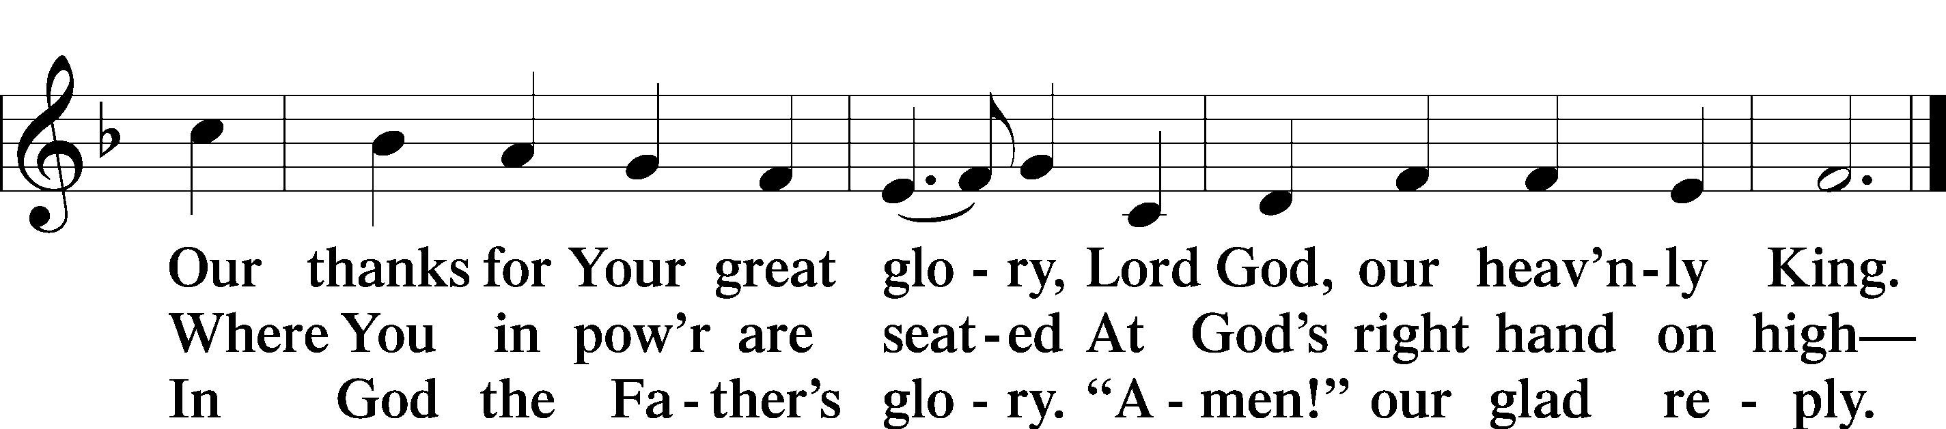

SALUTATION AND COLLECT OF THE DAY

P The Lord be with you.
C And also with you.

P Let us pray. O God, the giver of all that is good, by Your holy inspiration grant that we may think those things that are right and by Your merciful guiding accomplish them; through Jesus Christ, Your Son, our Lord, who lives and reigns with You and the Holy Spirit, one God, now and forever.
C Amen.

THIS WEEK’S THEME…The Lord Jesus Comforts Us with the Preaching of His Resurrection
FIRST READING Acts 17:16–31
While Paul was waiting for them at Athens, his spirit was provoked within him as he saw that the city was full of idols. So he reasoned in the synagogue with the Jews and the devout persons, and in the marketplace every day with those who happened to be there. Some of the Epicurean and Stoic philosophers also conversed with him. And some said, “What does this babbler wish to say?” Others said, “He seems to be a preacher of foreign divinities”—because he was preaching Jesus and the resurrection. And they took hold of him and brought him to the Areopagus, saying, “May we know what this new teaching is that you are presenting? For you bring some strange things to our ears. We wish to know therefore what these things mean.” Now all the Athenians and the foreigners who lived there would spend their time in nothing except telling or hearing something new. So Paul, standing in the midst of the Areopagus, said: “Men of Athens, I perceive that in every way you are very religious. For as I passed along and observed the objects of your worship, I found also an altar with this inscription, ‘To the unknown god.’ What therefore you worship as unknown, this I proclaim to you. The God who made the world and everything in it, being Lord of heaven and earth, does not live in temples made by man, nor is he served by human hands, as though he needed anything, since he himself gives to all mankind life and breath and everything. And he made from one man every nation of mankind to live on all the face of the earth, having determined allotted periods and the boundaries of their dwelling place, that they should seek God, in the hope that they might feel their way toward him and find him. Yet he is actually not far from each one of us, for “‘In him we live and move and have our being’; as even some of your own poets have said, “‘For we are indeed his offspring. Being then God’s offspring, we ought not to think that the divine being is like gold or silver or stone, an image formed by the art and imagination of man. The times of ignorance God overlooked, but now he commands all people everywhere to repent, because he has fixed a day on which he will judge the world in righteousness by a man whom he has appointed; and of this he has given assurance to all by raising him from the dead.”

L This is the Word of the Lord.
C Thanks be to God.

CHOIR ANTHEM “My Soul Rejoices” LSB 933

EPISTLE 1 Peter 3:13–22

Now who is there to harm you if you are zealous for what is good? But even if you should suffer for righteousness’ sake, you will be blessed. Have no fear of them, nor be troubled, but in your hearts regard Christ the Lord as holy, always being prepared to make a defense to anyone who asks you for a reason for the hope that is in you; yet do it with gentleness and respect, having a good conscience, so that, when you are slandered, those who revile your good behavior in Christ may be put to shame. For it is better to suffer for doing good, if that should be God’s will, than for doing evil. For Christ also suffered once for sins, the righteous for the unrighteous, that he might bring us to God, being put to death in the flesh but made alive in the spirit, in which he went and proclaimed to the spirits in prison, because they formerly did not obey, when God’s patience waited in the days of Noah, while the ark was being prepared, in which a few, that is, eight persons, were brought safely through water. Baptism, which corresponds to this, now saves you, not as a removal of dirt from the body but as an appeal to God for a good conscience, through the resurrection of Jesus Christ, who has gone into heaven and is at the right hand of God, with angels, authorities, and powers having been subjected to him.

L This is the Word of the Lord.
C Thanks be to God.

ALLELUIA AND VERSE
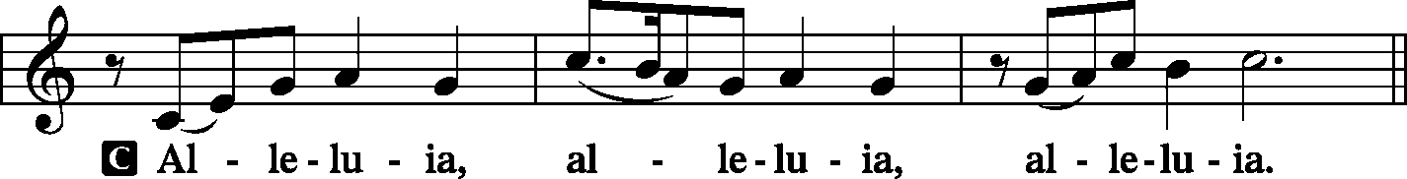
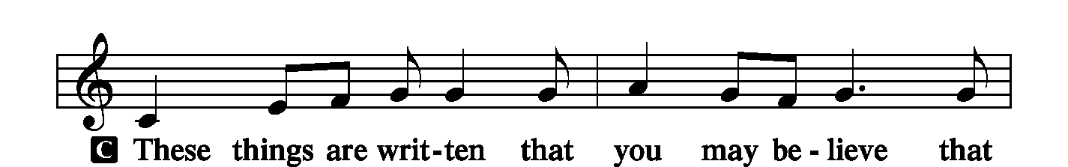
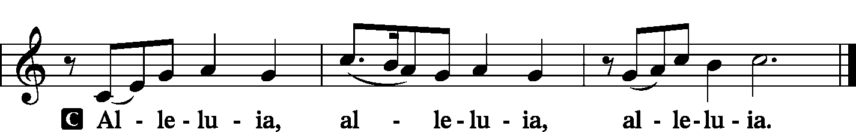
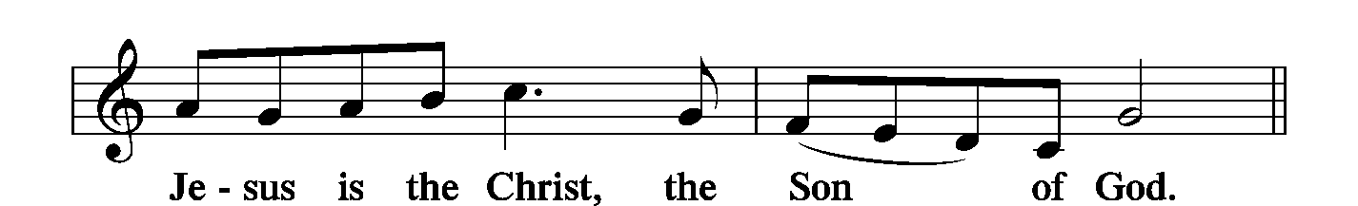
HOLY GOSPEL John 14:15–21
P The Holy Gospel according to St. John, the fourteenth chapter.
C Glory to You, O Lord.

[Jesus said:] “If you love me, you will keep my commandments.
And I will ask the Father, and he will give you another Helper, to be with you forever, even the Spirit of truth, whom the world cannot receive, because it neither sees him nor knows him. You know him, for he dwells with you and will be in you. “I will not leave you as orphans; I will come to you. Yet a little while and the world will see me no more, but you will see me. Because I live, you also will live. In that day you will know that I am in my Father, and you in me, and I in you. Whoever has my commandments and keeps them, he it is who loves me. And he who loves me will be loved by my Father, and I will love him and manifest myself to him.”

P This is the Gospel of the Lord.
C Praise to You, O Christ.

NICENE CREED LSB 206

C I believe in one God, the Father Almighty, maker of heaven and earth and of all things visible and invisible. And in one Lord Jesus Christ, the only-begotten Son of God, begotten of His Father before all worlds, God of God, Light of Light, very God of very God, begotten, not made, being of one substance with the Father, by whom all things were made; who for us men and for our salvation came down from heaven and was incarnate by the Holy Spirit of the virgin Mary and was made man; and was crucified also for us under Pontius Pilate. He suffered and was buried. And the third day He rose again according to the Scriptures and ascended into heaven and sits at the right hand of the Father. And He will come again with glory to judge both the living and the dead, whose kingdom will have no end. And I believe in the Holy Spirit, the Lord and giver of life, who proceeds from the Father and the Son, who with the Father and the Son together is worshiped and glorified, who spoke by the prophets. And I believe in one holy Christian and apostolic Church, I acknowledge one Baptism for the remission of sins, and I look for the resurrection of the dead and the life + of the world to come. Amen.

CHILDREN’S CHAPEL

HYMN OF THE DAY “Lord, Whose Love through Humble Service LSB 848

SERMON John 14:15-21; “Home Alone? I Don’t Think So”

THE PRAYERS OF THE CHURCH

Each prayer petition concludes:

P Lord, in Your mercy,
C Hear our prayer.

THE OFFERING

While we gather the offering today you are invited to fill out the red “Record of Fellowship” forms located at the end of the pew. If you would, please pass the red pad down the pew so everyone can complete the record. Thanks!

SERVICE OF THE SACRAMENT

PREFACE LSB 208

P The Lord be with you.
C And also with you.

P Lift up your hearts.
C We lift them to the Lord.

P Let us give thanks to the Lord our God.
C It is right to give Him thanks and praise.

P It is truly good, right, and salutary . . . evermore praising You and saying:

SANCTUS LSB 208
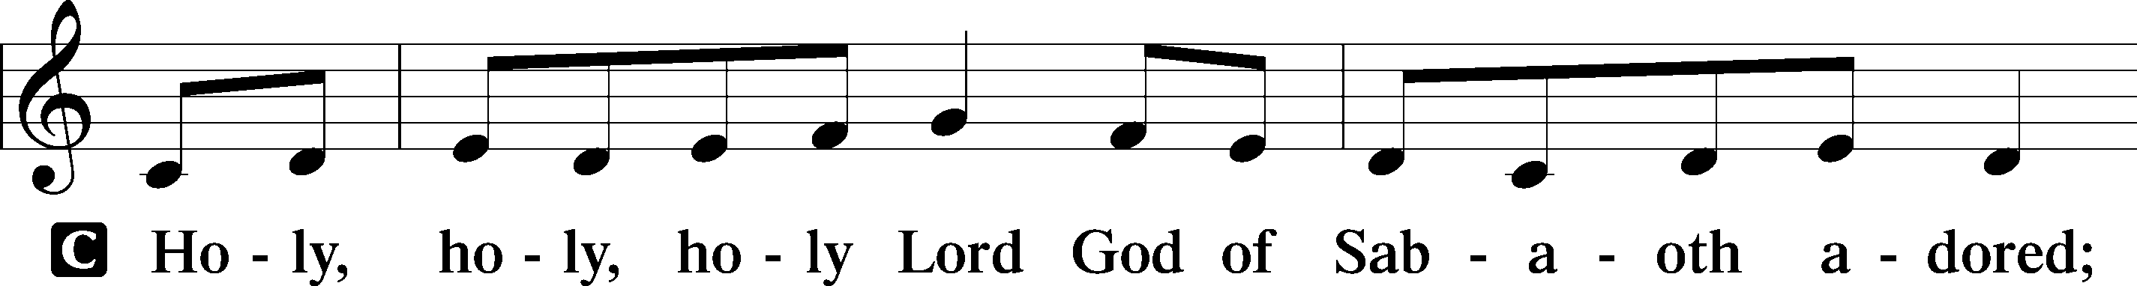
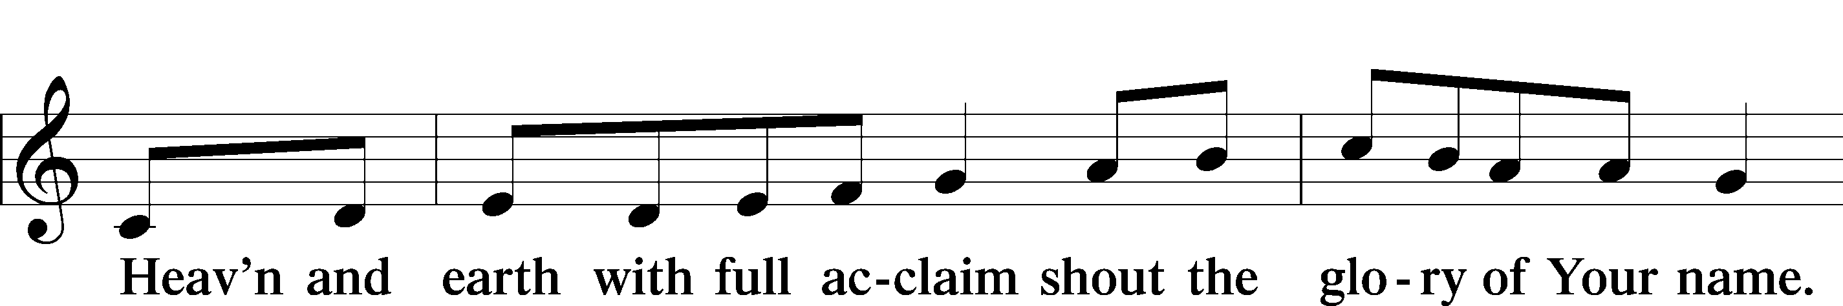
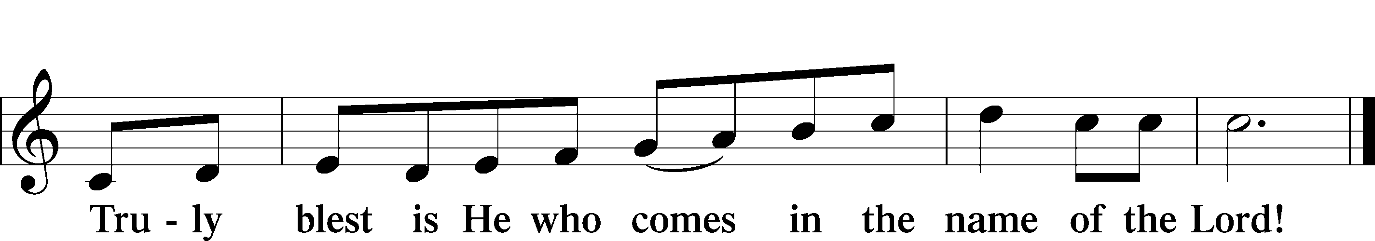
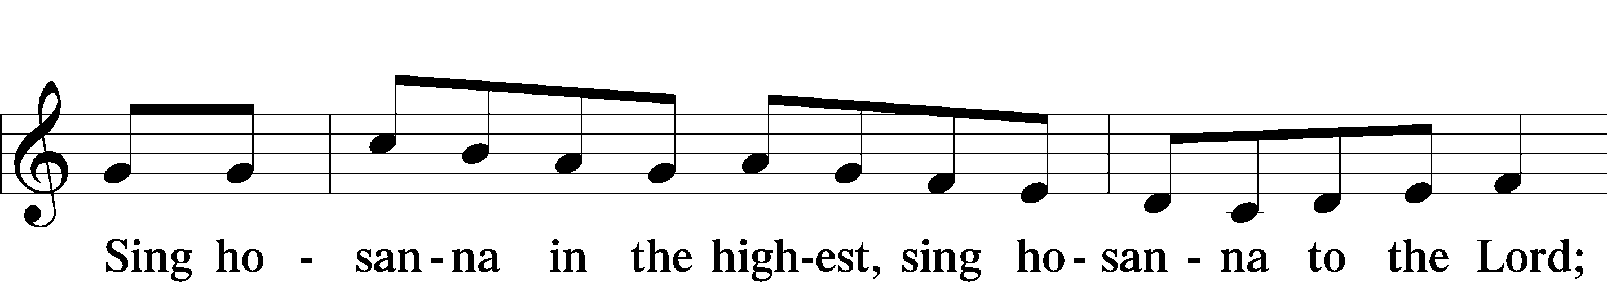

LORD'S PRAYER LSB 209

P Lord, remember us in Your kingdom and teach us to pray:
C Our Father who art in heaven, hallowed be Thy name, Thy kingdom come, Thy will be done on earth as it is in heaven; give us this day our daily bread; and forgive us our trespasses as we forgive those who trespass against us; and lead us not into temptation, but deliver us from evil. For Thine is the kingdom and the power and the glory forever and ever. Amen.

THE WORDS OF OUR LORD
PAX DOMINI LSB 209

P The peace of the Lord be with you always.
C And also with you.

AGNUS DEI LSB 210
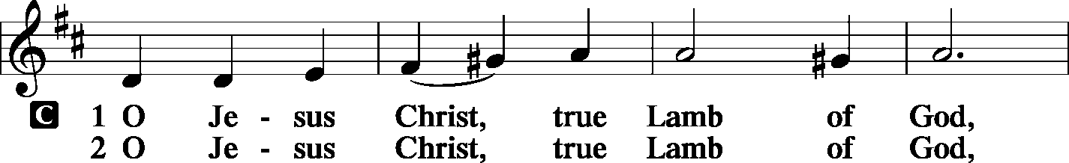
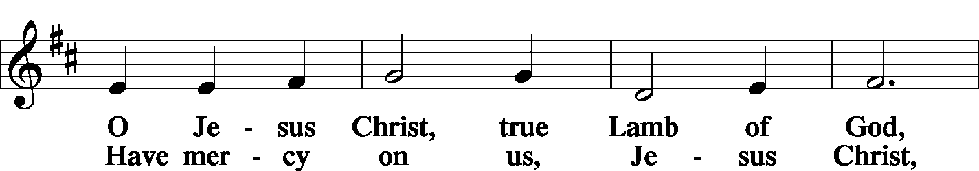
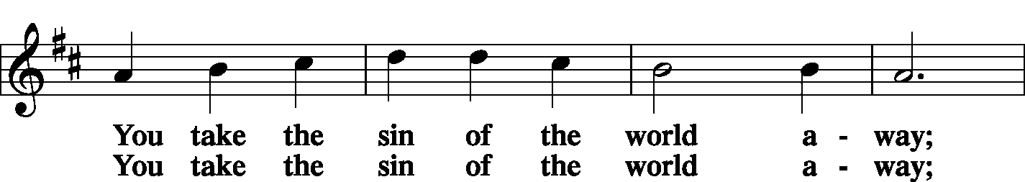

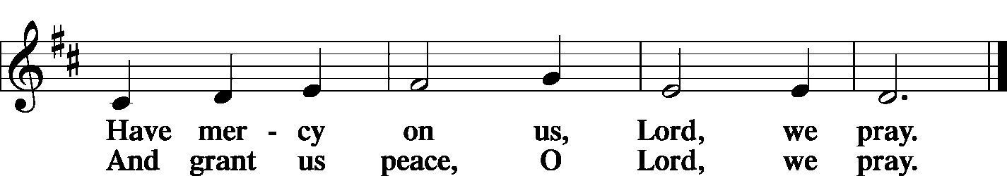
THE DISTRIBUTION

As Lutherans, in joyful obedience to the clear teaching of Lord Jesus, we now invite to His table those who trust His Word, repent of their sins, and set aside refusal to forgive and love just as we have been loved and forgiven by God. You will receive the host and then will have a choice of either the individual cups or the common cup. If you would like the common cup, place your hands FLAT on the rail while the individual cups are offered. This way Pastor will know that you desire the common cup. If for medical or other reasons you would prefer a non-alcoholic individual cup, they are located in the center of each tray. If you would like to receive communion in the pew, please inform an Usher and what your preference would be – either common or individual cup. Thank you.

HYMNS DURING THE DISTRIBUTION

“On Eagles’ Wings” LSB 727
“Jesus Lives! the Victory’s Won” LSB 490
“Son of God, Eternal Savior” LSB 842
“From All that Dwell Below the Skies” LSB 816

NUNC DIMITTIS LSB 211
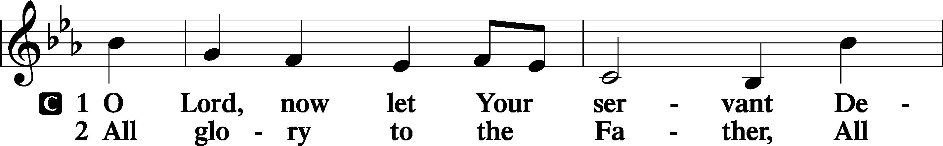
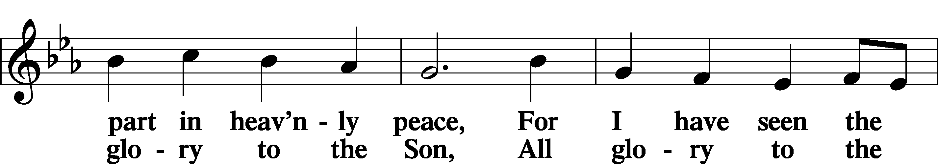
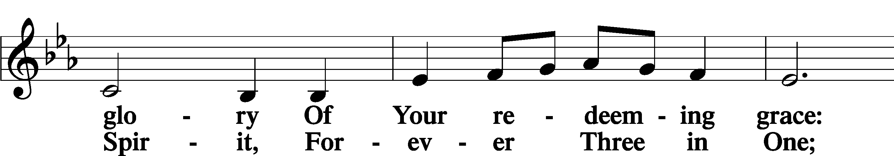

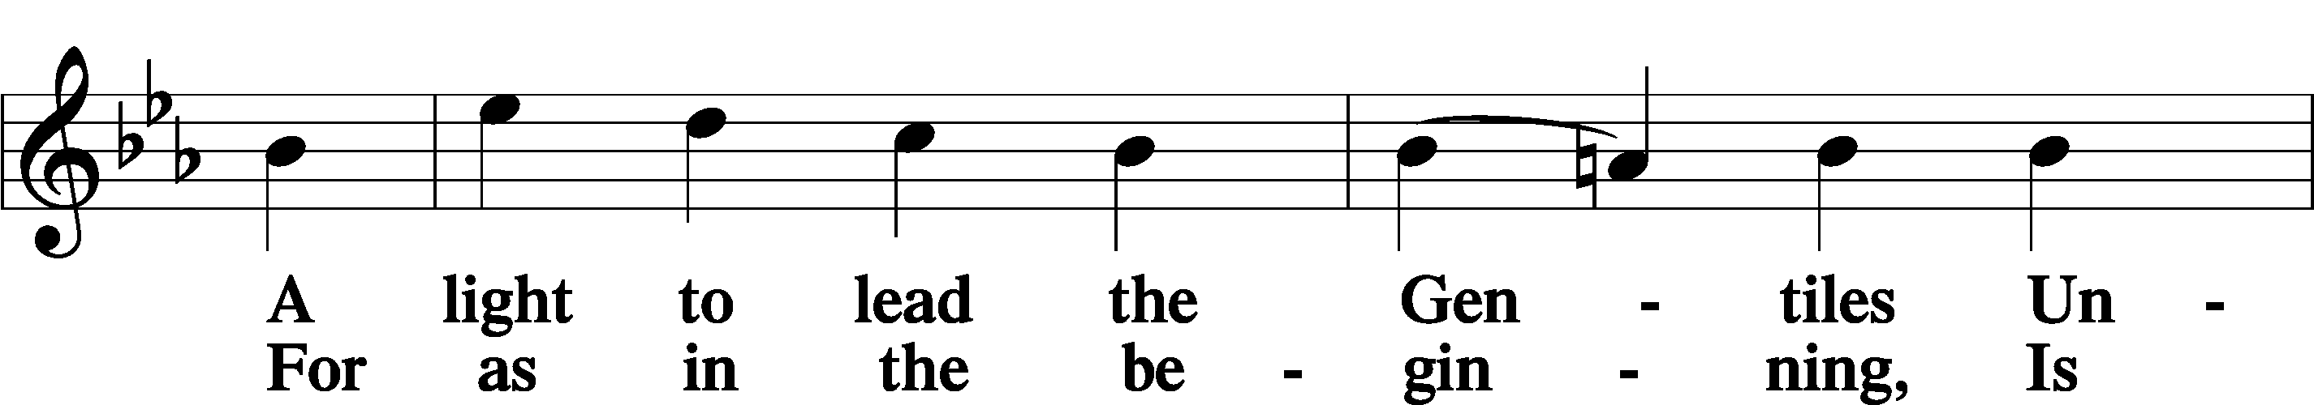

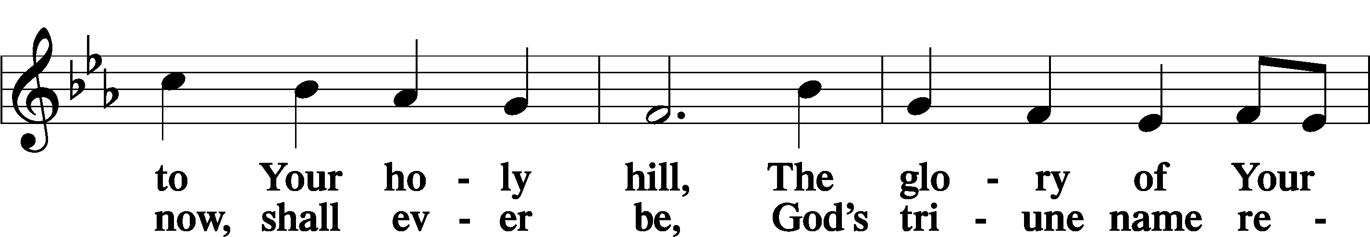

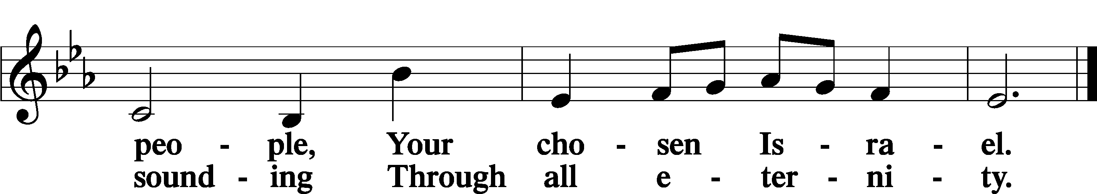

POST-COMMUNION COLLECT

P Let us pray.
O God, our Maker and Redeemer, You wonderfully created us and in the incarnation of Your Son yet more wondrously restored our human nature. Grant that we may ever be alive in Him who made Himself to be like us; through Jesus Christ, our Lord, who lives and reigns with You and the Holy Spirit, one God, now and forever.
C Amen.

BENEDICTION

P Let us bless the Lord.
C Thanks be to God.

P The Lord bless you and keep you. The Lord make His face shine on you and be gracious to you. The Lord look upon you with favor and + give you peace.
C Amen.

P Go in Peace. Serve the Lord.
C Thanks be to God!

CLOSING HYMN “For All the Faithful Women” LSB 855
Vs. 1,6-8

POSTLUDE

Acknowledgments Divine Service, Setting four from Lutheran Service Book. Unless otherwise indicated, all scripture quotations are from Holy Bible, English Standard Version, copyright © 2001 by Crossway Bibles, a division of Good News Publishers. Used by permission. All rights reserved. Created by Lutheran Service Builder © 2023 Concordia Publishing House.






COME SEE WHAT GOD IS DOING IN OUR MIDST;
COME GROW WITH US

MAY
2-24 AFFB Food Drive
10- Mother’s Day
12-School Board Mtg 5:45 PM
18-Church Council Mtg 6:00 PM
25- Memorial Day
27- Men’s Group 7:00 PM
MAY BIRTHDAYS
Carl Bayne 5/02
John Teller 5/02
Kenneth Allen 5/10
Joan Johnson 5/11
Richard Pohlman 5/16
Sandy Dion 5/18
Diane Gonzalez 5/18

Jerry McDermott 5/18
Linda Petersen 5/18
Kyle Buchholz 5/24
Lee Korn 5/26
Glenn Hankison 5/29
Robert Nauss 5/31

ANNIVERSARIES


Kyle & Emily Buchholz 05/05 14 yrs
Corey & Megan Rhinehart 05/17 18 yrs
Wilson & Irene Anderson 05/21 60 yrs
William & Barbara
Christensen 05/22 55 yrs

NOTARY SERVICE AVAILABLE
Call Sue at the office 941-3673

NEXT WEEK’S READINGS
Acts 1:1–11 Ephesians 1:15–23 Luke 24:44–53, Psalm 47



MORE WAYS TO GIVE
1st is Joyful Response- sign up from your checking or savings
account to the church on a recurring basis. There is no cost
for either the member or church to participate in this
program.
2nd is Zelle- sign into your bank via your cell phones and
initiate an on-time transfer from your account to the church
checking account. There is no cost for the members,
however, the church must pay a 1% fee to the bank.

WEEK OF MAY 3, 2026

TITHES & OFFERING: $6321
Attendance: Saturday 5/2: 14 ~ Sunday 5/3: 75



MAY 2-24
Church will be hosting a food drive and emphasize financial support from May 2nd through May 24th for All Faiths Food Bank to support hungry kids over the summer months when school is not in session.



BIBLE STUDY
Sundays After Service




GSLCS offers gift cards to those who need them and come to us for help. We offer cards for three businesses: Publix, Walgreen’s, and Wa-Wa (food, medicine, gas). We especially need more gift cards for Publix. The most common amounts the people give are in the $20-$25-dollar range and that is fine. If you are able, please pick up some gift cards and provide them to the church office and we’ll handle it from there. Thanks for your ongoing support of the mission and ministry of GSLCS.

VIST OUR WEBSITE:
GOODSHEPHERDSARASOTA.ORG

