


Good Shepherd Lutheran Church & School
is a welcoming, Christ-centered family,
dedicated to sharing our love and faith.

GOOD SHEPHERD LUTHERAN CHURCH
(The Lutheran Church-Missouri Synod)
PASTOR STEVE ANDERSON
5659 Honore Ave., Sarasota, Florida 34233
941-921-3673

parishcoord@goodshepherdsarasota.org
pastor@goodshepherdsarasota.org
www.goodshepherdsarasota.org

GOOD SHEPHERD LUTHERAN SCHOOL
941-922-8164
Email: GSLS@comcast.net



May 17, 2026

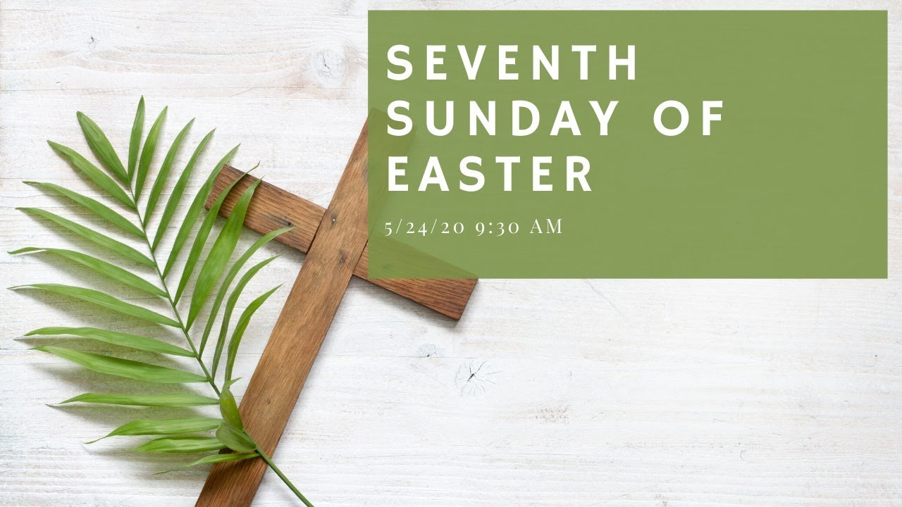

Sunday, May 17th 9:15 AM

LORD’S SUPPER - As Lutherans, in joyful obedience to the clear teaching of our Lord Jesus, we invite to His table at Good Shepherd those who trust His Word, repent of their sins, and set aside refusal to forgive and love just as we have been loved and forgiven by God. If you are unsure about whether you should commune or not, speak to an usher prior to the service. Thank you and welcome!

PRESERVICE MUSIC

WELCOME AND ANNOUNCEMENTS

OPENING HYMN “Christ the Eternal Lord” LSB 829,
Vs. 1-3, 5

THE SERVICE OF CONFESSION AND ABSOLUTION

P In the name of the Father and of the + Son and of the Holy Spirit.
C Amen.

P Our help is in the name of the Lord,
C who made heaven and earth.

P If You, O Lord, kept a record of sins, O Lord, who could stand?
C But with You there is forgiveness; therefore You are feared.
P Since we are gathered to hear God’s Word, call upon Him in prayer and praise, and receive the body and blood of our Lord Jesus Christ in the fellowship of this altar, let us first consider our unworthiness and confess before God and one another that we have sinned in thought, word, and deed, and that we cannot free ourselves from our sinful condition. Together as His people let us take refuge in the infinite mercy of God, our heavenly Father, seeking His grace for the sake of Christ, and saying: God, be merciful to me, a sinner.
C Almighty God, have mercy upon us, forgive us our sins, and lead us to everlasting life. Amen.

P Almighty God in His mercy has given His Son to die for you and for His sake forgives you all your sins. As an ordained servant of Christ, and by His authority, I therefore forgive you all your sins in the name of the Father and of the + Son and of the Holy Spirit.
C Amen.

GLORIA IN EXCELSIS
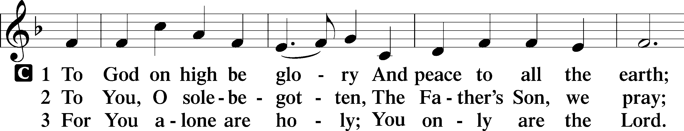
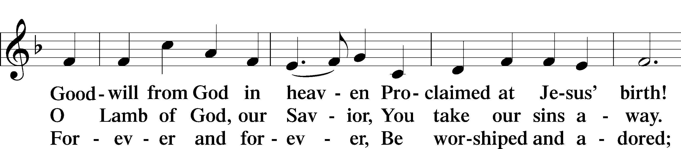
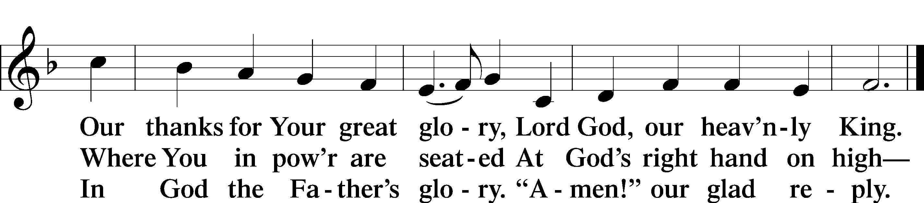
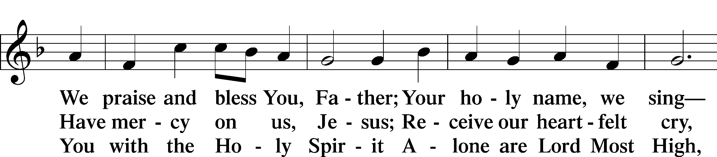

SALUTATION AND COLLECT OF THE DAY

P The Lord be with you.
C And also with you.

P Let us pray. Almighty God, as Your only-begotten Son, our Lord Jesus Christ, ascended into the heavens, so may we also ascend in heart and mind and continually dwell there with Him, who lives and reigns with You and the Holy Spirit, one God, now and forever.
C Amen.

THIS WEEK’S THEME… Christ Ascended Is with You Always
FIRST READING Acts 1:1-11
In the first book, O Theophilus, I have dealt with all that Jesus began to do and teach, until the day when he was taken up, after he had given commands through the Holy Spirit to the apostles whom he had chosen. To them he presented himself alive after his suffering by many proofs, appearing to them during forty days and speaking about the kingdom of God. And while staying with them he ordered them not to depart from Jerusalem, but to wait for the promise of the Father, which, he said, “you heard from me; for John baptized with water, but you will be baptized with the Holy Spirit not many days from now.” So when they had come together, they asked him, “Lord, will you at this time restore the kingdom to Israel?” He said to them, “It is not for you to know times or seasons that the Father has fixed by his own authority. But you will receive power when the Holy Spirit has come upon you, and you will be my witnesses in Jerusalem and in all Judea and Samaria, and to the end of the earth.” And when he had said these things, as they were looking on, he was lifted up, and a cloud took him out of their sight. And while they were gazing into heaven as he went, behold, two men stood by them in white robes, and said, “Men of Galilee, why do you stand looking into heaven? This Jesus, who was taken up from you into heaven, will come in the same way as you saw him go into heaven.”

L This is the Word of the Lord.
C Thanks be to God.

CHOIR ANTHEM “Hail Thee, Festival Day” LSB 489

EPISTLE Ephesians 1:15–23

For this reason, because I have heard of your faith in the Lord Jesus and your love toward all the saints, I do not cease to give thanks for you, remembering you in my prayers, that the God of our Lord Jesus Christ, the Father of glory, may give you a spirit of wisdom and of revelation in the knowledge of him, having the eyes of your hearts enlightened, that you may know what is the hope to which he has called you, what are the riches of his glorious inheritance in the saints, and what is the immeasurable greatness of his power toward us who believe, according to the working of his great might that he worked in Christ when he raised him from the dead and seated him at his right hand in the heavenly places, far above all rule and authority and power and dominion, and above every name that is named, not only in this age but also in the one to come. And he put all things under his feet and gave him as head over all things to the church, which is his body, the fullness of him who fills all in all.

L This is the Word of the Lord.
C Thanks be to God.

ALLELUIA AND VERSE
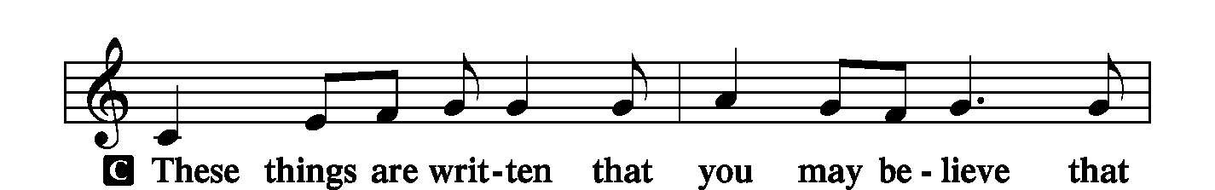
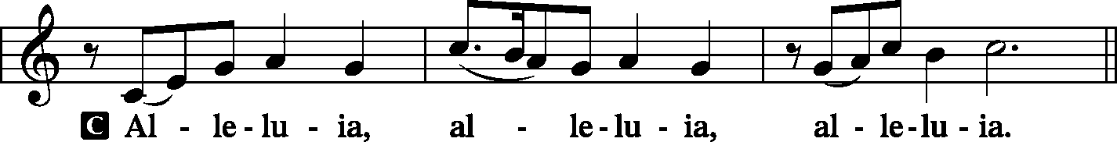

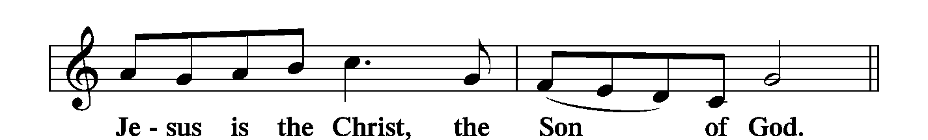

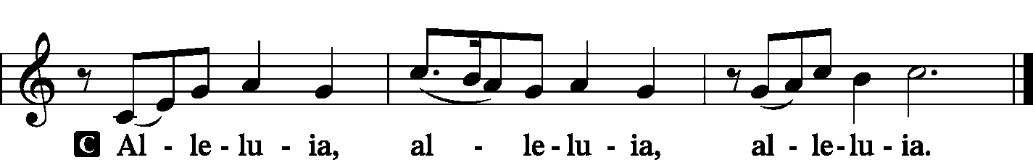

HOLY GOSPEL Luke 24:44–53
P The Holy Gospel according to St. Luke, the twenty-fourth chapter.
C Glory to You, O Lord.

Then [Jesus] said to them, “These are my words that I spoke to you while I was still with you, that everything written about me in the Law of Moses and the Prophets and the Psalms must be fulfilled.” Then he opened their minds to understand the Scriptures, and said to them, “Thus it is written, that the Christ should suffer and on the third day rise from the dead, and that repentance and forgiveness of sins should be proclaimed in his name to all nations, beginning from Jerusalem. You are witnesses of these things. And behold, I am sending the promise of my Father upon you. But stay in the city until you are clothed with power from on high.” Then he led them out as far as Bethany, and lifting up his hands he blessed them. While he blessed them, he parted from them and was carried up into heaven. And they worshiped him and returned to Jerusalem with great joy, and were continually in the temple blessing God.
P This is the Gospel of the Lord.
C Praise to You, O Christ.

NICENE CREED LSB 206

C I believe in one God, the Father Almighty, maker of heaven and earth and of all things visible and invisible. And in one Lord Jesus Christ, the only-begotten Son of God, begotten of His Father before all worlds, God of God, Light of Light, very God of very God, begotten, not made, being of one substance with the Father, by whom all things were made; who for us men and for our salvation came down from heaven and was incarnate by the Holy Spirit of the virgin Mary and was made man; and was crucified also for us under Pontius Pilate. He suffered and was buried. And the third day He rose again according to the Scriptures and ascended into heaven and sits at the right hand of the Father. And He will come again with glory to judge both the living and the dead, whose kingdom will have no end. And I believe in the Holy Spirit, the Lord and giver of life, who proceeds from the Father and the Son, who with the Father and the Son together is worshiped and glorified, who spoke by the prophets. And I believe in one holy Christian and apostolic Church, I acknowledge one Baptism for the remission of sins, and I look for the resurrection of the dead and the life + of the world to come. Amen.

HYMN OF THE DAY “A Hymn of Glory Let Us Sing” LSB 493 (all vs.)

SERMON Pastor Stephen Gaulke, Guest Pastor
Acts 1:11 What Is Jesus Up to, Ascended to Heaven?

1. What then did Jesus do and teach?

“I am for you the __________, _____________, _________!

2. What _______ does Jesus do and teach?

“Thru _______, I am for _______: Prophet, Priest, King!”

THE PRAYERS OF THE CHURCH
Each prayer petition concludes:

P Lord, in Your mercy,
C Hear our prayer.

THE OFFERING

While we gather the offering today you are invited to fill out the red “Record of Fellowship” forms located at the end of the pew. If you would, please pass the red pad down the pew so everyone can complete the record. Thanks!

SERVICE OF THE SACRAMENT

PREFACE LSB 208

P The Lord be with you.
C And also with you.

P Lift up your hearts.
C We lift them to the Lord.

P Let us give thanks to the Lord our God.
C It is right to give Him thanks and praise.

P It is truly good, right, and salutary . . . evermore praising You and saying:

SANCTUS LSB 208
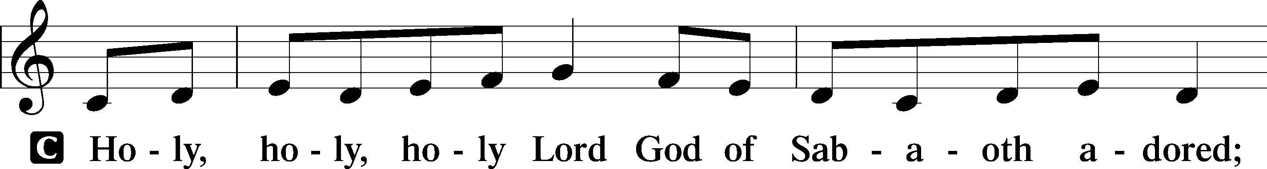
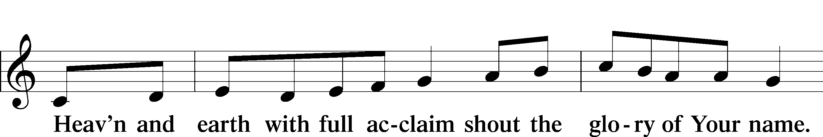
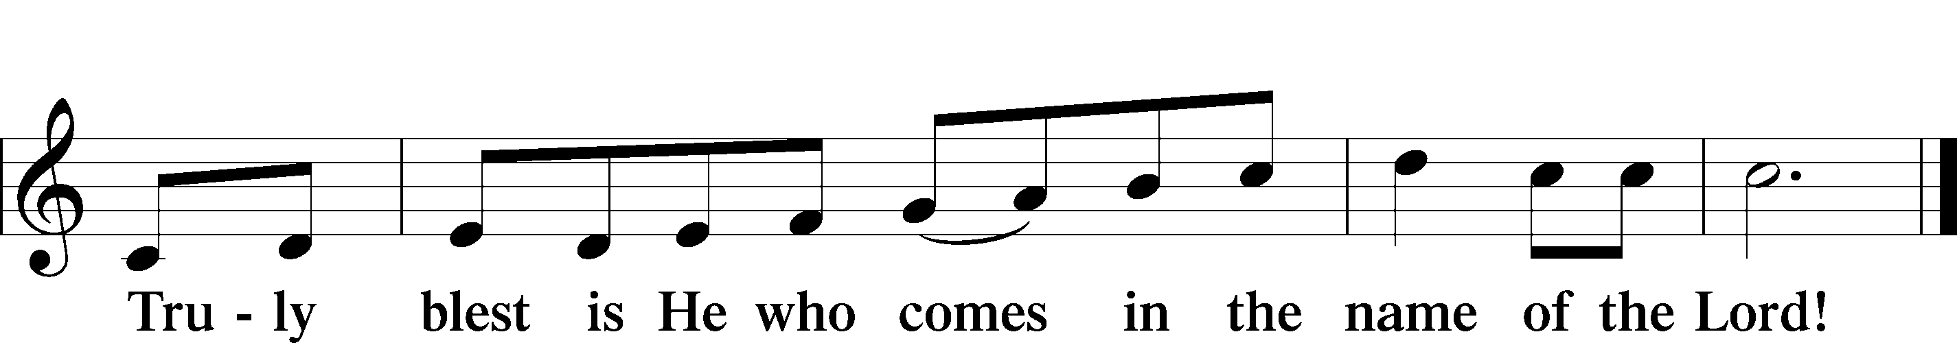
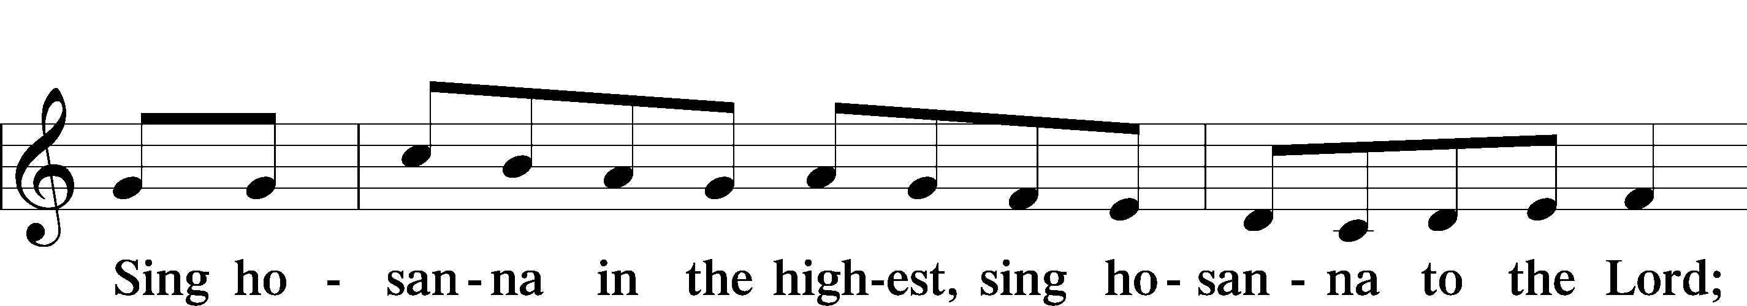

LORD'S PRAYER LSB 209

P Lord, remember us in Your kingdom and teach us to pray:
C Our Father who art in heaven, hallowed be Thy name, Thy kingdom come, Thy will be done on earth as it is in heaven; give us this day our daily bread; and forgive us our trespasses as we forgive those who trespass against us; and lead us not into temptation, but deliver us from evil. For Thine is the kingdom and the power and the glory forever and ever. Amen.

THE WORDS OF OUR LORD

PAX DOMINI LSB 209

P The peace of the Lord be with you always.
C And also with you.

AGNUS DEI LSB 210
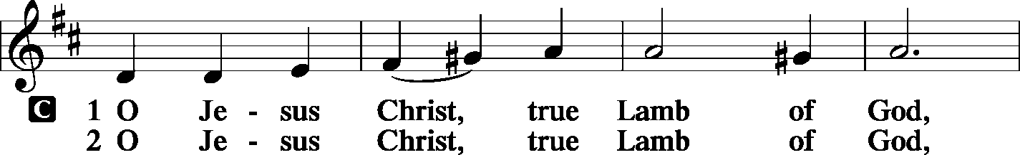
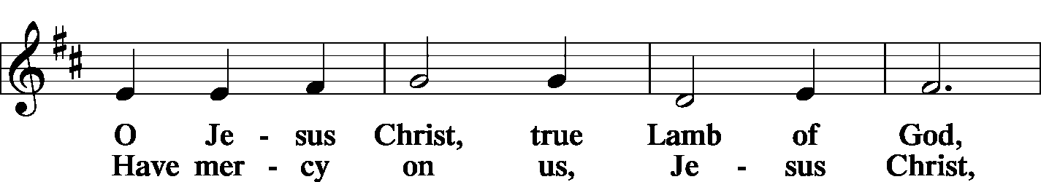
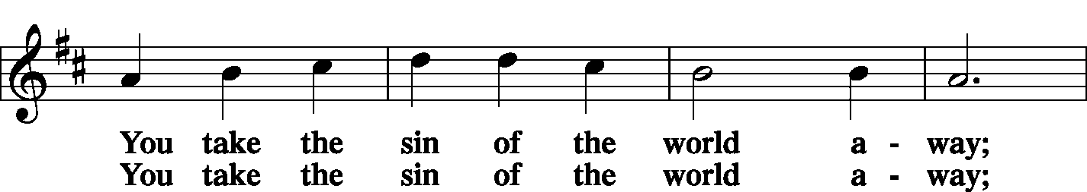

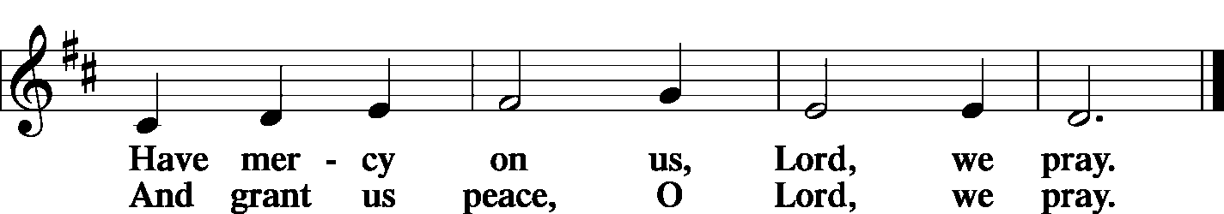

THE DISTRIBUTION

As Lutherans, in joyful obedience to the clear teaching of Lord Jesus, we now invite to His table those who trust His Word, repent of their sins, and set aside refusal to forgive and love just as we have been loved and forgiven by God. You will receive the host and then will have a choice of either the individual cups or the common cup. If you would like the common cup, place your hands FLAT on the rail while the individual cups are offered. This way Pastor will know that you desire the common cup. If for medical or other reasons you would prefer a non-alcoholic individual cup, they are located in the center of each tray. If you would like to receive communion in the pew, please inform an Usher and what your preference would be – either common or individual cup. Thank you.
HYMNS DURING THE DISTRIBUTION

“Beautiful Savior” LSB 537
“Alleluia! Sing to Jesus” LSB 821
“All Hail the Power of Jesus’ Name” LSB 549
“Crown Him with Many Crowns” LSB 525

NUNC DIMITTIS LSB 211
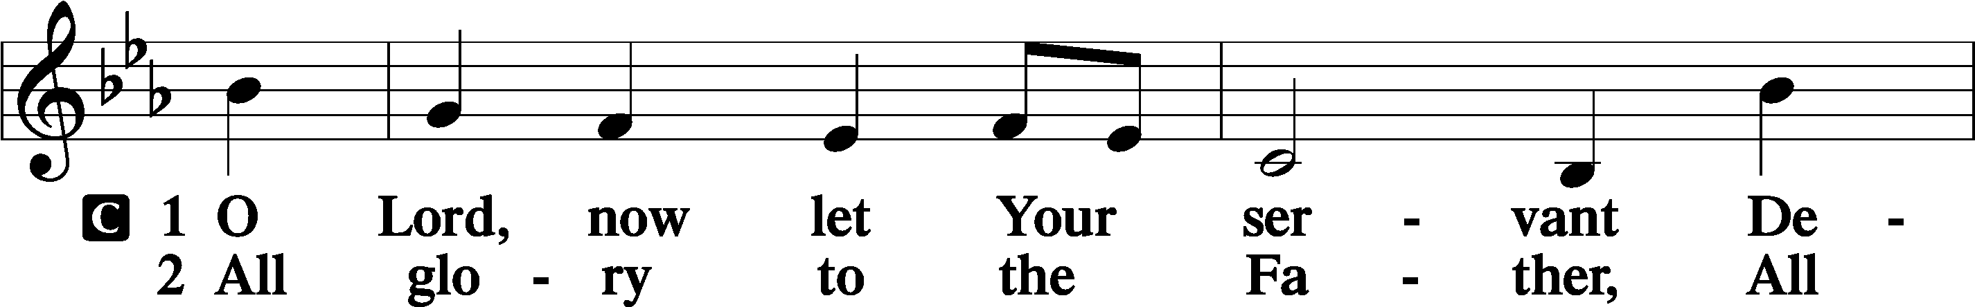
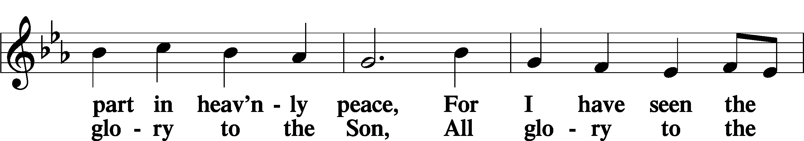
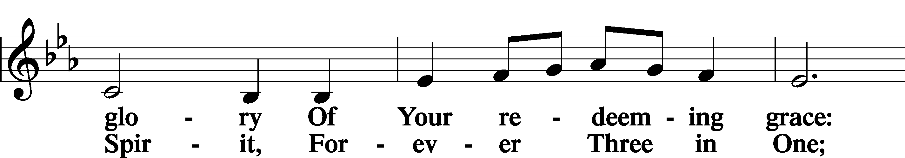

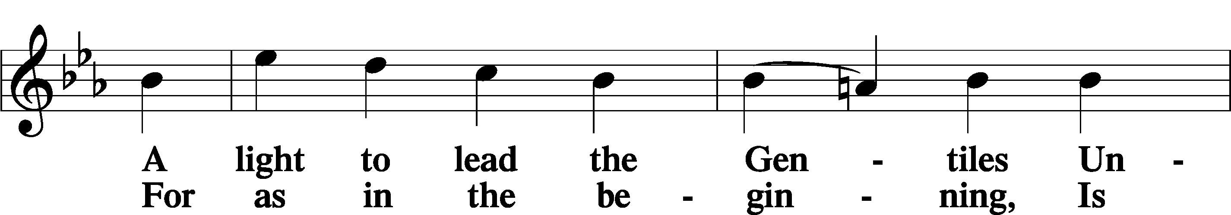

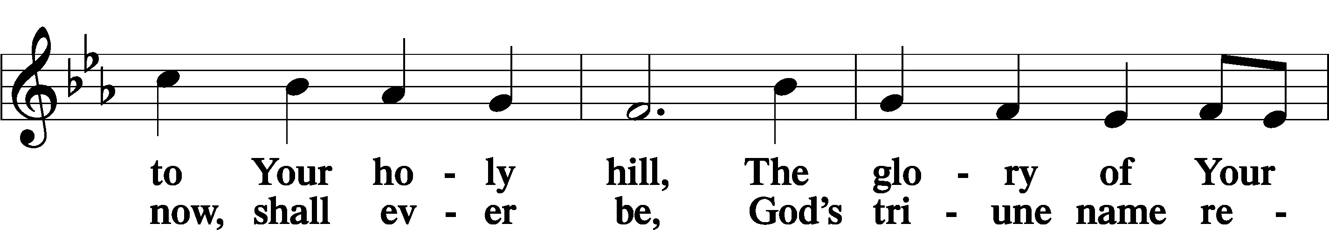

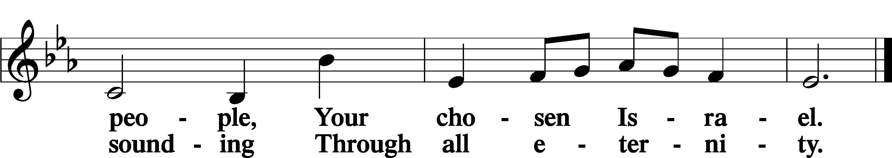

POST-COMMUNION COLLECT

P Let us pray.
O God, our Maker and Redeemer, You wonderfully created us and in the incarnation of Your Son yet more wondrously restored our human nature. Grant that we may ever be alive in Him who made Himself to be like us; through Jesus Christ, our Lord, who lives and reigns with You and the Holy Spirit, one God, now and forever.
C Amen.

BENEDICTION

P Let us bless the Lord.
C Thanks be to God.

P The Lord bless you and keep you. The Lord make His face shine on you and be gracious to you. The Lord look upon you with favor and + give you peace.
C Amen.

P Go in Peace. Serve the Lord.
C Thanks be to God!

CLOSING HYMN “Jesus Shall Reign” LSB 832 vs. 1,3-5

POSTLUDE

Acknowledgments Divine Service, Setting four from Lutheran Service Book. Unless otherwise indicated, all scripture quotations are from Holy Bible, English Standard Version, copyright © 2001 by Crossway Bibles, a division of Good News Publishers. Used by permission. All rights reserved. Created by Lutheran Service Builder © 2023 Concordia Publishing House.




COME SEE WHAT GOD IS DOING IN OUR MIDST;
COME GROW WITH US

MAY
2-24 AFFB Food Drive
18-Church Council Mtg 6:00 PM
25- Memorial Day
27- Men’s Group 7:00 PM
MAY BIRTHDAYS
Carl Bayne 5/02
John Teller 5/02
Kenneth Allen 5/10
Joan Johnson 5/11
Richard Pohlman 5/16
Sandy Dion 5/18

Diane Gonzalez 5/18
Jerry McDermott 5/18
Linda Petersen 5/18
Kyle Buchholz 5/24
Glenn Hankison 5/29
Robert Nauss 5/31

ANNIVERSARIES



Kyle & Emily Buchholz 05/05 14 yrs
Corey & Megan Rhinehart 05/17 18 yrs
William & Barbara
Christensen 05/22 55 yrs

NOTARY SERVICE AVAILABLE
Call Sue at the office 941-3673

NEXT WEEK’S READINGS
Numbers 11:24–30,Psalm 25:1–15
Acts 2:1–21John 7:37–39



MORE WAYS TO GIVE
1st is Joyful Response- sign up from your checking or savings
account to the church on a recurring basis. There is no cost
for either the member or church to participate in this
program.
2nd is Zelle- sign into your bank via your cell phones and
initiate an on-time transfer from your account to the church
checking account. There is no cost for the members,
however, the church must pay a 1% fee to the bank.

WEEK OF MAY 10, 2026

TITHES & OFFERING: $4533
Attendance: Saturday 5/9: 14 Sunday 5/10: 85



MAY 2-24
Church will be hosting a food drive and emphasize financial support from May 2nd through May 24th for All Faiths Food Bank to support hungry kids over the summer months when school is not in session.



BIBLE STUDY
Sundays After Service




GSLCS offers gift cards to those who need them and come to us for help. We offer cards for three businesses: Publix, Walgreen’s, and Wa-Wa (food, medicine, gas). We especially need more gift cards for Publix. The most common amounts the people give are in the $20-$25-dollar range and that is fine. If you are able, please pick up some gift cards and provide them to the church office and we’ll handle it from there. Thanks for your ongoing support of the mission and ministry of GSLCS.

VIST OUR WEBSITE:
GOODSHEPHERDSARASOTA.ORG

